3D Printing workshop. INTRO
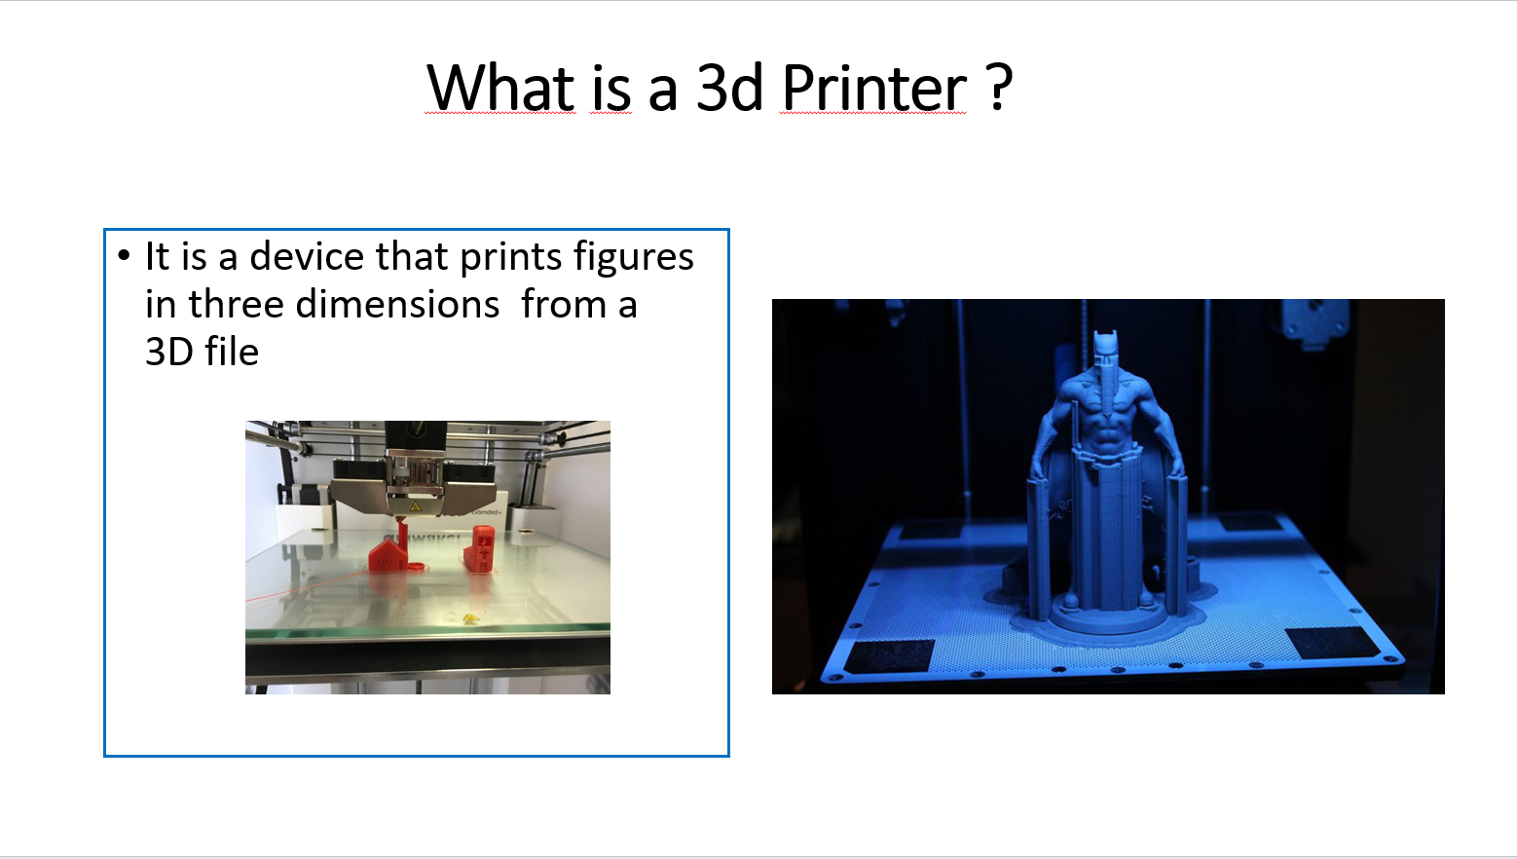
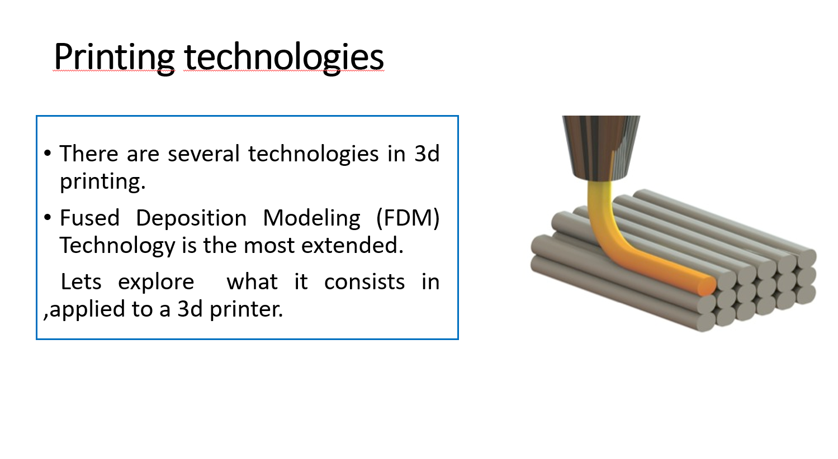
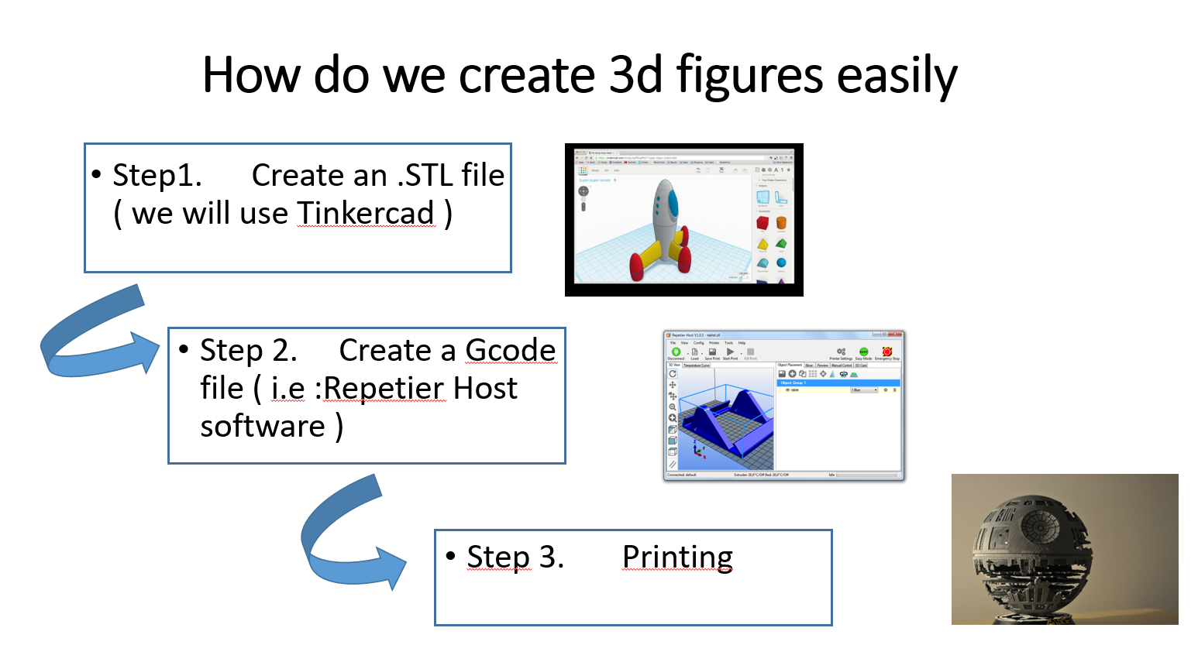

Tinkercad for newbies

Main components of Tinkercad interface
When we start a drawing we see a blank page
This is the equivalent in 3D tinkercad.
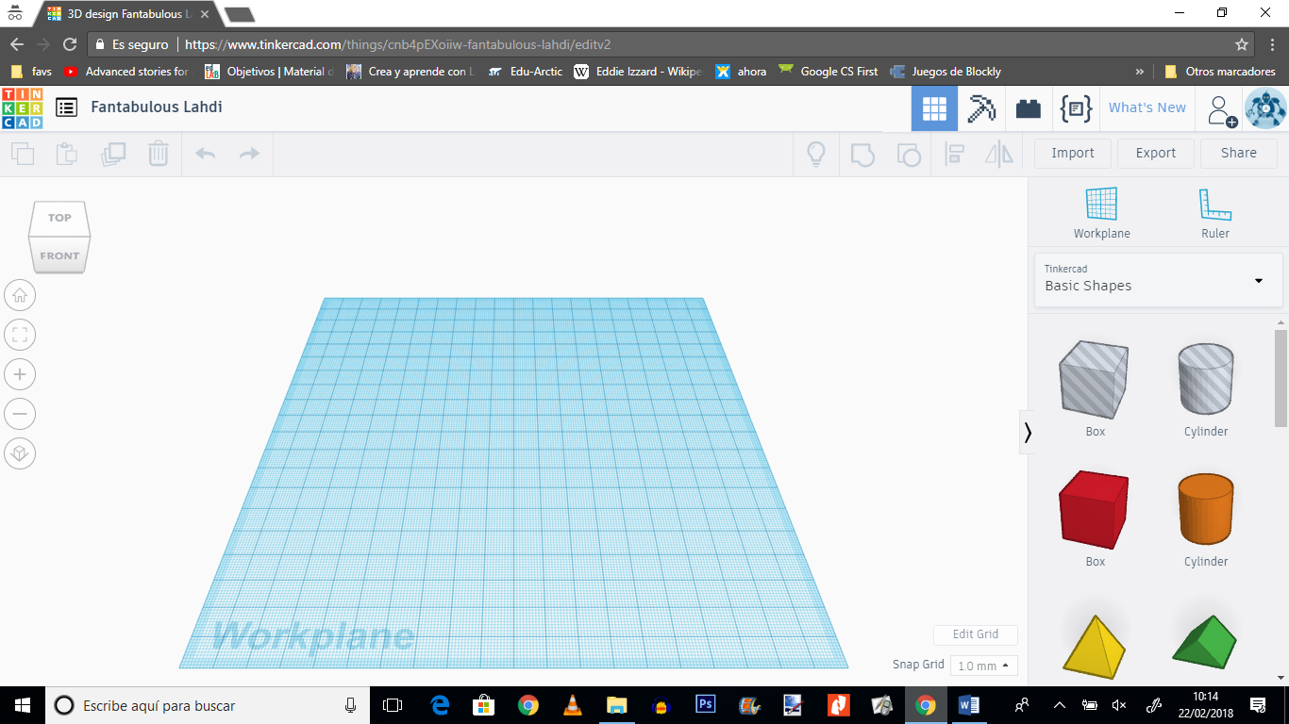

Use of the mouse
Right click on the mouse button while dragging the mouse : To change the perspective of your workplane
Scroll up: Zoom in
Scroll down :zoom out
Reset: click on the house icon on the left hand side

Menu on the upper right hand side
It contains basic operations we can do with shapes

Show all/ group / ungroup/align/ flip ( show examples )

Menu on the upper left hand side
It contains the conventional ops you find in all programmes( cut/ copy/…)

TIP:
We must consider an object as the addition of simple shapes.
Let´s see an example.
We are going to create the head or obverse of a coin.
- We change the grid to 0.25mm
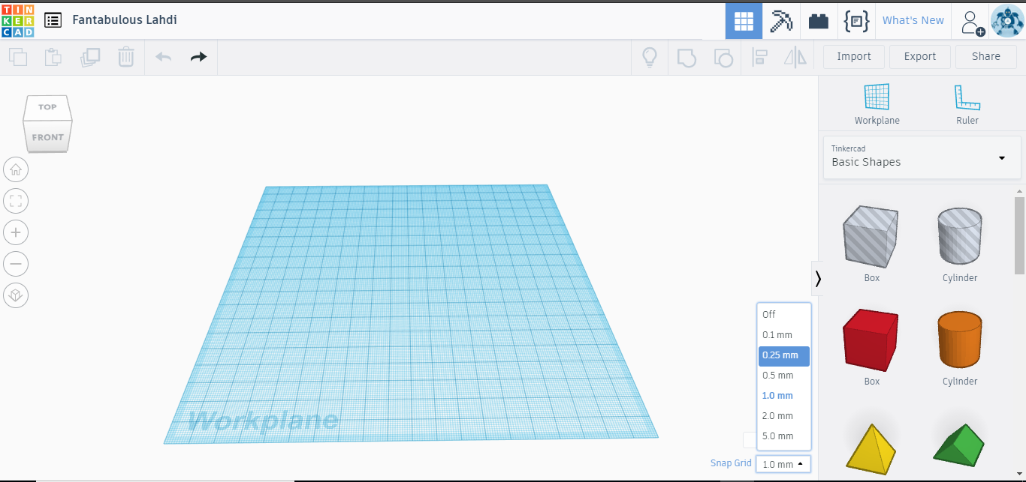
-Click on the cylinder shape / drag and drop into the workplane. It will be sitting on the workplane
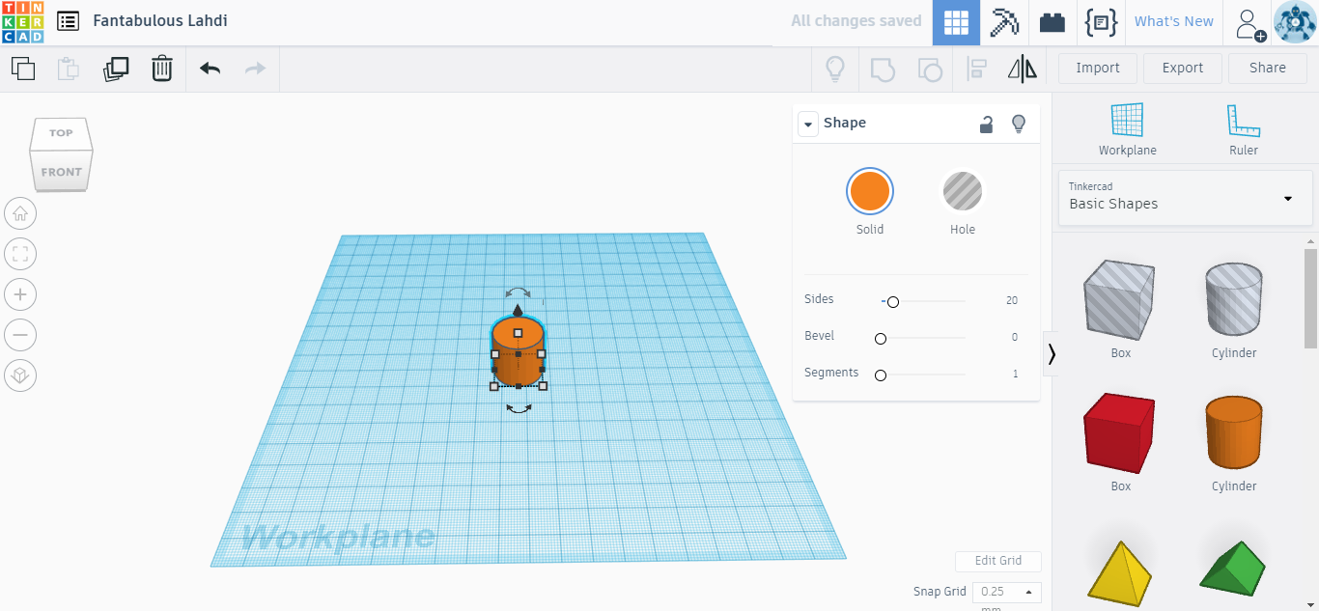
- Change its diameter and height to 32mm and 4mm.
To do so , click on the white square handles

And change the values
( type the value and press enter )
Now you have the base or your coin.
In order to create the border of it, we must go on with the use of other shapes in Tinkercad called holes
Holes in Tinkercad
We will make a copy of the base of our coin ( in red)

