- Select the red shape/click on hole

- and drag into the orange shape

- Select both shapes/ group them. We will get this final shape:

Let´s get back to our coin
In order to get a coin shape like this:
We must follow these steps ( if you do not want to follow this part , jump to page 11 )

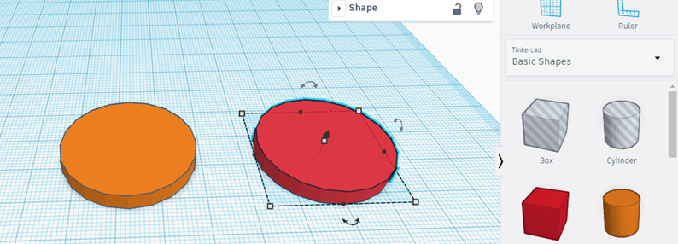

Orange
diameter=32mm height 4 mm
Red
Diameter 28mm height 4 mm
Red must be dragged into the orange one to obtain 2 concentric cylinders. How do I get it ¿
- Select both and align
- 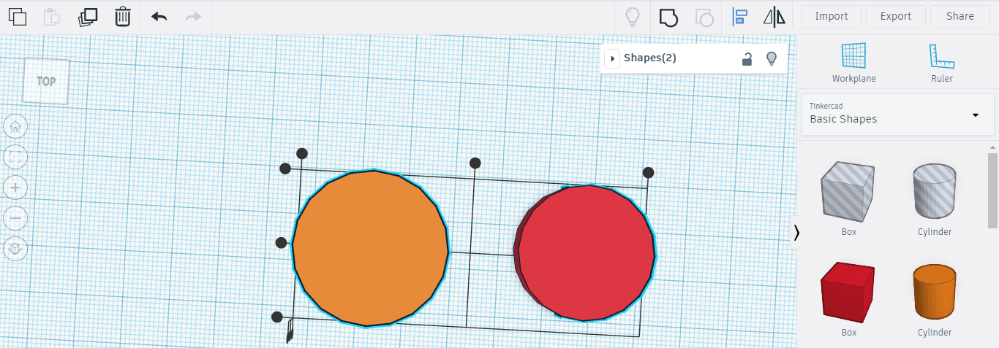

We will select this point
And next…
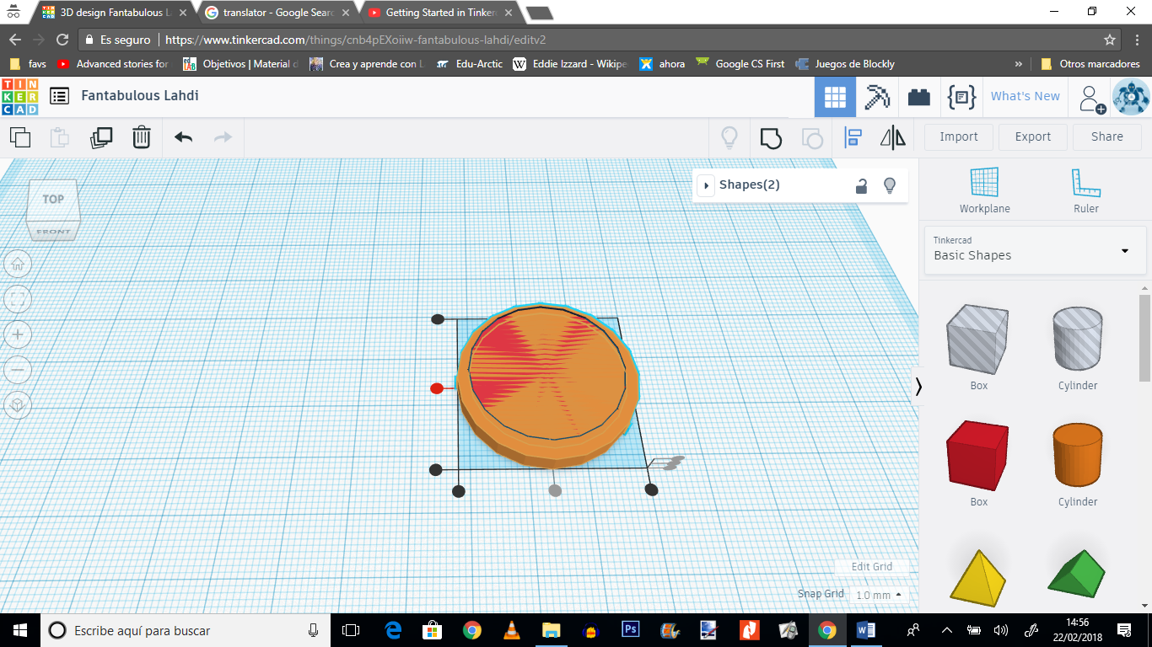

- We got the two concentric cylinders

Select inner red cylinder / select the arrowhead and lift it 1 mm

Now press Hole

