- Select our file

Then , click on Convert file

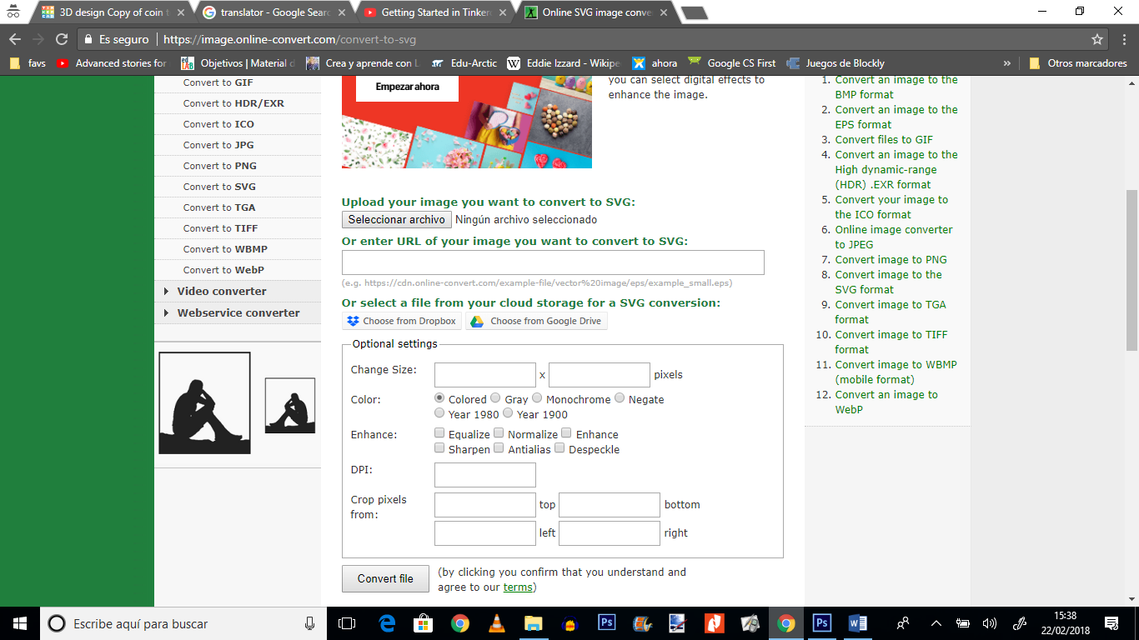

We ´ve got footballer.svg file

-Now let´s get back to our Tinkercad. Click on Import/choose a file/ footballer.svg…

And Import

We got…
We will have to reduce the figure

EXERCISE
You will have to create a coin with Tinkercad by importing 3 files.
Spanish partners will have to download these files( silohuette.stl; coin template.stl and madrid let33rs ) from their Gmail accounts and share with you. The final result will be similar to this

This way we can design eurocoins for Romania and Poland

