Yin & Yang:
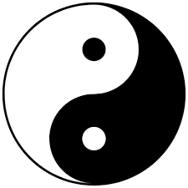
- The meaning of the Yin and the Yang is that there exists good inside the evil and vice versa.

Isaac Díaz 4ºESO A

