TRADITIONAL FOOD OF TURKEY
Every country has traditional foods. You want to try them when you go to foreign country. Turkey has a lot of traditional food, like other countries. Travelers try baklava, sarma, flat breads, meatballs, Turkish delight and then some when they come to Turkey. But I want to tell about sarma. Sarma is the most famous food in Turkey. From east to West every people know it. Sarma is made on special days for example; wedding days, religious holdays and to entertain guests. Also almost every Turkish like it. Sarma is made with grape leafs, rice, parsley, onion, tomato paste, red pepper paste, olive oil and spices. Some people add raisin, minced meat and bulghur. History of sarma goes to Turkish of Central Asia. It has a important place in Turkish’s kitchen. If there isn’t sarma on table on special days, meal is certainly deficient for us. Absolutely every travelers should try it.
Here is the recipe:
LEAF ROLLS (YAPRAK SARMASI)
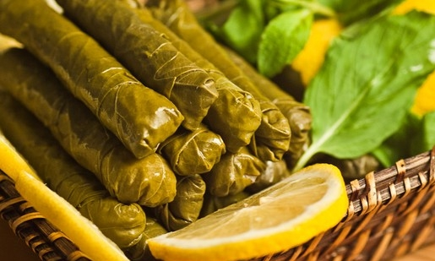
Ingredients:
2 cup rice,
1 medium onion,
2 large tomatos,
1 bunch of fresh parsley,
2 tbsp (table spoon) olive oil,
Salt and black pepper,
Fresh grape leaves

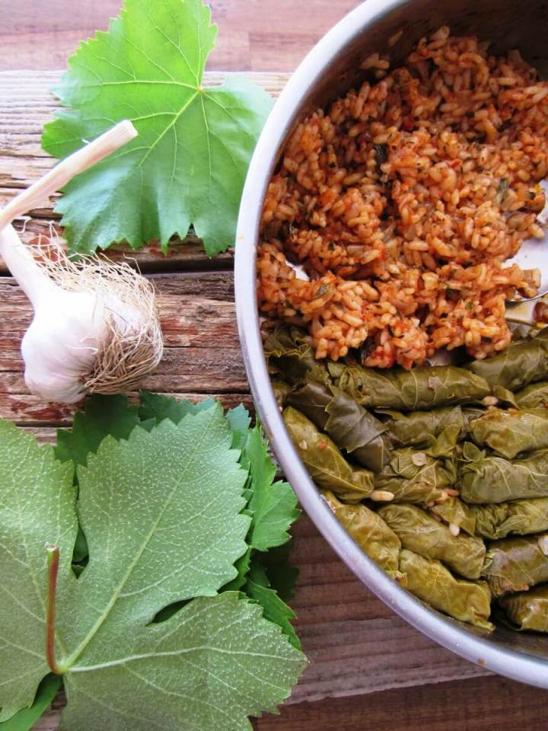
Preperation:
> Chop the onion, peeled tomato and parsley in small pieces. Put the onion in a saucepan with olive oil and move them around it.
> After a while add tomato and parsley. Continue adding rice, salt and black pepper. After 15-20 minutes remove the saucepan from heat.
> The mixture should wrapped in grape leaves one by one. Then saucepan placed under leaves with water to cook 30 minutes.
** Yoghurt can also be served with the leaf rolls depending on demand.
Your leaf rolls is ready! Enjoy your meal!

