Ingredients
Fresh mushrooms, caraway seed, salt, butter or lard, pasta
Process
Pick mushrooms in the forest. Clean the mushrooms and slice them. Then rinse them with water and drain them. Melt a bit of butter or lard in a pan and add the mushrooms (soaked with water), a bit of salt and a bit of caraway seed. The mushrooms will release the water so stir and stew them for a few minutes till the water steams out. After that, mix them into hot boiled pasta. Serve warm with gherkins.
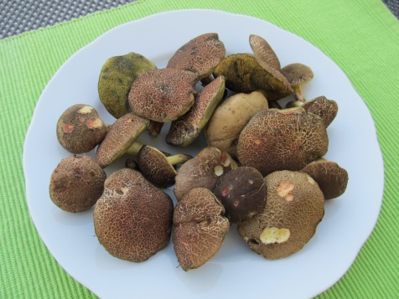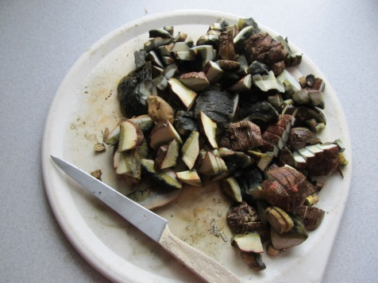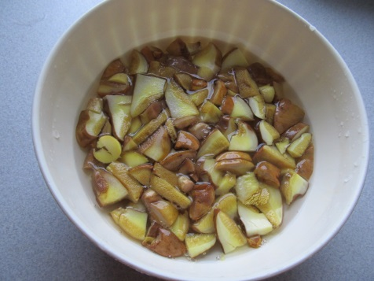
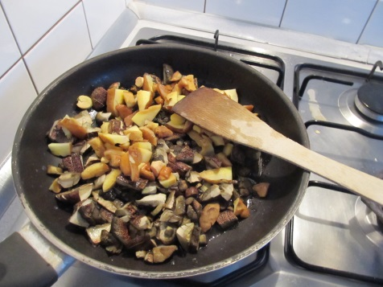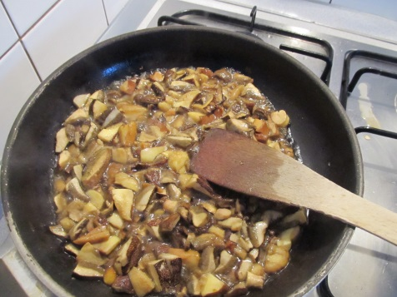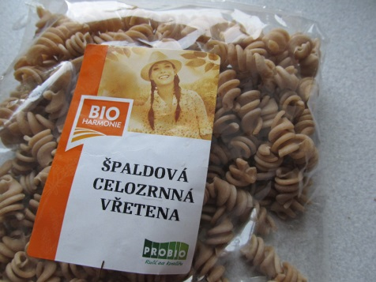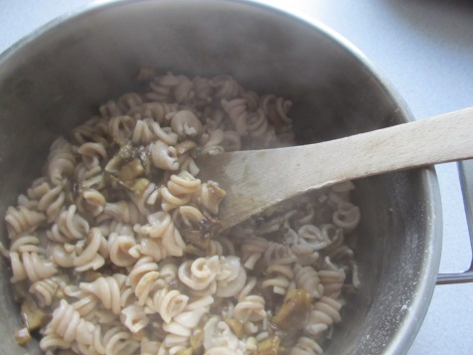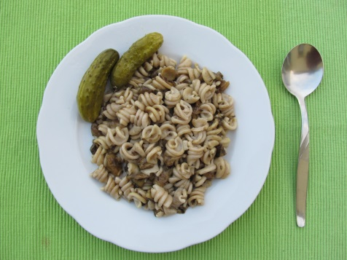
(Recipe and photos by Aneta H., GVM Czech Rep.)

