2Tuesday, March 8th – day at Paulette Billa school

EUROPE’S ABC OF SUPERFOODS MENU
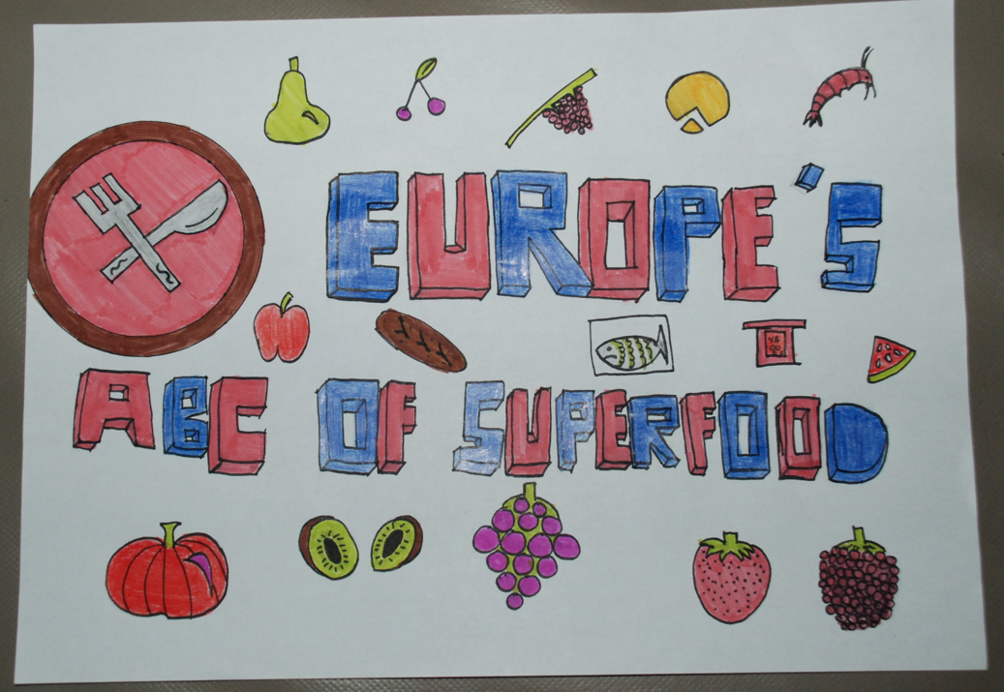
Pomegranate juice
Bruschettas with Tomatoes and Olive Oil
Artichokes with Yoghurt sauce
Cocido Madrileño with Chick peas
Baked Apples with Cinnamon and Honey
Cookies with Honey, tahini and Oats
