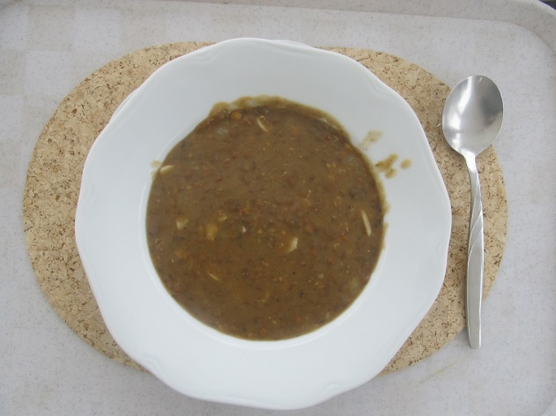
Ingredients
1 000 G lentil, salt, marjoram, sausage,
garlic, onion, mustard, lemon, butter
Process
Sort the lentils and soak them over
night. Leave it in the same water,
add chopped sausage, chopped onion and chopped two cloves of garlic, a handful of marjoram and boil till the lentils are soft. Then add a pinch of salt (now, not earlier!) and taste it with a teaspoon of mustard, a table spoon of butter and a few drops of lemon. BON APETIT!

