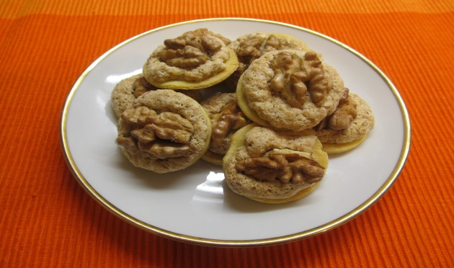Ingredients

Filling:  
3 egg whipped whites  
200 g ground walnuts   
200 g sugar

**Walnut buttons**

180 g butter

350 g fine flour  
50 g icing sugar

2 spoons of cold water

3 egg yolks  
1-2 table spoons of milk

Process  
We mix all the ingredients, make a dough and let it mature for 1-2 days in the fridge. Then we roll it flat (about 3 mm) on the rolling board, cut out small wheels, put some filling in the middle and top it with a half of walnut. Bake them in the oven to be slightly pink.

