Ingredients
Fresh peas, salt, marjoram , browning
Process
Pick some fresh pea husks in the garden and husk them. Soak the peas For an hour or two. Then boil it in water till soft. Add a pinch of salt, some marjoram and some light browning (made of butter and fine flour). Let it boil for 5 minutes. Then use the blender and blend it till smooth. You can serve it with small cubes of fried bread.
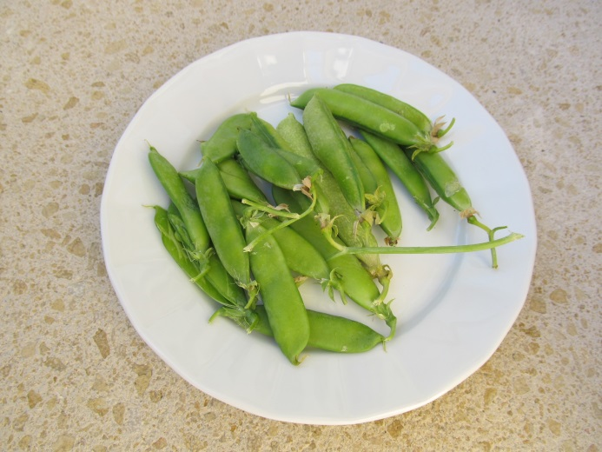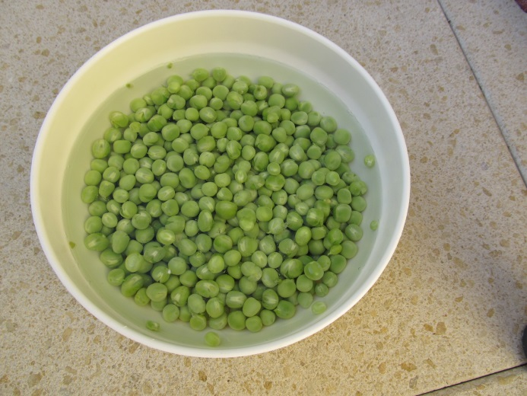
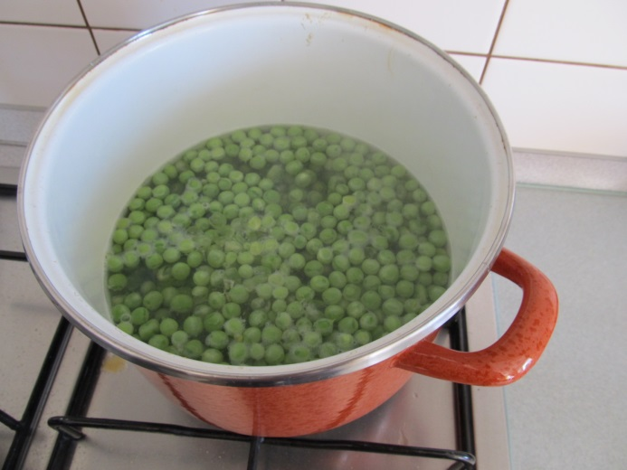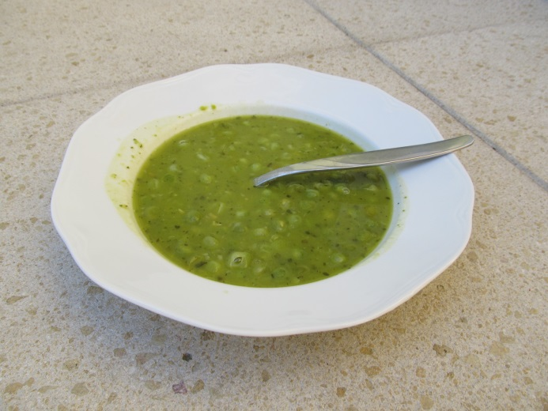
(Recipe and photos by Daniela, GVM Czech Rep.)

