Countess´s apple cakes (by Zuzana from the Czech team)

Ingredients:
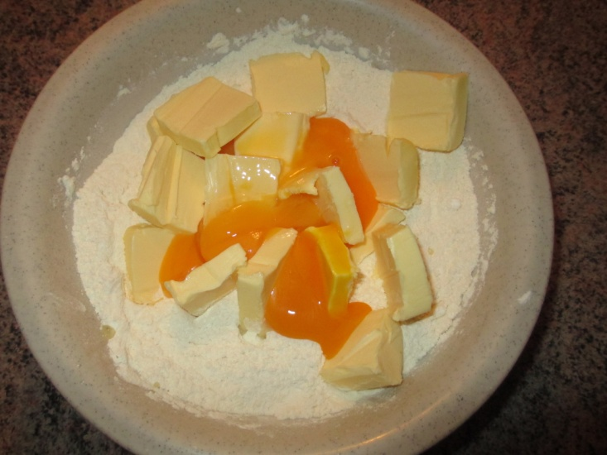
400g flour
250g butter
4 eggs (yolks and whites separately)
150g powdered sugar
120g caster sugar
1 baking powder
6 apples
1 Vanilla sugar 2.Make the dough.
Cinnamon

- Mix flour, butter, egg yolks, powdered sugar and baking powder.

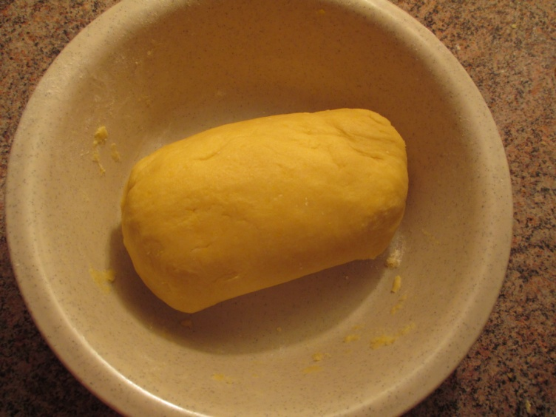

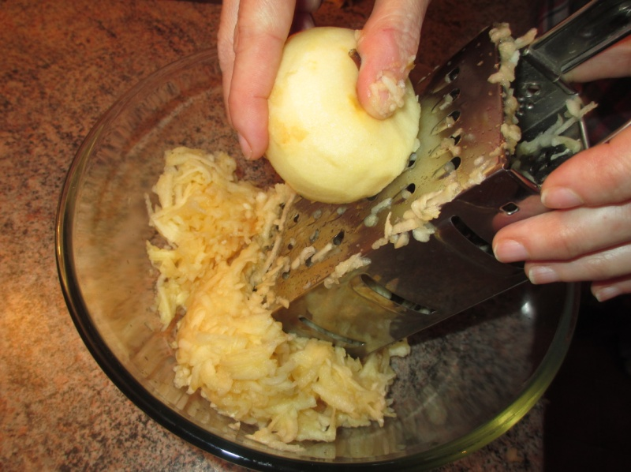
3. Peel and grate the apples.
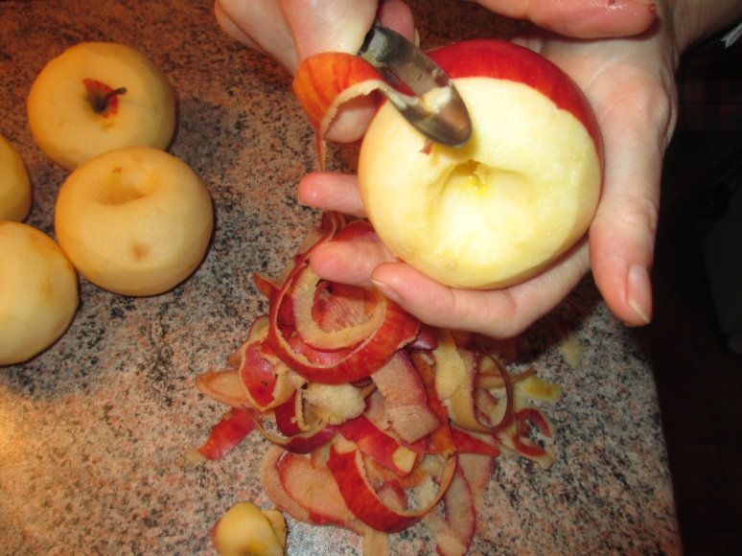

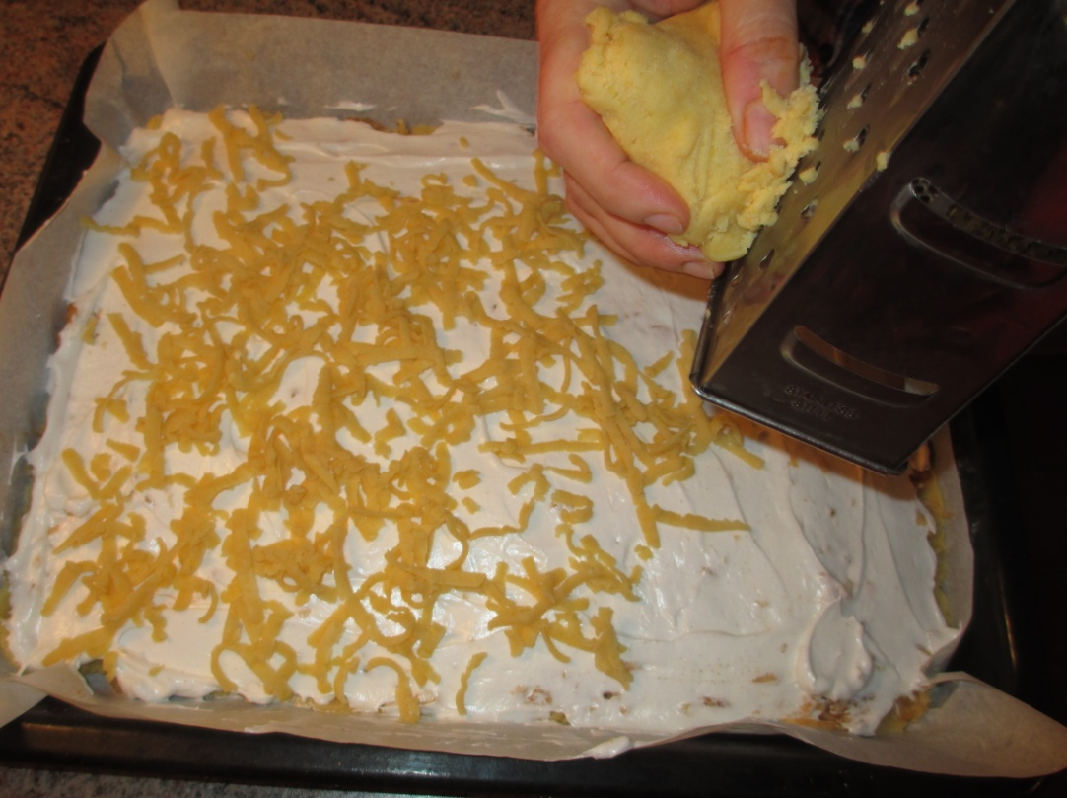

4. Roll out half the dough and put on it grated apples. Sprinkle it with cinnamon and vanilla sugar.
5. Whip egg whites and put it also on the dough. On top grate the other half of the dough.

6. Put it to the oven and bake.
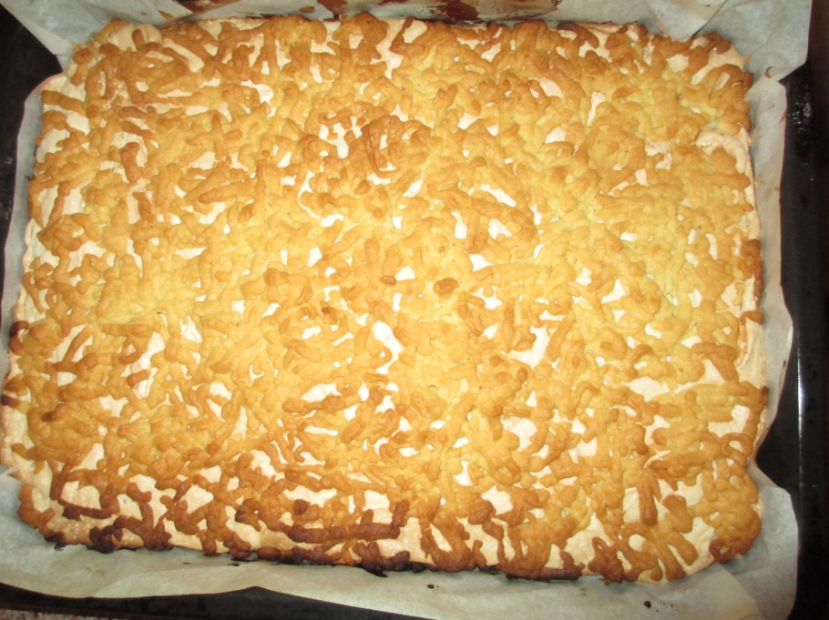

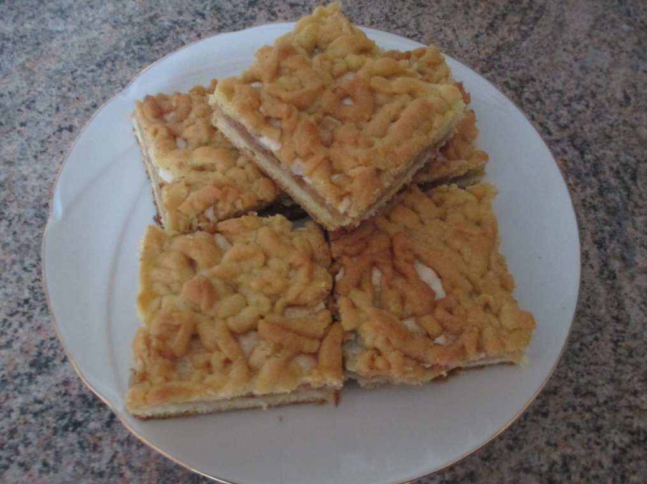

Take it from the oven, and we can eat. Enjoy your meal !

