Ingredients
Fresh oyster mushrooms, salt, spices, oil, browning
Process
Buy half a kilo of oyster mushrooms and chop them. Mix them with some spices (e.g. barbecue spices) and fry them shortly in a frying pan. Add some water and let it boil for half an hour. Make browning of some butter and fine flower, mix it into the soup and boil it for 5 more minutes. Serve with some fresh bread.
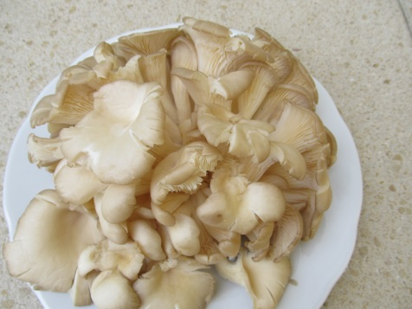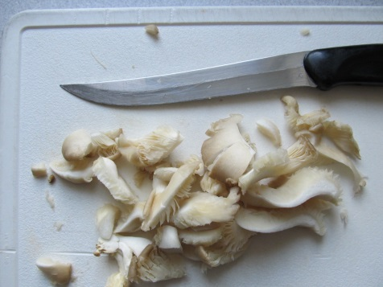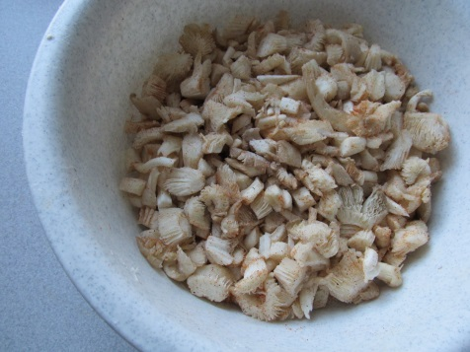
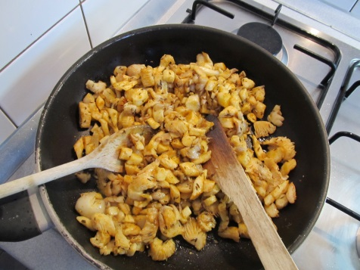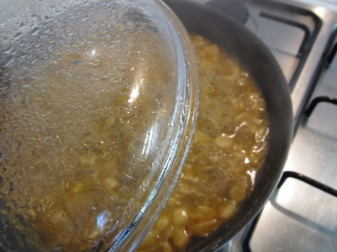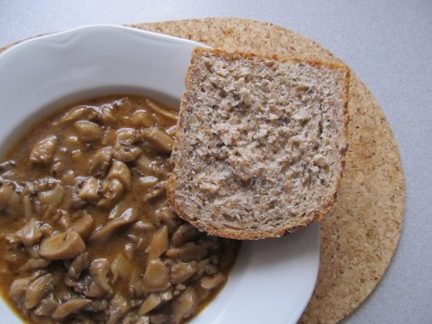

(Recipe and photos by Filip, GVM Czech Rep.)

