Ingredients
Fresh mushrooms, salt, eggs, fine flour, breadcrumbs, oil
Process
Clean the mushrooms, cut off the stems as we are going to use only the caps. Salt them a bit, then coat in fine flour, after that in whipped eggs and in the end in breadcrumbs. Pour some oil onto a frying pan and heat it. When it is hot, place the mushroom caps there and fry till golden brown on both the sides. Serve them hot with boiled potatoes. Tatar sauce is very nice with it.
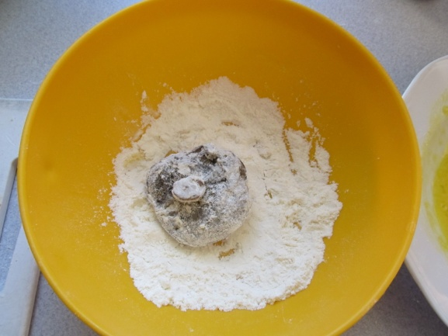
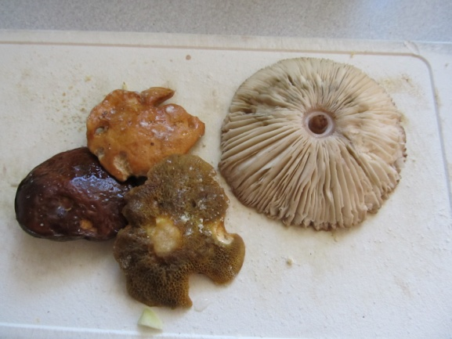
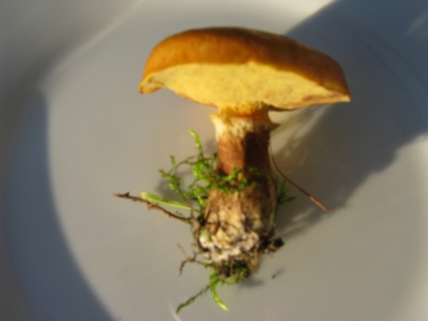

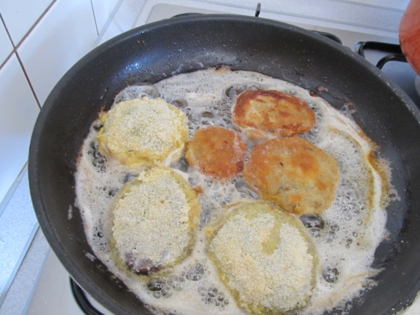
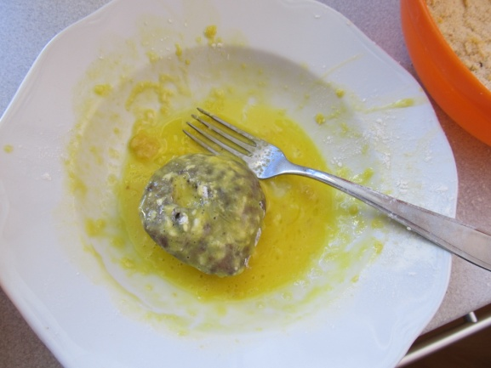
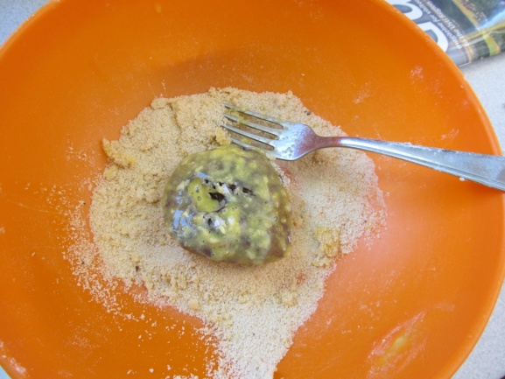
Pick them – clean them – salt them a bit – coat them in fine flour.

Coat them in fine whipped eggs – coat them in breadcrumbs – fry them...

(Recipe and photos by Jan., GVM Czech Rep.)

