(RECIPE by Monika and Jana, GVM, Czech Rep.)
Ingredients for the pastry:
350 g fine flour
250 g margarine
6 table spoons of cold water
1 tablespoon of vinegar
1 egg yolk
a pinch of salt
500 g apples
Procedure:
- Peel and slice apples.  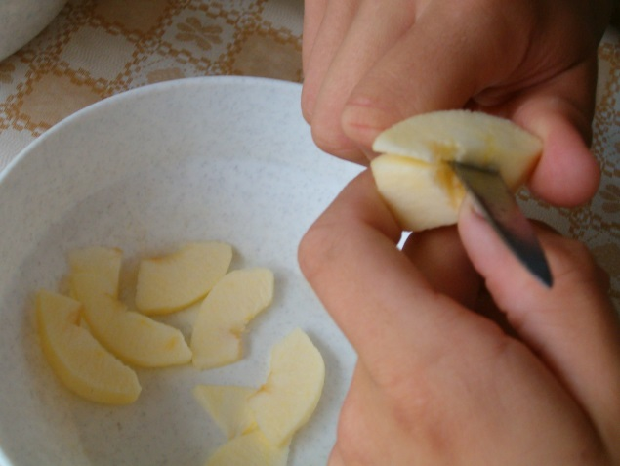 | 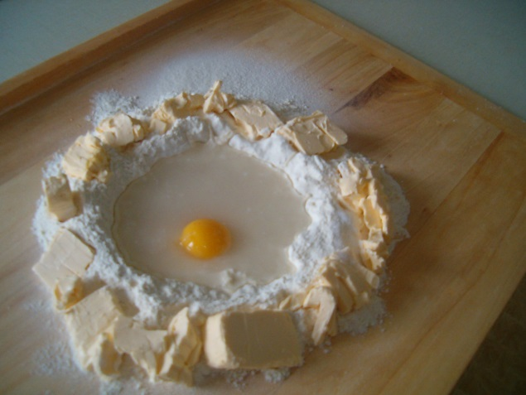  - Put all the ingredients on the board.
- Make the pastry.  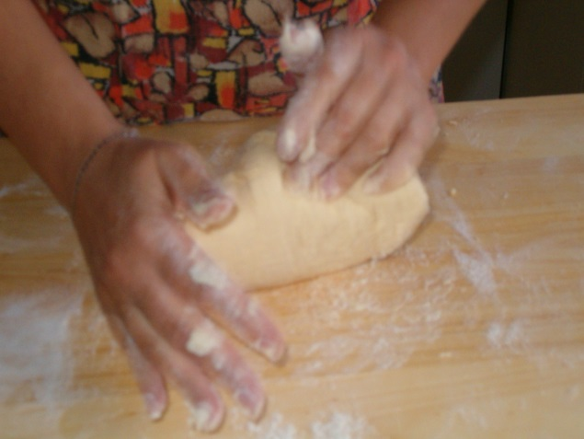 | 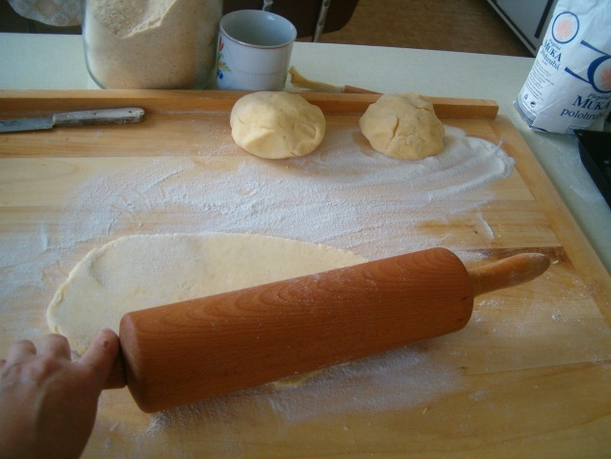  - Divide into thirds and roll one of the pieces flat.
- Put the sliced apples in the middle and some sugar with cinnamon.  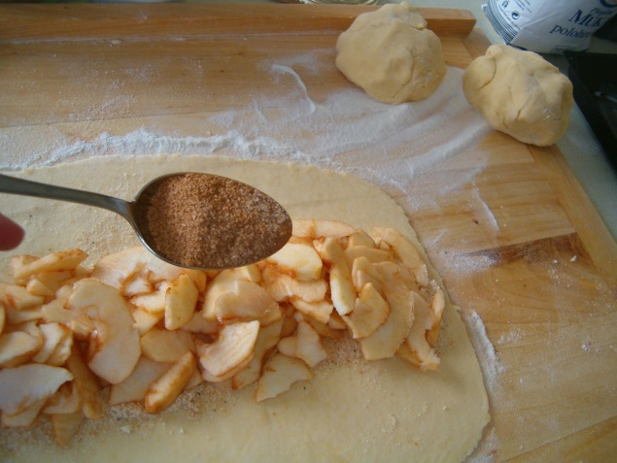 | 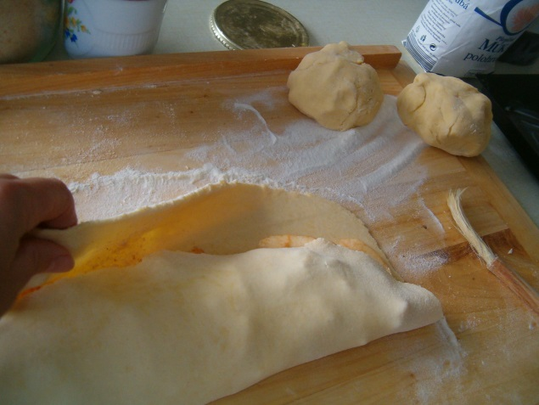  - Close the roll like an envelope on two sides
- Put it into the preheated oven and bake at 220 degrees for about 20 minutes.  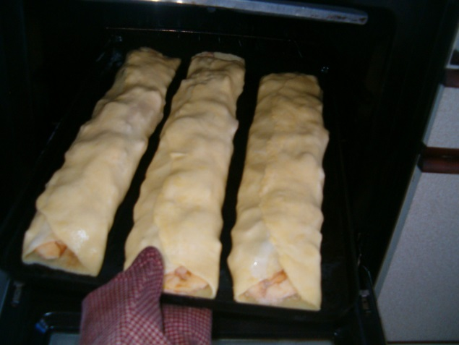 | 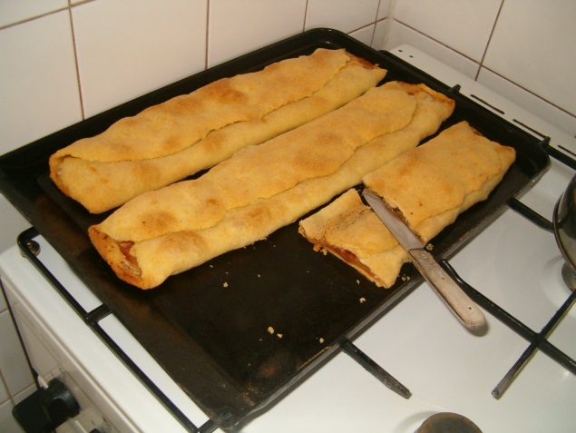  - When it is baked, you can sprinkle it with sugar.
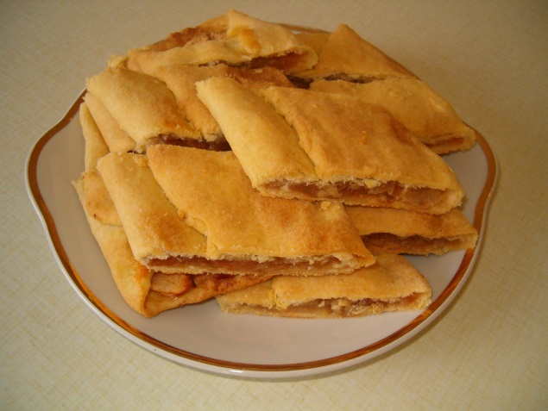

Bon apetit!

