Ingredients
Fresh mushrooms, eggs, caraway seed, salt, butter or lard
Process
Clean the mushrooms and slice them. Then rinse them with water and drain them. Melt a bit of butter or lard in a pan and add the mushrooms (soaked with water), a bit of salt and a bit of caraway seed. The mushrooms will release the water so stir stew them for a few minutes till the water steams out. After that add eggs and stir again. Serve warm with fresh bread and gherkins.

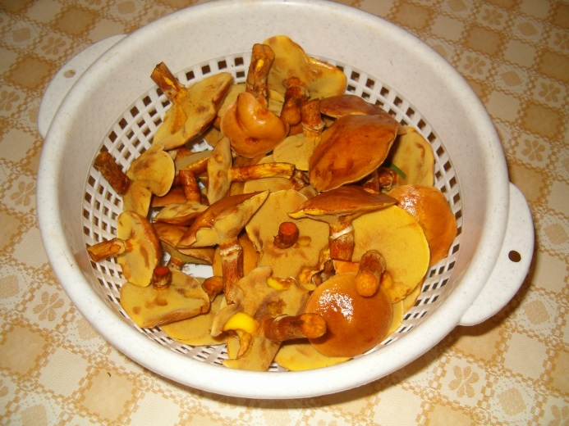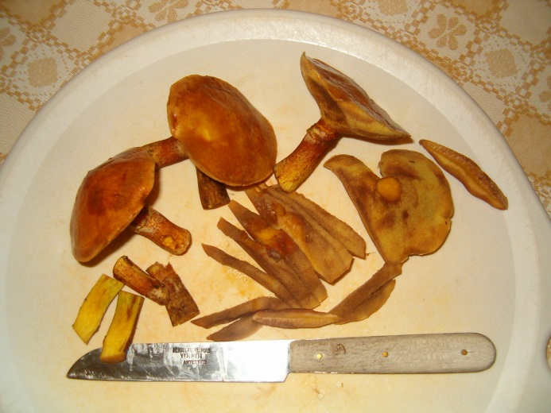
Pick them – clean them – wash them – put them in a sauce pan a salt them a bit.
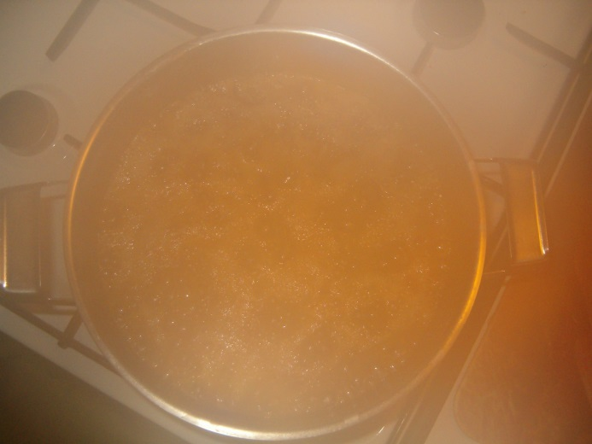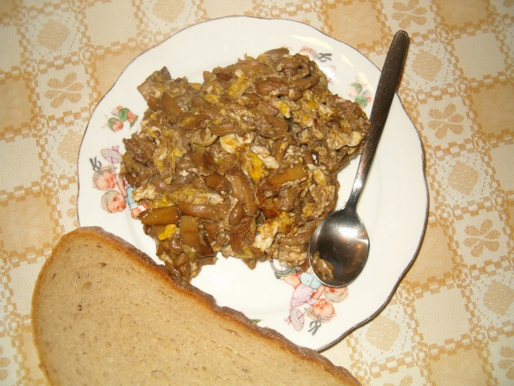
Stew them till the water expires – add eggs and mix them – serve with bread.
(Recipe and photos by Aneta H., GVM Czech Rep.)

