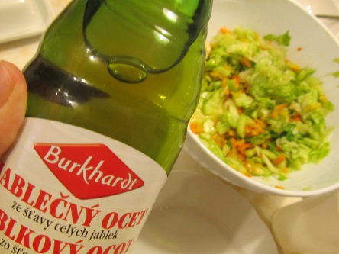
Ingredients
1 iceberg lettuce 2 orange bell peppers
1 cucumber 1 tea spoon of olive oil
1 tea spoon of salt 1 teaspoon of brown sugar
1 table spoon of vinegar from apple juice
Process
Take the lettuce to leaves and wash them. Tear them into small pieces. Peel the cucumber and chop it into cubes. Take the seeds out of the bell peppers and cut them. Mix all the vegetables in a bowl, add a teaspoon of salt, a tea spoon of brown sugar and squeeze a bit with your fingers so that the vegetables let out some juice. In the end add a table spoon of vinegar from apple juice and a table spoon of olive oil.

