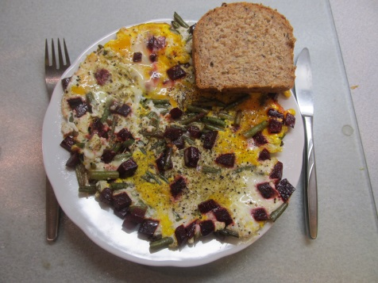
Ingredients
1 beetroot 2 eggs
100 g frozen green beans oil for frying
a pinch of salt with herbs a pinch of pepper

Process
Peel the beetroot, cut it into small cubes and steam for 15 minutes. Chop frozen beans and steam them for 5 minutes. Put both the beetroot and the beans onto a frying pan with a little of oil and shortly fry when stirring. Whip 2 eggs in a pot and pour them onto the frying pan. Sprinkle with a bit of salt with herbs and a bit of pepper. Serve it hot with wholemeal bread.

