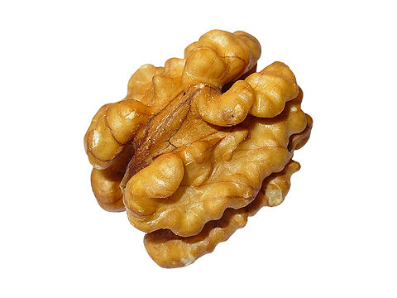
Walnuts are underestimated
And you should eat them more
Little, big, fat or slim
Nothing stands in your way
Use a spoon or eat with hands
That´s what you need to be OK

(Poem by Honza and Jáchym, Czech team)
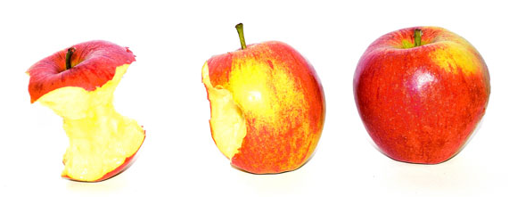
Appeared in the
Paradise garden
People ate this forbidden fruit and
Left the beautiful place to live in the
Exile
(Poem by David and Marek, Czech team)

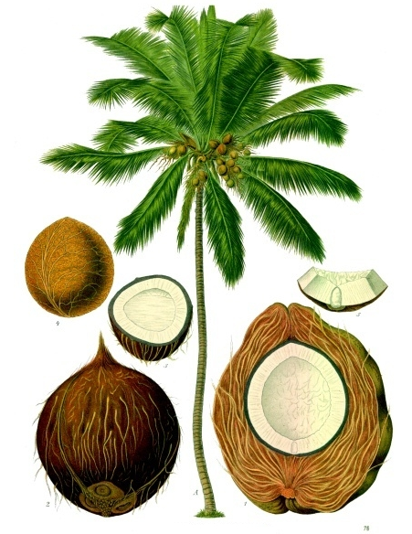
Coconut is a delicious nut
Of course from a coco palm
Coconut is a tasty nut but eat
Only a few pieces of this
Nut or you´ll be very fat
Up the palm you must climb to get
This awesome superfood for free

(Poem by Libor and Matěj, Czech team)
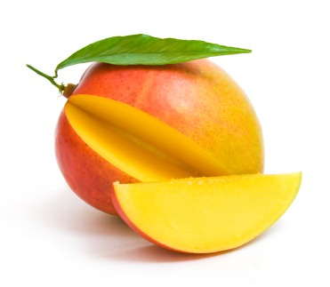
Much favourite fruit
And really tasty
Natural and
Great exotic fruit that you can eat with
Oranges.

(Poem by Linda and Zuzana, Czech team)
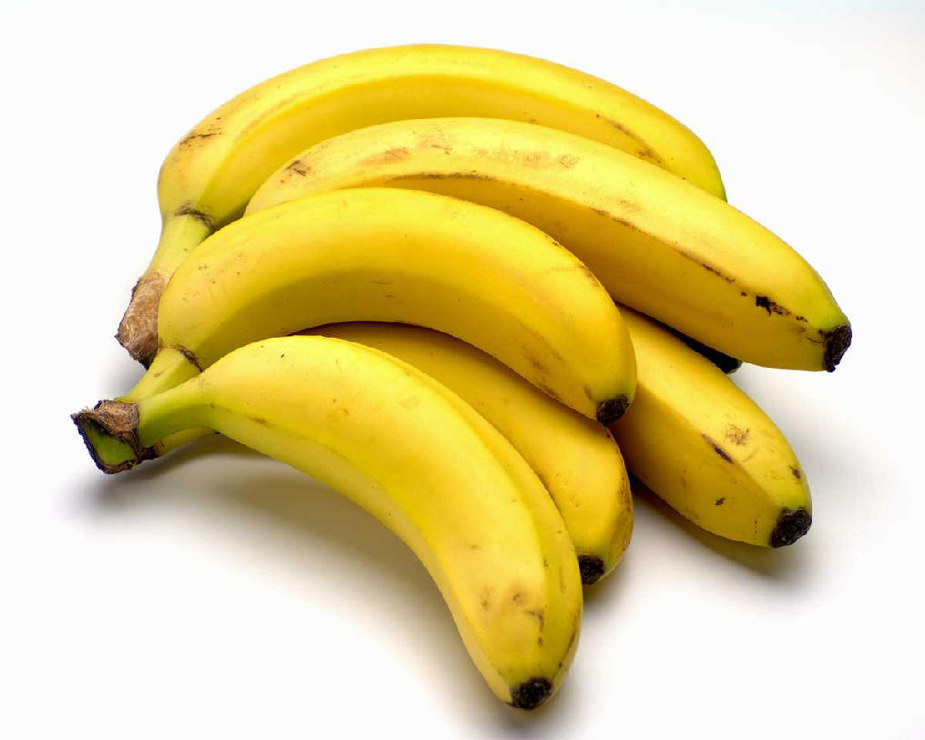
Because banana is
Awesome, you must taste it.
Now you know that banana is tasty
And healthy. It grows
On banana tree
And monkey love them so much.

(Poem by Áďa and Hanďa, Czech team)
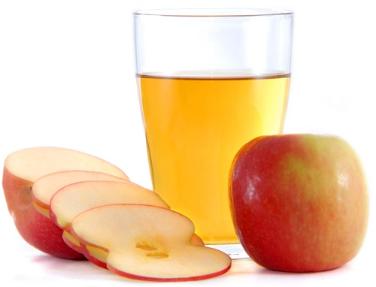
Juice is juicy and yummy
Universal taste of fruit
Ice lollies can be made from it
Coca-Cola is no competition
End of story

(Poem by Jakub and Láďa, Czech team)

