MAKOVEC (POPPY SEED CAKE)
In the Czech Republic, compared to many western European countries, you can buy poppy seeds in any supermarket and they are often used as an ingredient in many tasty foods. Poppy seed are highly nutritious and contain oil with delicious aroma, therefore they have culinary use as decorative garnish, spice or thickener especially in baked goods and deserts. Poppy seeds have long been used as a folk remedy to aid sleeping, promote fertility and wealth, and even to provide supposed magical powers of invisibility. Well, the magical powers of poppy are not used in cuisine but it has been proved that poppy seeds can really help with diarrhoea, abdominal pain, cough, and insomnia. Our grannies used to warm up a cup of milk with little bit of honey and poppy seeds to help when somebody could not fall asleep.
Ingredients:

2 and 1/2 cup flour
1 cup milk
1 cup sugar
1/4 cup vegetable oil
1 cup poppy seed
touch of salt
2 tsp baking powder
1 packet vanilla sugar
(ground lemon peel)
2 eggs (yolks apart from whites, which we add whipped at the end)

Mix, pour into the buttered and floured baking dish, bake and eat! (Bake at about 375F until golden brown - 40-50 minutes).
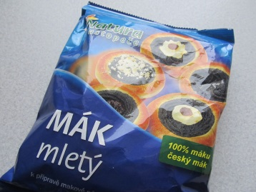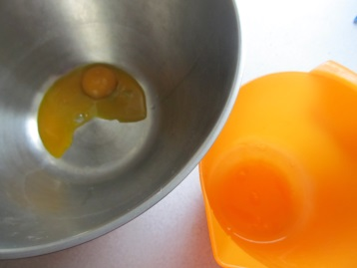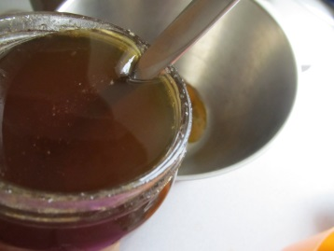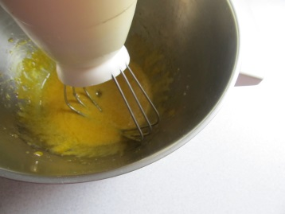
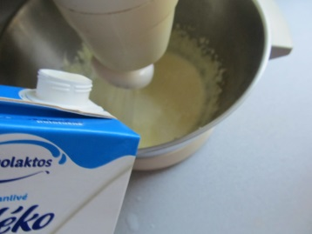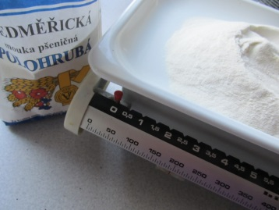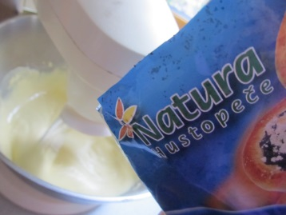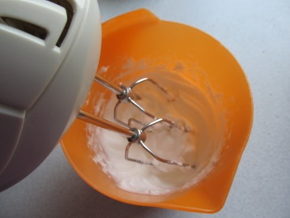
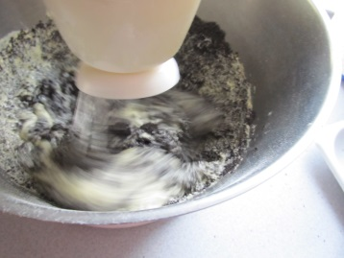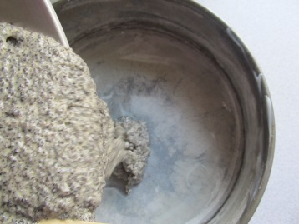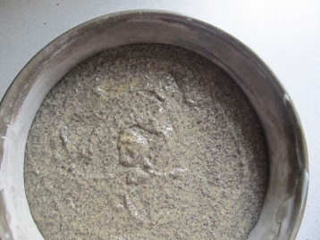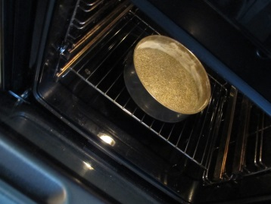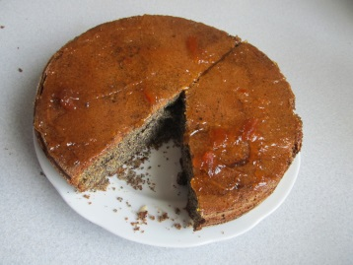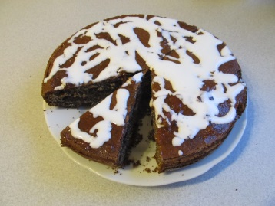
Bon Apetit!

