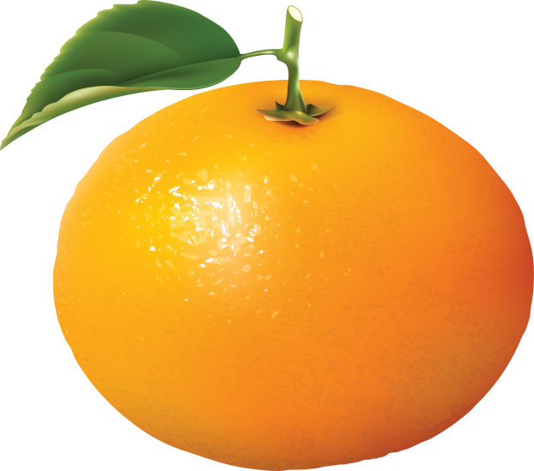
On the other side of the river ;
Reindeers are eating NUTS,
Alligators are playing with AVACADOS,
Nightingales are tasting HONEY,
Goats are plucking APPLES,
Endless happiness,we are looking for YOU !
Written by HACER
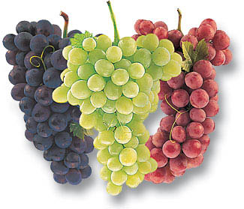
Grapes are sweet,juicy and jelly-like
Raisins are healthy
And delicious
Purple,green,white and red
Everyone should taste.

Written by MELISA

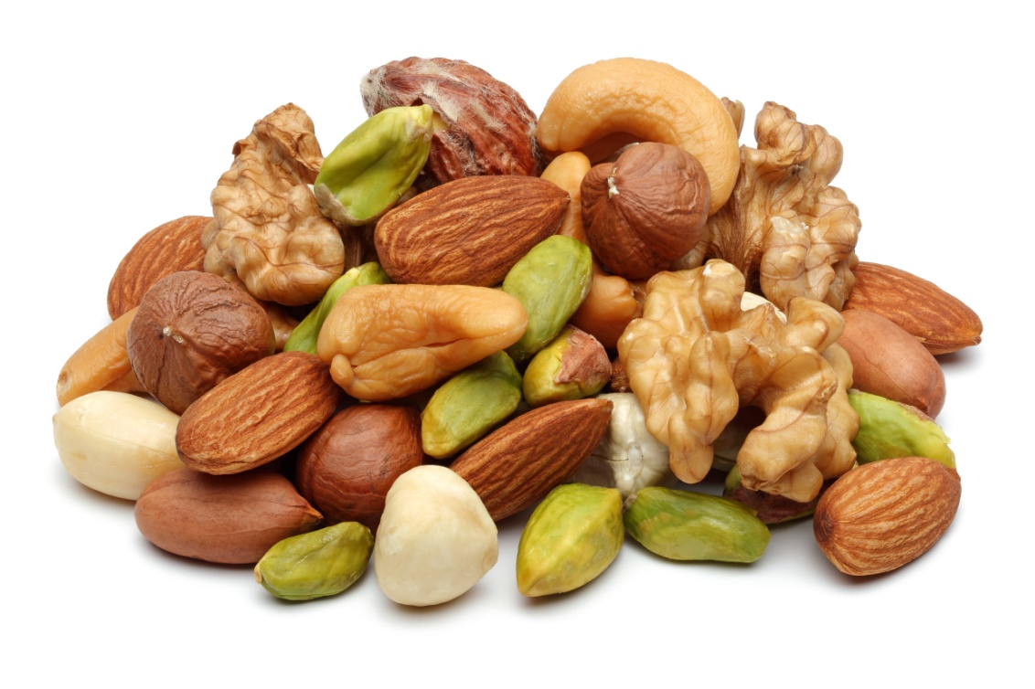
Nuts are very healthy for you
Useful for your body and brain
Throw fast food away for yourself
Start to eat superfoods for your health.

Written by BENGU

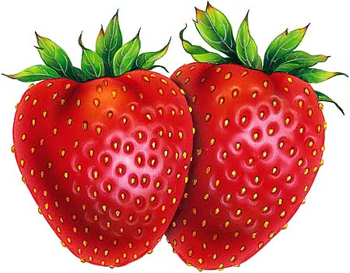 Written by OZGE
SUPERFOOD AND SUPERFRUIT
TASTY LIKE PIE
RIPE
AND JUICY
WE LOVE ROSE FAMILY
BOTH BEAUTIFUL,RED AND
EXCELLENT TASTE
RUN AND
ROAR OUTSIDE THE HOUSE
YUMMY,YUMMY,YUMMY.I AM HUNGRY !
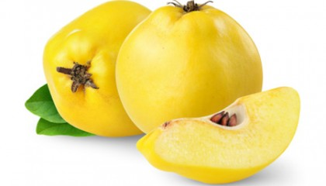

Queen of the fruits
Useful and healthy
It smells of perfume
Never eat raw
Cook it if you like
Energizer for your life.

WRİTTEN BY ILAYDA

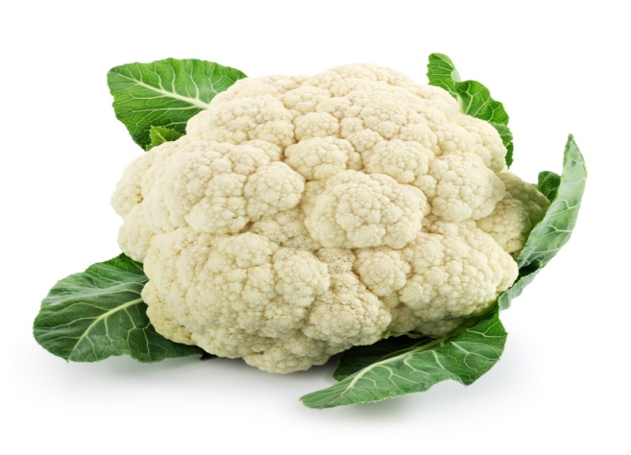Written by EMRE
Crazy
About it
Useful like
Lovely cabbage
If you try ,you will never
Feel hungry
Laugh,smile and go
Ooutside to a restaurant
Whatever you like
Erase your pessimism
Relax and eat CAULIFLOWER !

