LITTLE VANILLA ROLLS

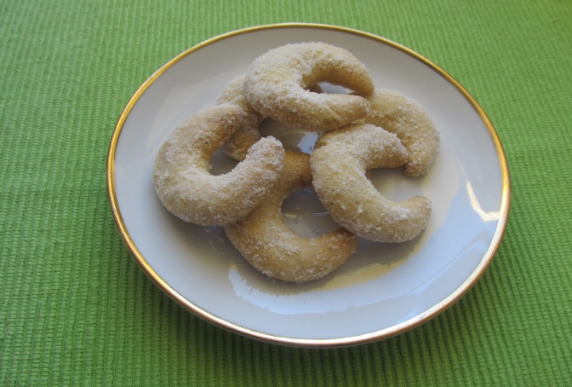
Ingredients
280g fine flor
200 g butter
120 g ground walnut
100 g icing sugar
Some vanilla sugar mixed with plain sugar
for the coating in the end.
Process
Put all the ingredients onto the rolling board and process them into dough. It is good to leave it for a few hours in the fridge. Then put it on the rolling board again, take a piece and roll it with your palm into the short „snake“ . Then bend it into a roll shape and place it on the baking sheet covered with baking paper. Bake them till they are slightly pink. Coat them in vanilla sugar in the end.

