RECIPE: SALTY STRUDEL WITH EGGS
(by Martina from the Czech team)
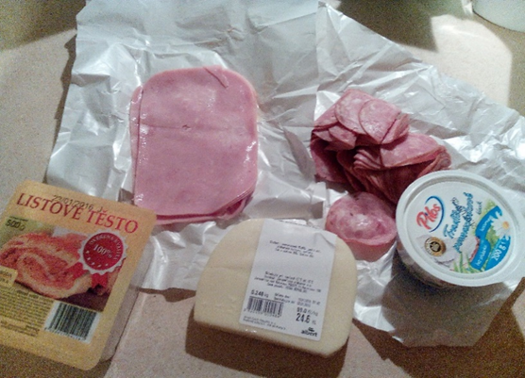
Ingredients:
- 5 eggs
- 150g ham
- 250g cheese
- 1x onion
- 1x butter spread
- 500g pastry
- Flour
Procedure
1 Sprinkle the rolling board with some flour, put there pastry onto it and roll it flat. | 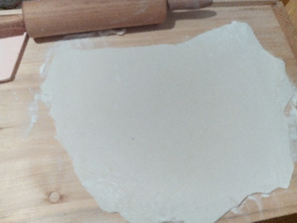
2 Grease it with spread butter. | 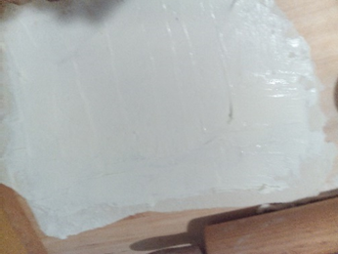
3 Put on ham or salami. | 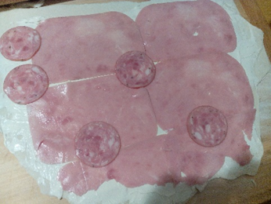
4 Chop the onion and grate cheese. | 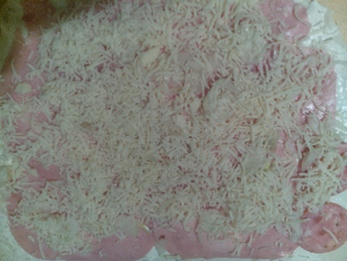
5 Put some sliced hard-boiled eggs

6 Packed roll and brush whole strudel with egg | 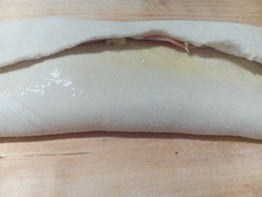
7 Sprinkle with caraway seeds and place in hot oven at 150°C. Bake for twenty minutes | 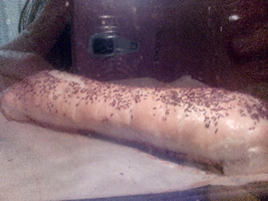
Bon apetit!

