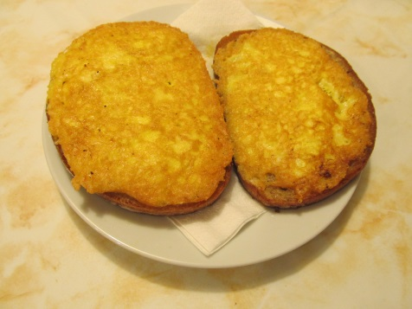
A fast, easy and tasty supper for you!
Ingredients
3 eggs 250 g cheese ( e. g. Aidam)
6 slices of bread oil for frying
Process
Grate the cheese. Mix the eggs in a bowl and add the grated cheese. Spread the mixture onto a slice of bread. Pour some oil onto a frying pan and when it is hot, put the bread there with the egg and cheese down. When it gets golden brown, turn it upside down and fry shortly. Take it out and let the oil soak into a paper napkin. Serve hot – you can spread a bit of mustard or ketchup on the top.
