GROUP OF: AIMAR, LETIZIA, DARIO AND IOSUNE
SPORT
¿Can disabled people play? ¿Is there any specific competition for them?
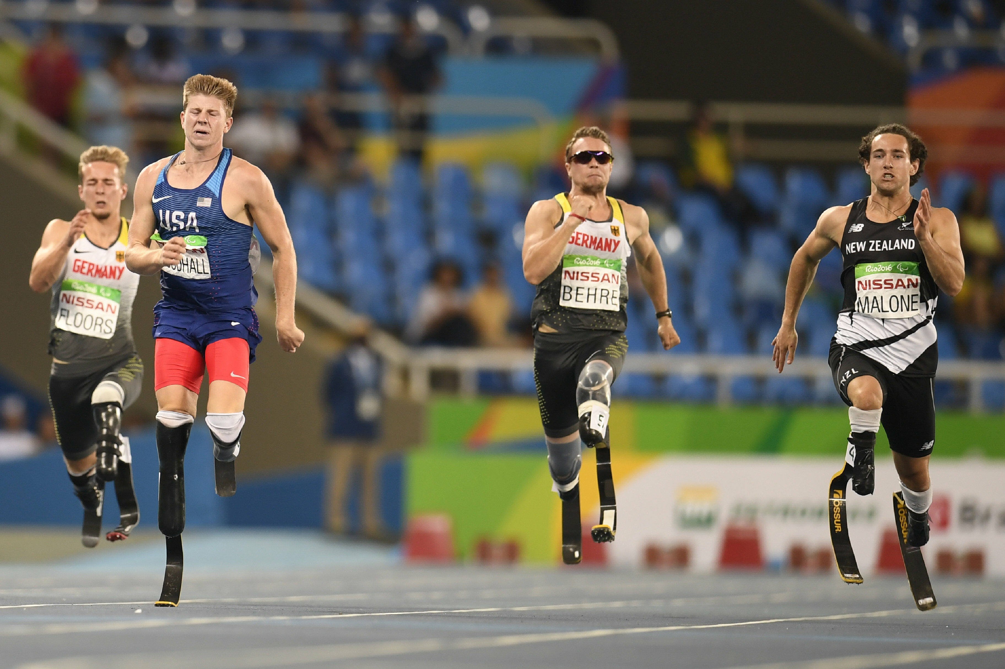

Yes, there is one called Paralympic Games. It is made for ‘’disabled’’ people, most of them are people with physical diversities. This Paralympic Games are equivalent as Olympic ones, but made specifically for this kind of diversities and adapted for them.

¿Are there any disabled players who compete/play together with not disabled ones?
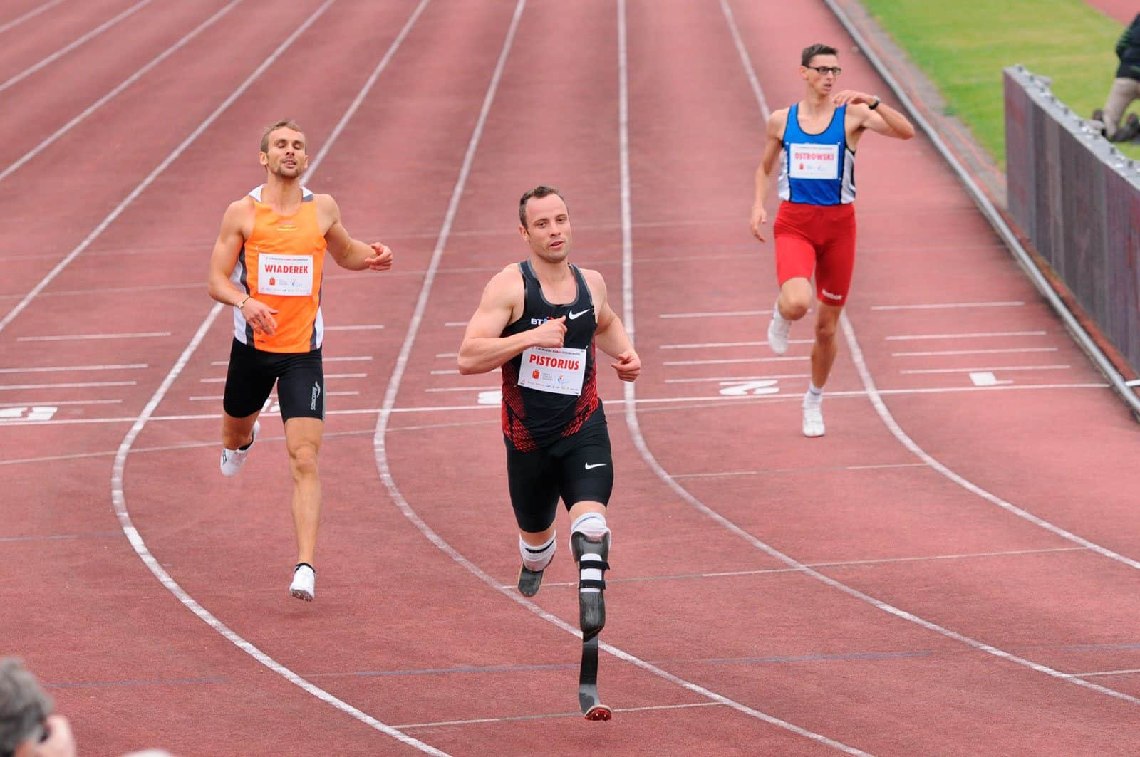
Nowadays no, but in the past yes. We think that disabled people must compete in Olympics as there are examples of better time from a ‘’disabled’’ person than a non disabled person. A good example is Baka, who in T13 cathegory achieved a time of 3 hours and 48 minutes, while Centrowitz (non disabled) in a Olympic career achieved 3 hours and 50 minutes.

If “Yes” | ¿Why?
 | In my opinion, even if in most sports, a disabled person cannot complete with an able-bodied person, fighting to try to overcome one’s physical disadvantage is the best benefit, especially from a psychological poit of view.
 | ¿Does it need something which improves the inclusion?

Yes, they need more people that support them, also to social media and media in general should visibilize more this subject and to not treat them as if they were different because they aren’t. We think that this kind of people are capable of compete in Olympics and to also win them.

If “not” | ¿Why?
 | ¿Have you got any idea for enabling that this sport become inclusive?

Conclusion, taking into account different disabilities: blind people, people in wheelchairs, hemiplegia, people without a leg, people without an arm, etc.
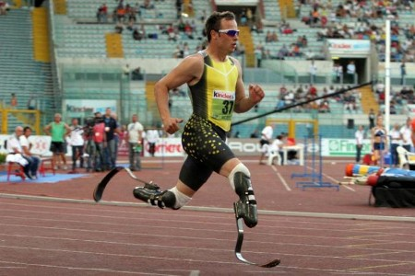
We think that there mustn’t exist social differences in sports, as if a disabled person is prepared for any sport, he can do the same as a non-disabled person.
From a psychological point of view for people with disabilities, sport is an important resource for achieving degrees of autonomy and self-management that otherwise could be unthinkable.

