CURS 2019 2020
Centre concertat per la Generalitat de Catalunya

Name: Number: Class: 6A
Date:

ERASMUS PROJECT
MARCH 2020
2 A POSTCARD FROM IRELAND
1 Tick the postcard you received.
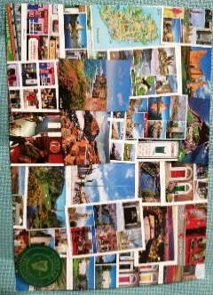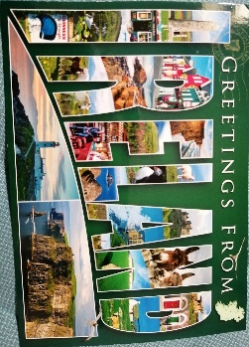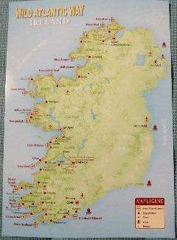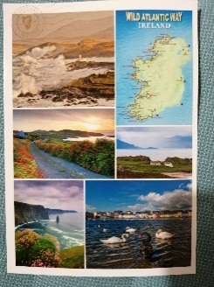
2 Who wrote the postcard?
3 When did they write it? (full date in English)
4 Who received the postcard?
5 When was it sent? Take the envelope and look at postmark (marking indicating the date and time that a mailed item was delivered into the care of the postal service) (full date in English)

6 Where was it sent from?
7 How much is the stamp in the postcard?
8 What type of sweet did they send?
9 Your Let’s Communicate teachers sent 102 letters. How much did they spend all together?
Each stamp:.........euro 102 stamps ...............euros
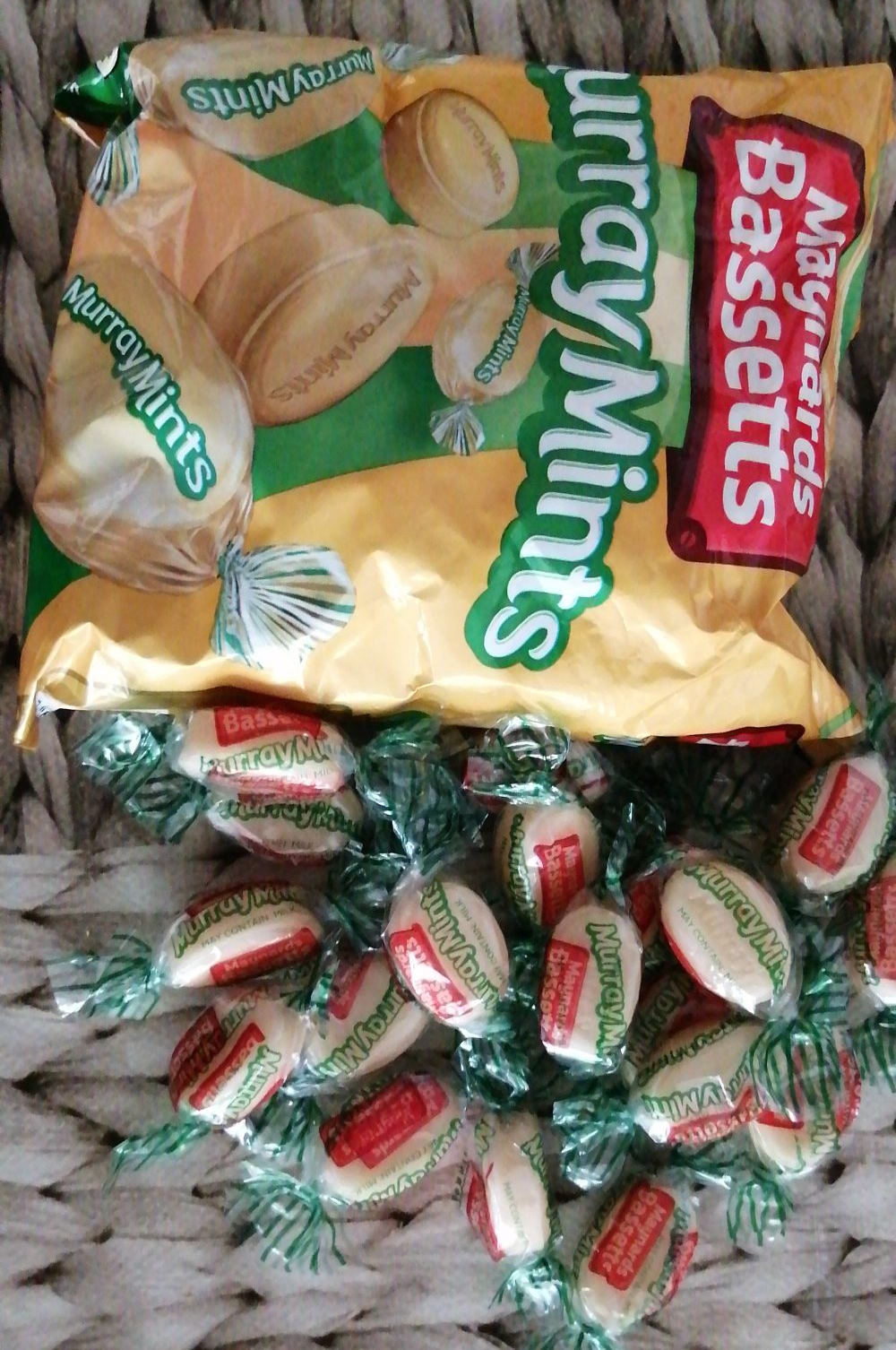
Each envelope 0,15 euro 102 envelopes ..............euros
Each postcard 0,50 euro 102 postcards ..............euros
1 bag of sweets 2 euros. They bought 4 bags of sweets ................euros
Lídia and Beneta spent ................................euros in total
10 It took them 12 minutes to prepare every letter. How many hours did they spend preparing all the letters? (remember ,there are 102 pupils)
102 pupils x 12 minutes=............................ minutes The teachers spent ............. hours and ........ minutes
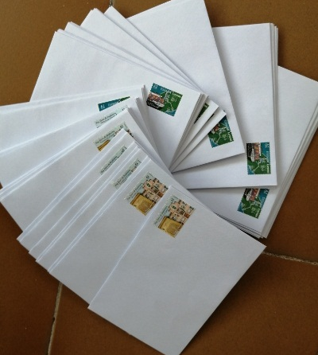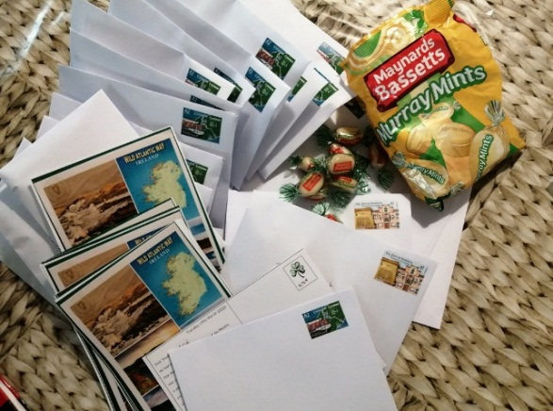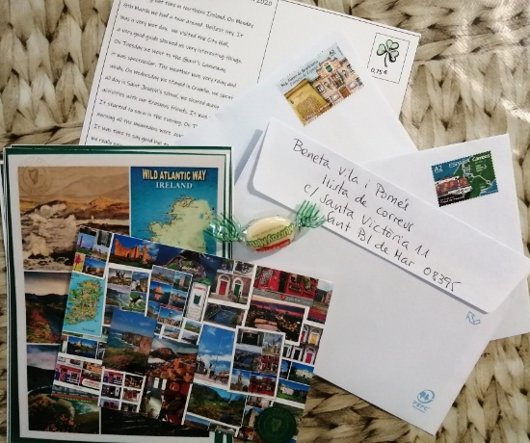

Tuesday 17th March 2020  Dear Student,  We had a great time in Northern Ireland. On Monday  9th March we had a tour around Belfast city. It  Was a very wet day. We visited the City Hall,  a very good guide showed us very interesting things.  On Tuesday we Went to the Giant’s Causeway,  it was spectacular. The weather was very rainy and  windy. On Wednesday we stayed in Crumlin, we spent  all day in Saint Joseph’s school, we shared many  activities with our Erasmus friends. It was really fun.  It started to snow in the evening. On Thursday  morning all the mountains were covered with snow.  It was time to say good bye to our Erasmus friends,  we really enjoyed our trip, we thought of you and we  bought a little sweet Irish treat. I hope you like it.  Kind regards,  Lídia and Beneta | 0,75  ..................................................................................  ..................................................................................  ...................................................................................  ................................................

11 Read the postcard and write the days of the week that appear in the text.
_______________ __________________ ________________ _______________
12 Draw the weather it appears in the text and write its name

_________________

____________________

_________________

13 Look at the stamp on your envelope and tick the stamp you received

If you received “Fuero de Brañosera” stamp and you like collecting stamps , you are a lucky person, it’s a limited edition stamp, issued on 9th january 2020 and you must complete the following activity.
Check and complete with: 824/ Spain/ Castille and León/ Palencia/ 271
Brañosera is in the province of ....................................... in the administrative division in .....................................There are ..................inhabitants.It became the first townhall in .............................in the year ...............................
What can you see in the stamp? (describe it)

If you received “Ingeniería Canal de Panamá”stamp issued in 2019 ,complete the following activity.
Check and complete with: Pacific/ 1914/ oceans/ America/ 82
The Panama Canal is an artificial waterway in Panama in ........................ It is.................. km long. It connects the Atlantic Ocean with the .....................Ocean. The canal was opened on August 15th, ................The Panama Canal shortcut reduced the time for ships to travel between the Atlantic and Pacific ...............................
What can you see in the stamp? (describe it)
14 You have to get in touch with you classmates to do this activity. Ask them and write the ordinal number it was given to them by the teacher when they got the postcard from Ireland.

4 AGNES THE COW LOCKED DOWN IN CATALONIA
Fill in the blanks correctly with the following words:
Catalonia ,sheep, badminton, Ireland, hedgehog, Denmark, cow, France, December, hay
On March 8th we took Séan the ................. with us to Northern Ireland During this Erasmus mobility to Crumlin (Belfast) we exchanged our Ted Travel.. Our Erasmus friends from England took Séan the sheep with them and our friends from Ireland gave us Agnes the cow, this is our new Ted Travel for this term. Do you remember our Ted Travel Spiky the .......................................? He is still in France, he couldn’t travel to Northern ..................................due to coronavirus, so he’ll stay in ........................................ for another term.
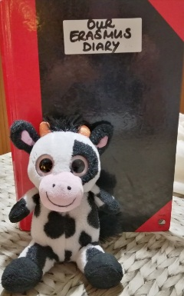 Agnes the cow
Séan the sheep

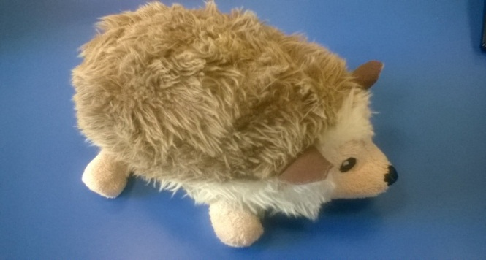 Spiky the hedgehog

Agnes the cow is from............................................., she has black and white spots. She has a pink nose. She is ten years old. Her birthday is on 14th ............................................ She lives in Arden school. Her favourite colour is orange. She likes eating burgers and pizza. She likes drinking lemonade and eating chips as a Snack. She loves ..........................and she loves hugging all the people and animals on earth. She loves sleeping.
In 2017 Agnes travelled to France, she went to many school trips and visited many places with our French Erasmus friends ,she also did many activities and practised sports in the school in Bordeaux: museum, creation of comics in the library “ La Source”, musical Hansel and Gretel at the theatre “Grand-Théâtre”, swimming pool, orienteering race, Easter celebrations, beekeeper visit, Kamishibai ( Japanese street theatre), speedminton game ( kind of .......................................... with no net), a special school menu cooked by a chef.
After France she visited .................................................. and went to colònies (summer camp) to Can castellar with 6th class. Last year she started the new project Respect, Re-use and Recycle back in Denmark and this year in Northern Ireland and now is our turn again, a very exceptional visit. Agnes the ........................... cannot visit the school yet. She is confined at teacher Beneta’s house and she is helping Beneta and Kayla with the video classes.

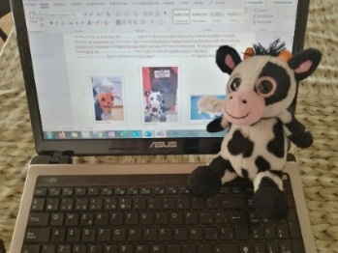

ENJOY YOUR WORK

Did you like doing these activities?
Was it easy or difficult?...........................................
Which was your favourite activity?........................
What did you learn from all these activities?.............................................................................................................
Self-evaluation: (from 1 to 10) write the result you think you should get in each activity. Be sincere!
Activity 2 A POSTCARD FROM IRELAND ……
Activity 4 AGNES THE COW…..

