CURS 2019 2020

Centre concertat per la Generalitat de Catalunya
Name: .......................................................................................... Number: ......... Class: ....... Date: ...............................................................................................................................................
A DAY TO WEAR SOMETHING GREEN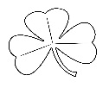
SAINT PATRICK’S DAY IN IRELAND
"Lá Fhéile Pádraig"
(17th March)
- Listen and read the following text and answer the questions
Saint Patrick is the patron saint of Ireland. He lived from the year 385 to the year 461. There are many stories and legends about Saint Patrick. One of the most famous stories tells us that he made all the snakes leave Ireland.
17th March is a national holiday in Ireland to honour St Patrick. There are lots of parades. Many people wear green clothes and also wear a shamrock, which is an emblem of Ireland. A shamrock has got three leaves on every stem.
Schools prepare activities during the week to celebrate Saint Patrick’s Day .They also call it "Lá Fhéile Pádraig" in Gaelic.
This year some students from your class were in Northern Ireland for the Erasmus project from Sunday 8th to Thursday 12th March and they were lucky to enjoy part of the saint Patrick’s celebrations. First and Second year primary students performed the legend of Saint Patrick and they also sang and danced some traditional songs. In the evening we were all invited for a meal in the school and we learnt how to dance some popular dances called céili. Before we said good bye to our friends we sang Auld lang syne and Ireland’s call.
1 Who is the patron saint of Ireland? .......................................................................................
2 How old was he when he died? .............................................................................................
3 What animal did Patrick expel from Ireland? ...........................................................................
4 When do Irish people celebrate Saint Patrick’s Day? .............................................................
5 How do they celebrate Saint Patrick’s day? .............................................................................
6 What does “Lá Fhéile Pádraig” mean in English? ....................................................................
7 What are the official languages of Ireland? .................................. and .................................
8 Which plant is the symbol of Ireland? ......................................................................................

- Listen to the song and fill in the gaps (https://youtu.be/4ufcQe5D27s)
IRELAND’S CALL
Come the ........... and come the hour
Come the power and the glory Ireland, ..................... Ireland, Ireland
We have .............. to answer Together standing tall Together standing .........
Our Country's call Shoulder to ................... Shoulder to shoulder
From the four proud provinces of Ireland We'll answer Ireland's call We'll .............. Ireland's call

- Circle in green the pictures related to Saint Patrick’s Day

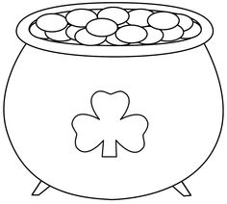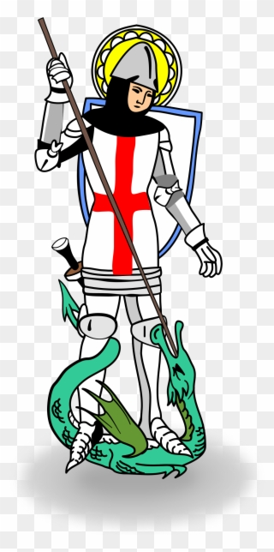
ST PATRICK ROSE LEPRECHAUN POT OF GOLD SAINT GEORGE
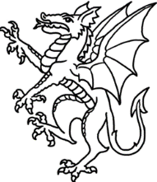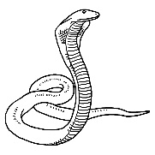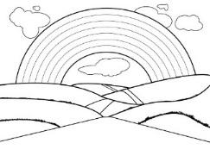
BOOKS SHAMROCK DRAGON SNAKE PRINCESS RAINBOW

- Listen, read and look at the pictures
ERASMUS MOBILITY TO CRUMLIN, BELFAST, NORTHERN IRELAND
FROM SUNDAY 8TH TO 12TH MARCH 2020
On Sunday we flew from Barcelona to Dublin. We took a bus from Dublin to Belfast.
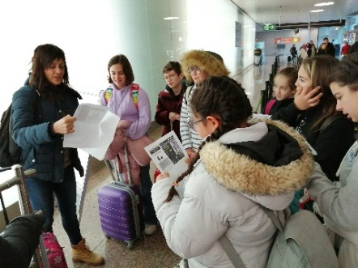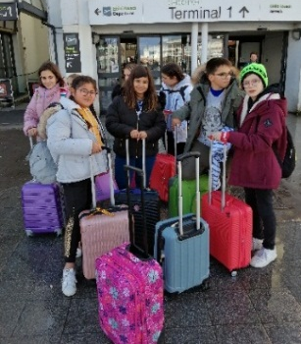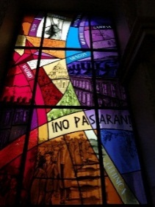BARCELONA AIRPORT DUBLIN AIRPORT BELFAST CITY HALL

On Monday we visited Belfast city by bus.
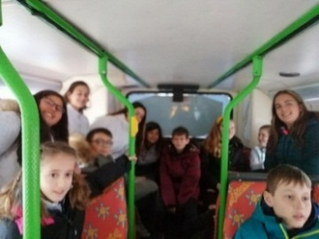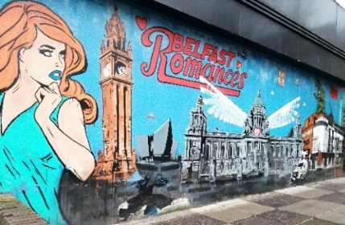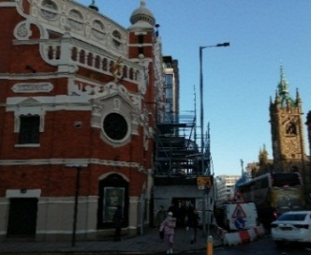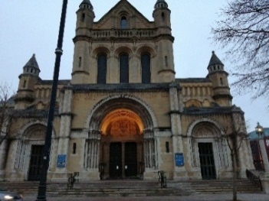HOP ON HOP OFF BUS A MURAL ALBERT GRAND OPERA HOUSE BELFAST CATHEDRAL CLOCK 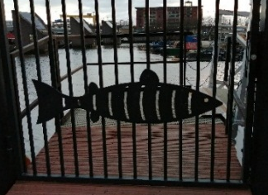 THE BIG FISH (SALMON OF KNOWLEDGE) THE HARBOUR AND THE TITANIC QUARTER

On Tuesday we went to the Giant’s Causeway. It was very windy and rainy. We also saw Game of Thrones place. On Wednesday we stayed in Crumlin. We spent all day in Saint Joseph’s school.
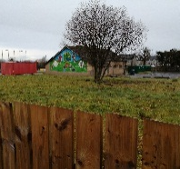
LOUGH NEAGH AND CRUMLIN
In the morning we learnt and played games about Respect Re-use and Recycle. We watched Saint Patrick’s legend performed by 1st and 2nd Primary students. All Erasmus students from England, Northern Ireland, Denmark and Catalonia presented their Respect Re-use and Recycle projects from their schools. Students from France couldn’t come due to coronavirus restrictions. In the evening we had dinner in the school and we danced after dinner. When we left the school in the evening, it started to snow.We were excited.
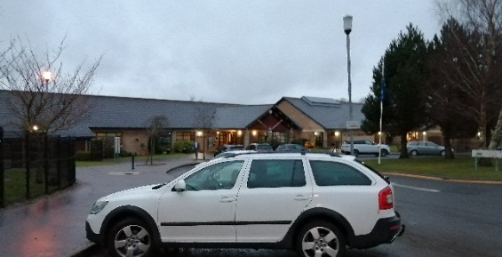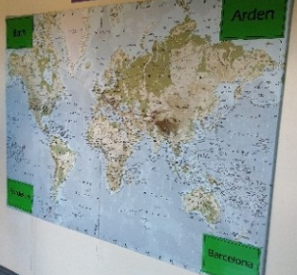
On Thursday it was time to go back home, full of good memories. We left Séan the sheep to our friends from Bath and our Danish friends gave us Agnes the cow. We took a bus back to Dublin. We saw the hills covered with snow.
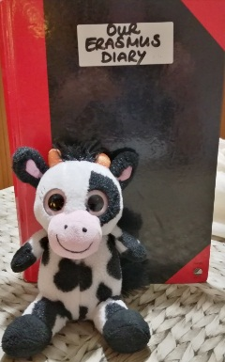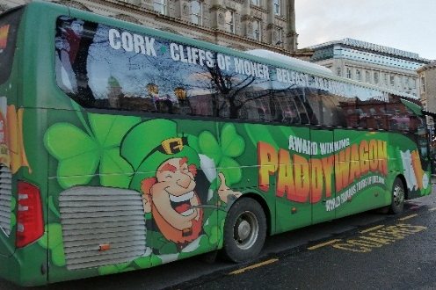 RISE (THE BALLS ON THE FALLS) PEACE MONUMENT
In Dublin we took the plane back to Barcelona where all our families were waiting for us and told us the latest news that schools were going to be closed due to coronavirus. We look forward to meeting our friends again. 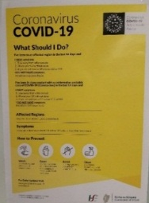 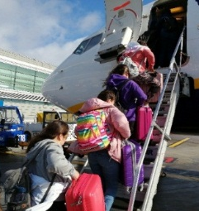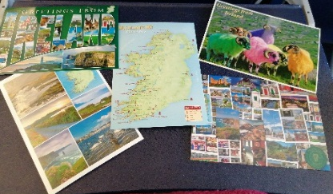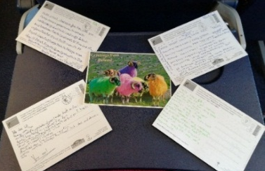

- Write the yellow highlighted verbs from activity 4 in the simple past column and complete the chart
CATALAN | INFINITIVE | PAST | P.PARTICIPLE | REGULAR/IRREGULAR
VOLAR | TO FLY | FLEW | FLOWN | IRREGULAR
AGAFAR |  | TOOK |  | IRREGULAR
VISITAR |  | VISITED | VISITED | REGULAR

- Look at activity 4 and number the following sentences in chronological order:
We spent all day in Saint Joseph’s school in Crumlin.
4
We visited Belfast city by a tour bus.
We flew back to Barcelona where all our families were waiting for us.
We took a bus back to Dublin, we saw the hills covered with snow.
We went to the Giant’s causeway by bus. It was very windy and rainy.
We flew from Barcelona to Dublin. We took a bus from Dublin to Belfast
- Look at activity 6 and number the following pictures in the correct order
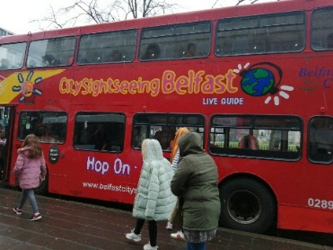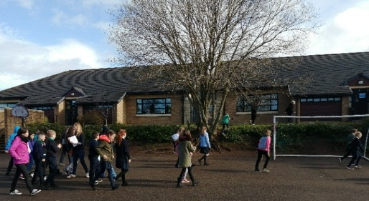
4

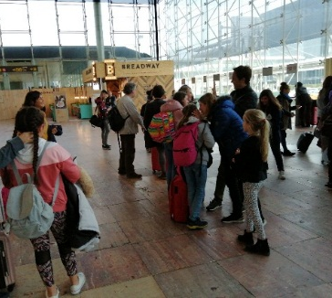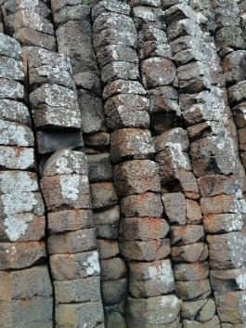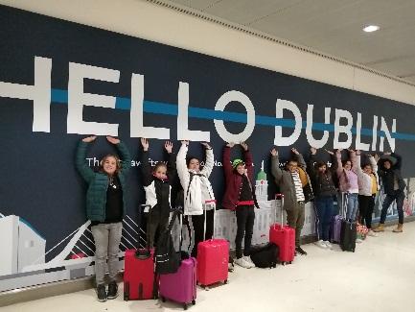

- Write the names of the teachers and pupils who went to Northern Ireland (Erasmus mobility):

Teachers: ..................................................... and ...................................................
Pupils from 6A .......................................... and .......................................................
Pupils from 6B ...........................................
Pupils from 6C ........................................... and ......................................................
Pupils from 6D ............................................, ............................................... and .......................................

LÁ FHÉILE PÁDRAIG SONA DUIT

9 Did you like doing these activities?
10 Were they easy or difficult?...........................................
11 Which was your favourite activity?........................
12 Self-evaluation: (from 1 to 10) write the result you think you should get in each activity.
Be sincere!
Activity 1 ….. Activity 2 .…. Activity 3 ….. Activity 4 ….. Activity 5 ….. Activity 6 .… Activity 7…. Activity 8 ….

