Shoscombe School
St. Julians Rd
Shoscombe
ba2 8nb

Dear Eramus Friend,

Merry Christmas! How are you? In England it is a bit hit or miss, with Covid-19 around. In June last year I was meant to be going to stay with our Erasmus partners in Barcelona, Spain. It was fun seeing you on the Zoom and asking you questions about your school.

We have recently gone into Lockdown two, with the conid cases rising. Here at Shoscombe, it is only our class left in the whole school! All the younger classes have people with Covid in them, so have to self isolate for two weeks! Luckily it wasn’t my class as yesterday I took my Grade 1 piano at last as it was postponed from June. Are you aloud out of the house besides going to school? Does someone in your family have Covid meaning you have to stay at home?

Well, at least we have something to look forward to… CHRISTMAS!!!!
I love all the lights, and songs, and the spirit. I hope I get to see my family this year. One of my aunties and her family live in Australia, so I won’t see them sadly. But I have lots of relatives in England, so I’m hoping to see them. On Christmas day, we have a big roast dinner and pull crackers, and open lots of presents from family and friends. And, of course, Santa! What do you do on Christmas day? Do you open your present on Christmas day or another tome? Do you get presents at all? What do you eat on your main Christmas dinner? We have turkey in England, with yorkshire puddings and pigs in blankets; sausages wrapped in bacon! YUM! Another Christmas tradition is to have a decorated fir tree, with the presents under it! Do you have a tree?
IN 2021, I’m hoping to visit your country on Erasmus, and that I’m able to go skiing. We would normally go to Italy to ski, but with the current situation we are driving to Scotland to ski. I also hope scientists will develop a vaccine pretty soon, enabling things to go back to normal.
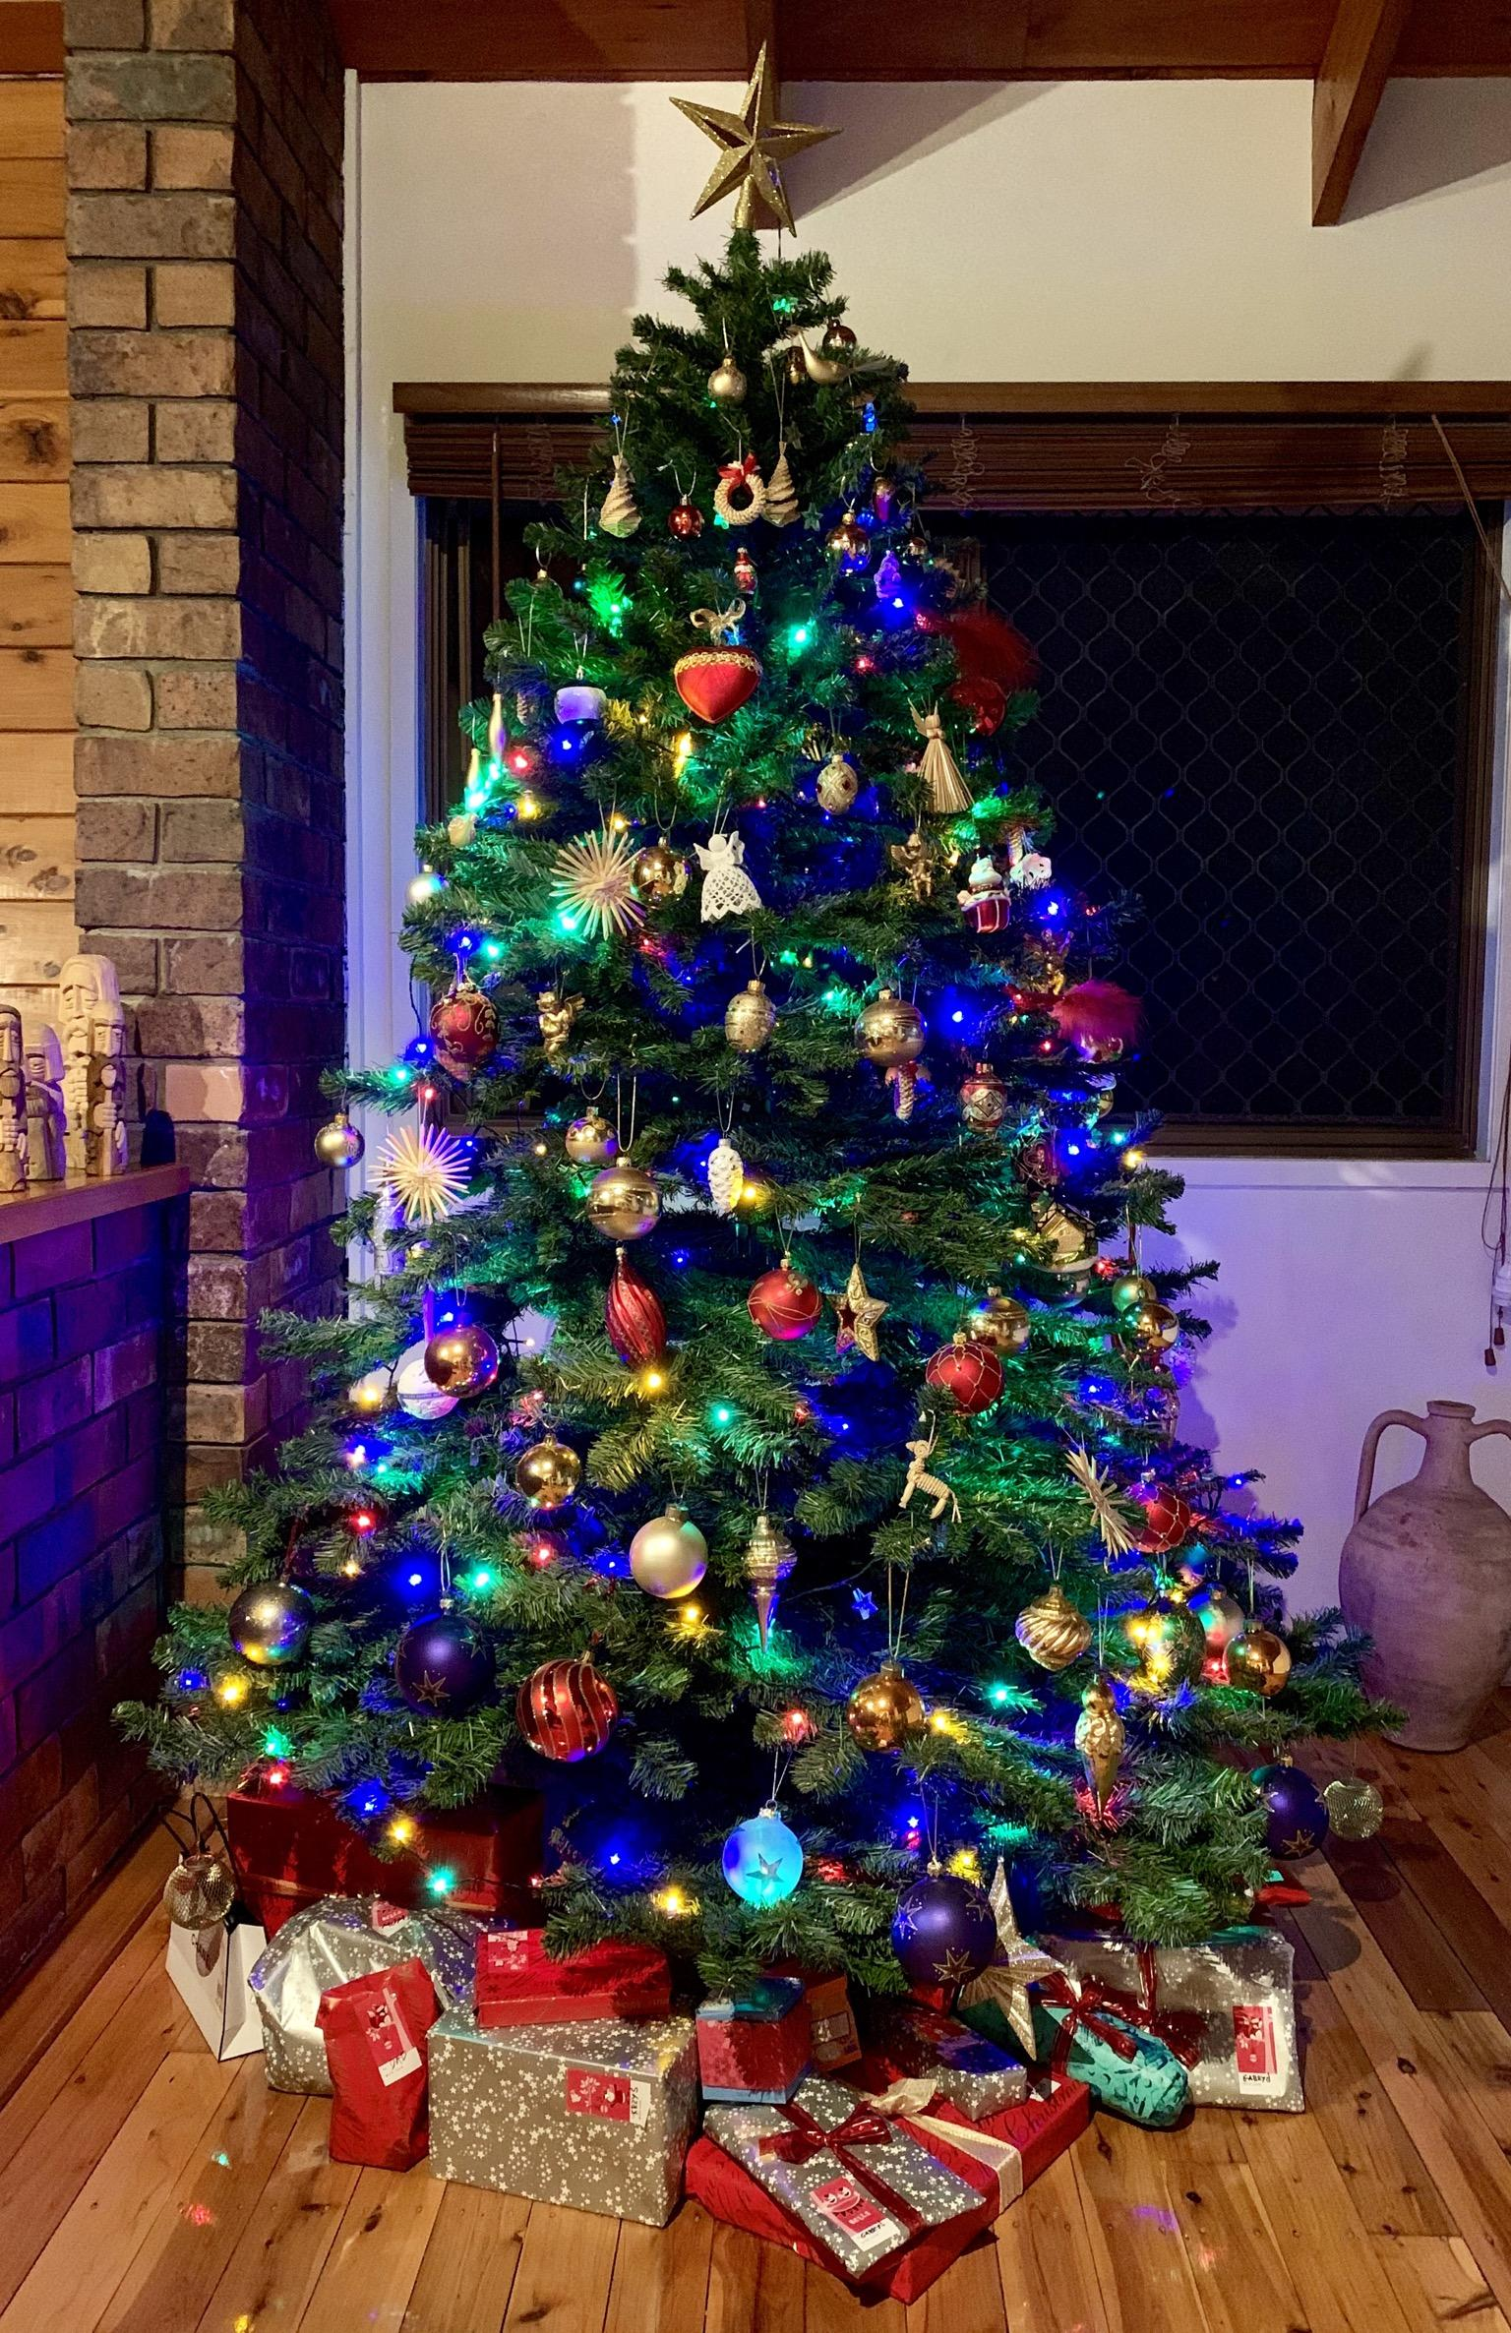
I hope you have a very merry Christmas whatever global state, and get what you have asked for. I’d love it if you could write back, as if we can’t see each other, it would be ace if we could feel connected to those all over the world.

MERRY CHRISTMAS!!!!

From Tilly While

