EU Questionnaire for students 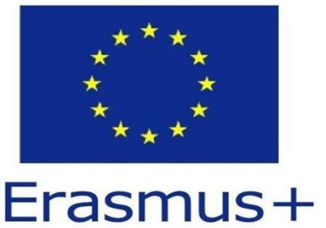

We would like to find out how you feel about the EU. Can you please answer these questions about the EU.Thank you.

I am from _____________________________ (country)

I am ___________ years old.

1. If it had been up to you whether your country joined the EU – what would you have decided?

For the EU O Against the EU O

2. What was the reason for your country to become part of the EU?

_______________ _______________________________________________________

3. After joining the EU what has changed for the better in your country?

___
4. After joining the EU what has changed for the worse in your country?

__________________________________________________________________

5. Have the living conditions improved since your country joined the EU?

6. Do you think that you are more respected by other countries since you joined the EU?

7. How did the political style in your country change after joining the EU?

___________________________________________________________________________

8. How do you rate the work of the EU on a scale from 10 (= very good) to 1 (= very bad)?

9. Which positive experiences have you had personally with the EU?

_
___________________________________________________________________________

10. Which negative experiences have you had personally with the EU?

___________________________________________________________________________

11. Do you think the Euro offers advantages?

If the answer is ´yes` - which advantages: __

12. How important is the Kyoto drive (the effort to cut down on greenhouse gases like CO2) to you on a scale from 10 (= very important) to 1 (= not important)?

________________________________________________

