“Our world of well-being”
Traditional healthy recipe
“Fagioli e scarole” This is a vegetable soup. It is a quick and easy dish!

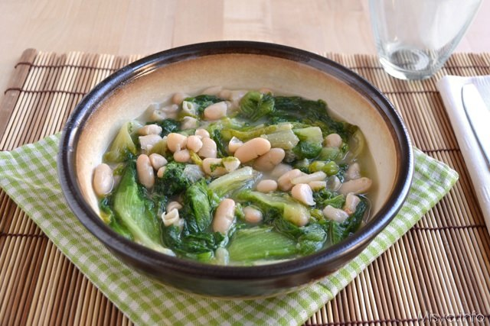

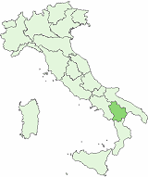
Basilicata

Ingredienti per 2 persone: Ingredients for 2 people

- 400 gr di fagioli lessi 400 gr boiled beans
- 1 cespo di scarola 1 small head of escarole
- 1 spicchio di aglio 1 clove of garlic
- Peperoncino dry pepper
- Olio olive oil
- Sale salt

Directions
Boil the beans for 30 minutes . Add the dry pepper, the garlic , a tablespoon of olive oil, salt and cook for other 5 minutes.
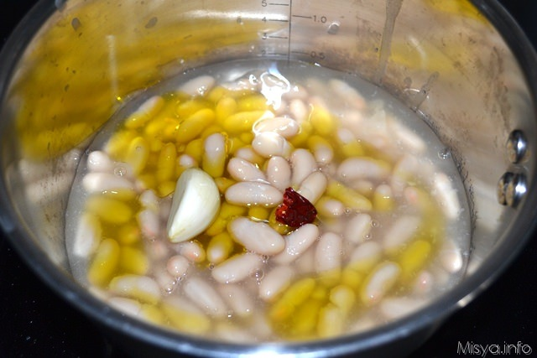
Boil the vegetable for 10/15 minutes.
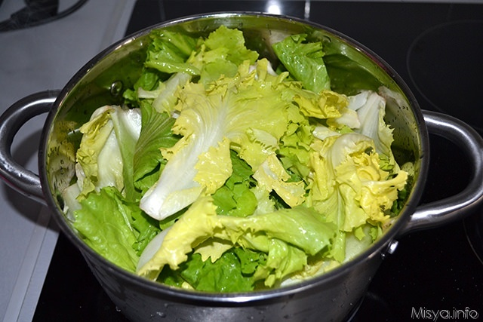
Drain the vegetable and add it to the beans.

Cook for 10 minutes more. Ready to eat!

