“Our world of well-being”
Traditional healthy recipe
“Pancotto con i broccoli”
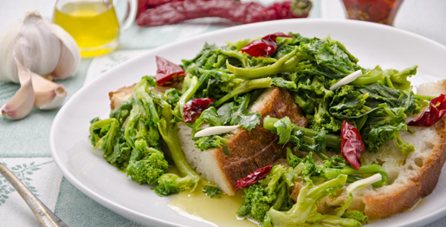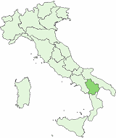
Basilicata
Ingredienti (4 persone): Ingredients (4 people)
- pane raffermo, g 250 stale bread, 250 grams
- broccoli siciliani, 2 broccoli
- olio extravergine d’ oliva, q.b. olive oil
- aglio, 1 spicchio garlic , 1 clove
- sale, q.b. salt
- peperoncini, 2 dry peppers, 2

Put some water in a pan. Put the stale bread on a plate. Boil the water and add the “broccoli”. Drain the broccoli, pour some water on the stale bread and drain that. Add the broccoli. In a frying pan put some oil, garlic and dry peppers , then sprinkle that on the bread with broccoli.

This receipe was done by the students of the first class. The work was coordinated by the English teacher.

