“Our world of well-being”
Traditional healthy recipe
“Cavatelli with broccoli and cheese”
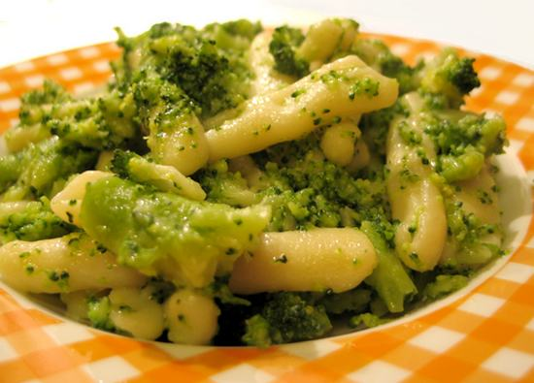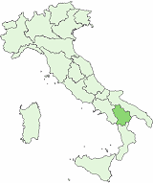
Basilicata
Ingredienti (4 persone): Ingredients (4 people)
- Cavatelli , 500 grams Cavatelli, 500 grams
- broccoli siciliani, 2 broccoli
- olio extravergine d’ oliva, q.b. olive oil
- aglio, 1 spicchio garlic , 1 clove
- sale, q.b. salt
- peperoncini, 2 dry peppers, 2
- formaggio cheese

“cavatelli” is a handmade pasta but you can use “spaghetti” too.
Put some water in a pan. Boil the water and add the “broccoli” then “pasta” and cook for 8 minutes. In a frying pan put some oil, garlic and dry peppers and cook for 2 or 3 minutes. Drain the broccoli and pasta and put them again in a pan. Sprinkle the oil and peppers on them . Stir all of ingredients with a wooden spoon and put on the plates. “Buon appetito” as Italians say before eating!

