A healthy lunch
My healthy lunch is tuna pasta bake it has nutritious and carbs it’s good for after swimming and running and other sports as well the cheese has dairy and the sauce has spaghetti sauce, shredded mozzarella cheese, pasta, and browned ground beef and onion mixture.

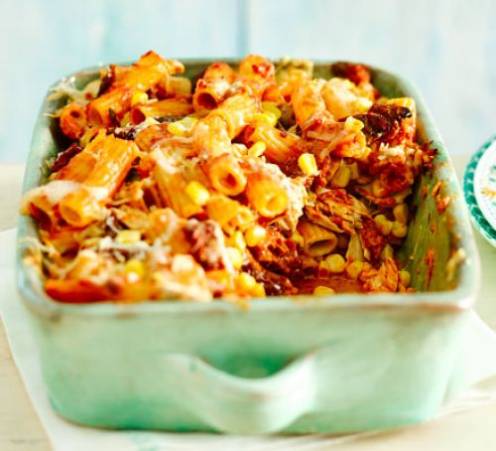
This is by Mr Eric Sean Gregory Woods

