My favourite healthy lunch is

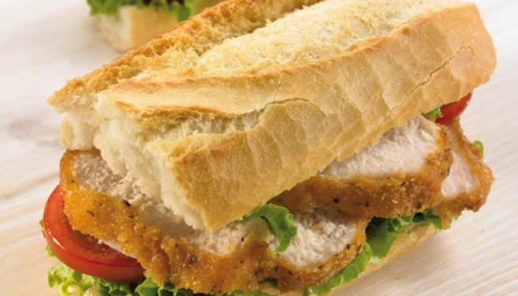

Chicken fillet roll with lettuce and tomato

You get a fresh brown roll and cut it in half. You spread mayonnaise on the roll, then put on lettuce and sliced tomato add the cooked chicken fillet cover with other slice of brown roll. By Kyle

