HEATHLY LUNCH
My favourite healthy lunch is brown bread with fish fingers with mayo with some fruit on the side of my plate.

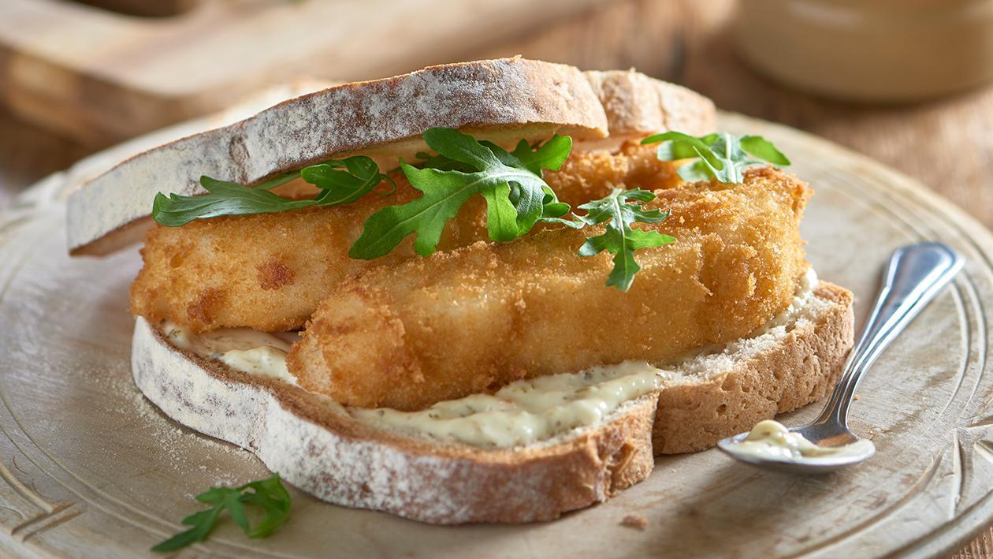

By Jenny Keeling!!!!

