Healthy lunch
My favourite lunch is fish fingers on brown bread and some fruit on the side of my plate it is so tasty!!!

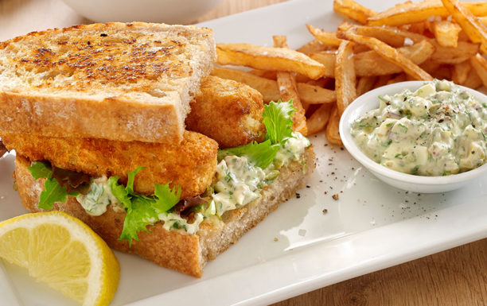
By Jenny Keeling

