“Our world of well-being”
Traditional healthy recipe
“Cicoira strascinata in padella”
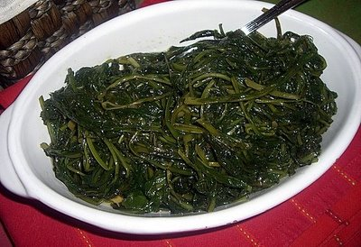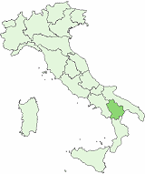
“Cicoira” is a kind of vegetable.
Put the oil, the bacon, a clove of garlic, dry pepper in a frying pan and cook for some minutes. Add “cicoira” and cook for ten minutes. Then put it on a plate. It’s ready to eat!

Made by Chiara Cerone class II B “G.Pascoli” dpt

