THEMATICS
Μαθηματικά στο Ελληνικό Γενικό Λύκειο

MATHEMATICS

Έφη Φιλιππάκη

in Greek upper secondary general education
( students 15-18 years old)

CLASS A (for students 15-16 years old)

ALGEBRA (3h/week)
INTRODUCTORY CHAPTER E : The mathematical logic, Sets
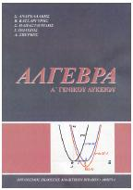
CHAPTER1: Probabilities (Sample space, events, the meaning of probabilities)
CHAPTER 2: Real numbers (the operations and their properties, powers, special factoring formulas, the absolute value of a real number, the roots of real numbers)
CHAPTER 3: Equations 1st and 2nd degree, the equation x^{v}=a
CHAPTER 4: Inequalities
CHAPTER 5: Sequences (arithmetic and geometric sequences)
CHAPTER 6: Functions (the meaning of a function, graph, f(x)=ax+b)
CHAPTER 7: The functions f(x)=ax², f(x)=a/x, f(x)=ax²+bx+c

GEOMETRY (2h/week)

CHAPTER 1: Introduction to Euclidean Geometry, The subject of Euclidean Geometry, Historical elements
CHAPTER 2: Basic geometric figures(Points, lines, surfaces, angles, circle, arc, polygons)
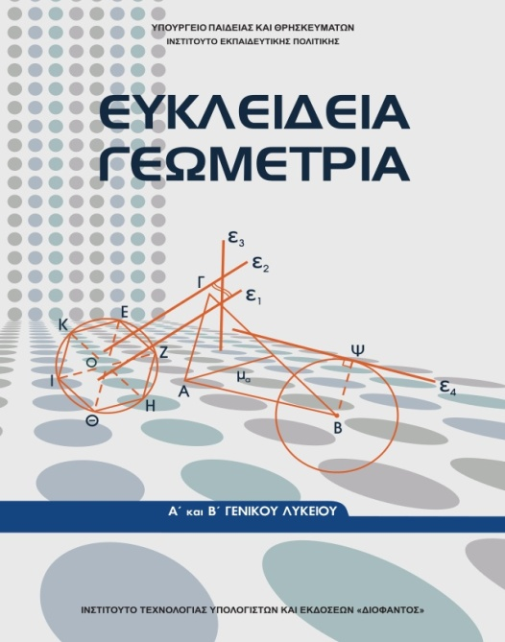
CHAPTER 3: The triangles, kinds and elements of the triangles, the theorems of the triangles equality. The circle, the mid-perpendicular, the bisector of an angle ,the relation between the exterior and the opposite angle of a triangle, the triangle inequality, tangent segments, positions between a line and a circle and between two circles. Symmetry per center, symmetry per axis, Simple geometric constructions, basic triangle constructions.
CHAPTER 4: Parallel lines (The Euclidean postulate, the construction of a parallel line,, angles with parallel sides, remarkable circles of a triangle. The sum of the angles of a triangle, angles with perpendicular sides, the sum of the angles of a convex polygon
CHAPTER 5: Parallelograms and Trapezium (introduction to parallelograms, rectangle, rhombus, square, applications on triangles, centroid, orthocenter, properties of right angle triangles, the trapezium, the isosceles trapezium, remarkable lines and circles of a triangle.
CHAPTER 6: Definitions , relationship between an inscribed and a central angle corresponding to the same arc, the angle formed by a chord and a tangent, Inscribable and inscribed quadrilateral.

CLASS B (Students 16-17 years old)

ALGEBRA (3 h/ week)
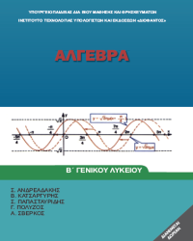
CHAPTER 1: Systems (Linear systems with two variables, linear systems with 3 variables, non linear systems)
CHAPTER 2: Properties of functions (monotony, max/min of a function, symmetries in a function). Horizontal and vertical shifts.
CHAPTER 3: Trigonometry (trigonometric numbers of an angle, trigonometric identities, reduction on the first quartile, trigonometric functions, , trigonometric equations, sin(a±b), cos(a±b), tan(a±b), sin(2a), cos(2a), tan(2a)
CHAPTER 4: Polynomials and polynomial equations (definitions, the Division of polynomials, polynomial equations, equations and inequalities referring to polynomials)
CHAPTER 5: The exponential and the logarithmic function

GEOMETRY (2h/week)
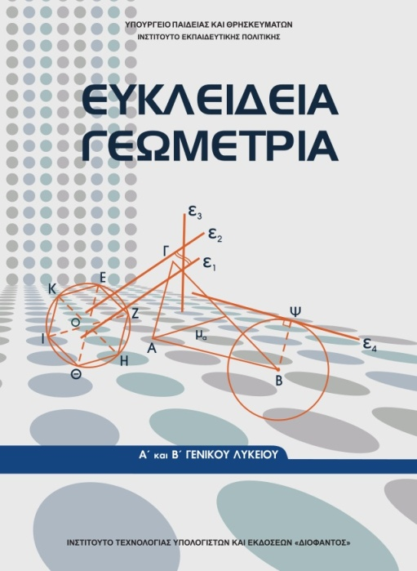
CHAPTER 7: Analogues and their properties, Thales’ theorem, the bisector’s theorem, the Apollonius’ circle
CHAPTER 8: Similarity (Similar figures, theorems of similarity)
CHAPTER 9: Metric relations (projection of a point or a segment on a line, Pythagoras’ theorem, geometric constructions, generalization of Pythagoras’ theorem, theorems of the medians of a triangle, the secants of a circle
CHAPTER 10: The areas ( the areas of flat figures, additional formulas for the area of a triangle, the ratio of the areas between similar triangles and polygons, transformation of a polygon to its equivalent
CHAPTER 11: Measurement of a circle ( definition of a regular polygon, properties and elements of regular polygons, basic polygons inscribed in a circle, approach of the length and the area of a circle using regular polygons, the length of an arc of a circle, the area of the sector of a circle, the squaring of the circle)

ADVANCED MATHEMATICS -for the field of science (2h/week)

CHAPTER 1: The Vectors ( the meaning of a vector, addition and subtraction of vectors, the multiplication of a real number by a vector , coordinates on the plane, arithmetical product of two vectors).
CHAPTER 2: The line on a plane (The equation of the line, the general form of the linear equation, the calculation of the area of a triangle
CHAPTER 3: The conic sections (circle, parabola, ellipse, hyperbola, the equation Ax²+By²+Cx+Dy+E=0)

CLASS C (students 17-18 years old)

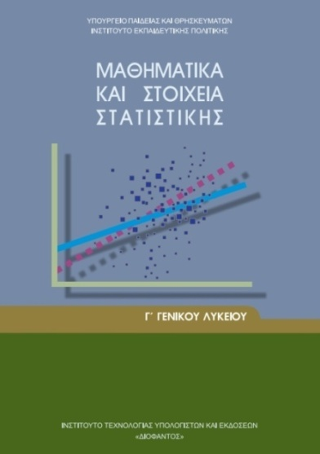
GENERAL MATHEMATICS-INTRODUCTION TO STATISTICS (2h/week)
CHAPTER 1: Differential calculus (the functions, the meaning of the derivative, the derivative of a function, applications of the derivatives)
CHAPTER 2: Statistics (Basic meanings and definitions, average, median, weighted mean, range, variance, standard deviation , coefficient of variance)
CHAPTER 3: Probabilities (Sample space, events, the meaning of the probabilities, simply additive law, additive law.

ADVANCED MATHEMATICS-for the fields of science, technology and economics (5h/week)
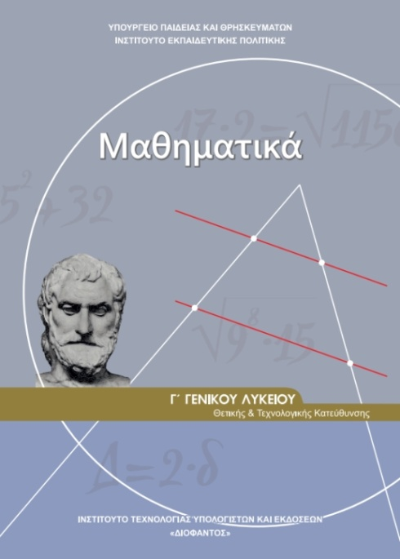
CHAPTER 1: Limits, continuous functions (real numbers, functions, monotonous functions, inverse functions, limits when x x_{0,} x∞, the properties of the limits, continuous functions, Bolzano theorem).
CHAPTER 2: Differential calculus (The meaning of the derivative, Differentiable functions, The derivative function, Properties of the differentiable functions, The rate of change, The average theorem of the differential Calculus, Rolle’s theorem, The consequences of the Average theorem, local max and min of a function, The convexity of a function, The inflection points, The asymptotes. The De L’ Hospital theorem. Study and the outlining of a curve.
CHAPTER 3: Integral calculus (The indefinite integral, the definite integral, the function F(x)= , The average theorem of the Integral calculus, The calculation of a plane area.

