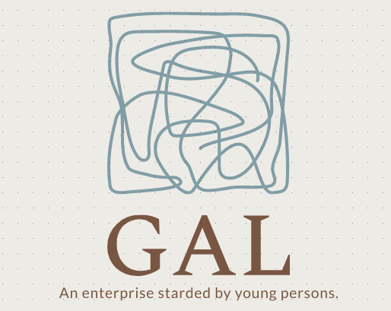 |  | Gal cooperatı-ve  Job Anouncement
PRIORITY REQUIREMENT:  We GAL Cooperative are asking for college graduated, hardworking and cheerful staffs.  Contact:  PHONE:  0 598 989 8989  WEB SITE:  www.gaziantepanadolulisesi.com  E-MAIL:  galcooperative@gmail.com |  | Socıal medıa manager  JOB TYPE: Paid Intern  JOB SCHEDULE: Part-Time  JOB LOCATION: Gaziantep-Turkey  JOB REQUIREMENTS - the candidate should:  -be experienced,  -be hardworking,  -be atleast 24,  -highlight our cooperative,  -be kind.  SALARY=1750$+bonus by each succesful post.  sECURITY  JOB SCHEDULE: Full-Time  JOB LOCATION: Gaziantep-Turkey  JOB REQUIREMENTS - the candidate should:  -be experienced,  -be kind,  -be cold-blooded,  SALARY=2100$

