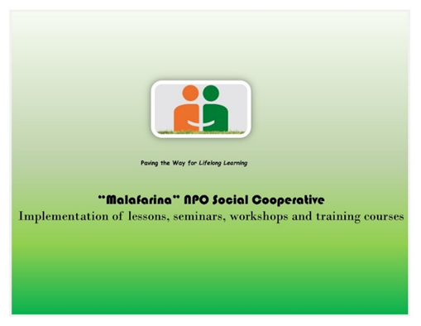
«MALAFARINA» SOCIAL COOPERATIVE ENTERPRISE is looking for these workers’ profiles:
1 Volunteer
1 Training Course Director
1 Promotion of children’s rights projects Manager
1 Chairman of the Board

If you are interested send an email to www.msce.it
enclosing
- CV
- an intent letter

1 Volunteer:
JOB TYPE: Paid Intern
JOB SCHEDULE: Part-Time
JOB LOCATION: Soverato (CZ) Italy
JOB RESPONSIBILITIES - the candidate should:
- help out with a variety of events planned by the company or events the organization will be attending for public speaking or as a vendor. (fundraising, conferences, Children’s Rights Awareness Campaigns, Training, etc.).
QUALIFICATIONS - the applier should
- be at least 16 years old.
- be flexible, friendly, and possess good communication skills. The shift commitment is 5 events within 2 months.
- accomplish the common role of volunteerism and community partnerships
- have strong written and verbal communications skills.
- have strong interpersonal skills
SALARY: All reasonable expenses will be covered

2: Training Course Director
JOB TYPE: Associate Member
JOB SCHEDULE: Full-Time
JOB LOCATION: Soverato (CZ) Italy
JOB RESPONSIBILITIES - the candidate should:
- ensure training needs of the courses are met; analyze needs and training requests, helping to prioritize and design training programs to impact positive employee growth and drive business results
- evaluate training programs, resources and tools for impact and results; produce reports to assist in prioritizing needs and building new programs as appropriate
- hold design, IT skills
- assess learning solutions to ensure all course contents cover the needs of the employees and that the desired principles and skills are being taught in the most learnable ways to produce desired outcomes
- build positive working relationships with the company members to better understand training and development needs
QUALIFICATIONS- the applier should:
- hold Bachelor's Degree in Organizational Development, Education, Training, Business Management or related fields; progressive job related experience will be considered in lieu of degree.
- have 2+ years of experience managing and leading people
- have strong written, verbal, interpersonal and facilitation skills required
- have excellent analytical and organizational skills
- have the ability to anticipate and respond to the needs of stakeholders
SALARY: 1950€ a month

3: Promotion of children’s rights projects Manager
JOB TYPE: Paid Associate
JOB SCHEDULE: Full-Time
JOB LOCATION: Soverato (CZ) Italy
JOB RESPONSIBILITIES - the candidate should:
- research, recommend and coordinate program and service changes; review and evaluate assigned programs
- ensure the efficient and economical use of program funds, personnel, materials, facilities, and time; prepare and submit required funding requests
- manages assigned programs to achieve goals within budget; plans, organize and review workload and priorities to ensure completion of duties in a timely and efficient manner
- foster cooperation and increase collaboration with system
- promote assigned programs and services; maintain contacts in service area communities; attend various public meetings and make presentations to increase public awareness of children’s rights
QUALIFICATIONS - the applier should
- hold a Bachelor’s degree in a related area of study
- have 2+ years of experience in providing training and education on children’s rights;
- have the ability to handle projects independently and demonstrate exceptional organizational and project management skills.
- demonstrate role model organizational skills and effective communication abilities at all levels.
- be flexible in various situations with the ability to provide leadership and influence others.
SALARY: 1600€ a month

4: Chairman of the Board
JOB TYPE: Paid associate
JOB SCHEDULE: Full-Time
JOB LOCATION: Soverato (CZ) Italy
JOB RESPONSIBILITIES - the candidate should:
- provide organizational leadership by working with the board, staff and stakeholders
- work with the board to set OSI’s strategic direction and annual goals, plans and budget
- build staff capacity through hiring and lead staff to achieve desired results
- ensure operational excellence by working with staff on financial and system management
- build relationships with multiple stakeholder groups.
- evangelize MALAFARINA SOCIAL COOPERATIVE ENTERPRISE’s mission through speaking engagements, blogs and social media
QUALIFICATIONS - the applier should:
- have 3-5 years of leadership experience
- have strong organizational leadership skills
- have an experienced setting strategy and plans that lead to measurable results
- have a board management experience including facilitating strategy sessions and providing board and committee meeting support
- have stakeholder management experience including networking, insight gathering, and convening
SALARY: 2500€ a month

«MALAFARINA» SOCIAL COOPERATIVE ENTERPRISE, inspired by the principles of solidarity and mutuality of the cooperative setting, intends to:

- pursue the general interest of the community in human promotion and social integration with particular reference to socially disadvantaged subjects, through the rational use of the human and material resources available.
- provide a qualified response to social, educational and training issues and needs.
- guarantee the answers that best meet users' needs, through the personalization of interventions, qualifying training courses, promoting the well-being of the person and the groups through prevention actions, active involvement and sharing of objectives

