

Determination of water pH

Worksheet no. 1



Determination of water pH

**Overview**

Dissolving CO2 in seawaters occurs with the formation of carbonic acid and the release of hydrogen ions into the solution. There is an increase in acidity and, consequently, a decrease in pH. Thus, changes associated with increasing seawater CO2 concentrations are often referred to as ocean acidification.

pH is the negative decimal logarithm of hydronium ion concentration and it is important for determining the alkalinity and acidity of the water.

Necessary lab equipment: water sample, pH paper, pH meter, Berzelius beaker.

**1.The Colorimetric method**

• take a quantity of water sample and place it into the Berzelius beaker

• take a piece of pH paper and insert it into the water sample

• the resulted color is compared with the pH scale

**2.The electrometric method (pH meter)**

• insert the electrode into the water sample

• read the pH value on the pH meter scale

**LABORATORY TASK**

Determine the pH value of your water sample.

**Requirements**

•perform the given task

•fill in table with the results

•comply with safety and security measures in laboratory

•compare the obtained results to the water quality standard values.

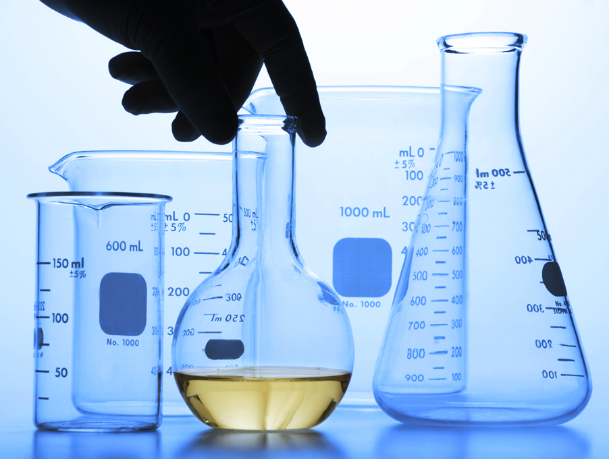



Determination of water pH

|  |  |  |  |  |  |
| --- | --- | --- | --- | --- | --- |
| **Sample No.** | **The source of the water sample** | **pH Value**  **(Colorimetric Method)** | **pH Value**  **(Electrometric Method)** | **Standard water pH ​​** | **Remarks** |
| **1** | Atlantic Ocean |  |  | **6.5-9** |  |
| **2** | Adriatic Sea |  |  | **6.5-9** |  |
| **3** | Black Sea |  |  | **6.5-9** |  |
| **4** | Fresh water |  |  | **6.5-8.5** |  |

