

Determination of water electric conductivity

Worksheet no. 2



Determination of water electric conductivity

**Overview**

The conductivity reflects the salt content of the water

The electrical conductivity of the water depends on the content of electrolytes and their strength.

The electric conductivity of the water is measured in the laboratory with a device called conductometer.

The electrical conductivity has as Siemens unit of measure per meter, S ∙ m-1 and its sub-multiples. The determination of the electrical conductivity of a water sample based on the property of an aqueous solution to conduct electrical current.

Necessary lab equipment: water sample, conductometer, Berzelius beaker.

**Procedure**

• calibrate the device with distilled water

• insert the electrode into the water sample

• read the determined value

**LABORATORY TASK**

Determine the electric conductivity of your water sample.

**Requirements**

•perform the given task

•fill in table with the results

•comply with safety and security measures in laboratory

•compare the obtained results to the water quality standard values.

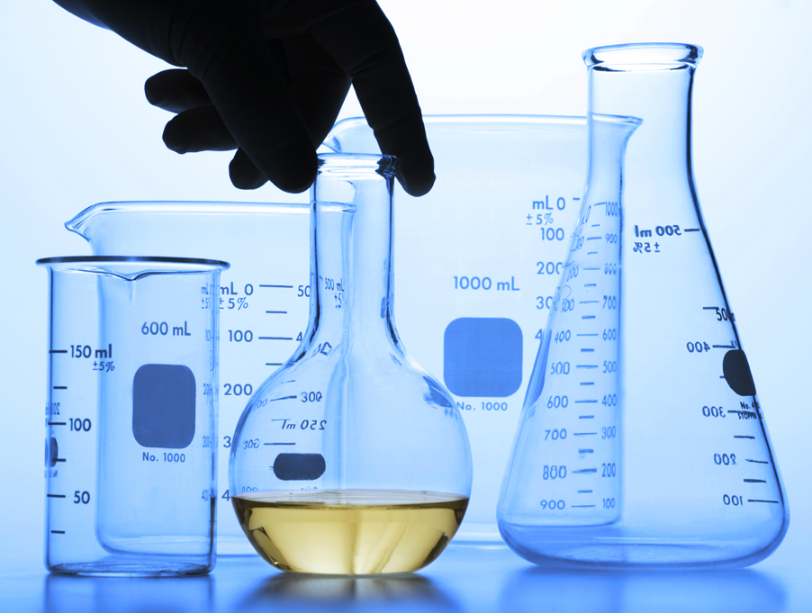



Determination of water electric conductivity

|  |  |  |  |  |
| --- | --- | --- | --- | --- |
| **Sample No.** | **The source of the water sample** | **Conductivity,**  **µS/cm** | **Standard Conductivity ​​of water µS/cm** | **Remarks** |
| **1** | Atlantic ocean |  |  |  |
| **2** | Adriatic sea |  |  |  |
| **3** | Black sea |  |  |  |
| **4** | Fresh water |  | 2500 |  |

