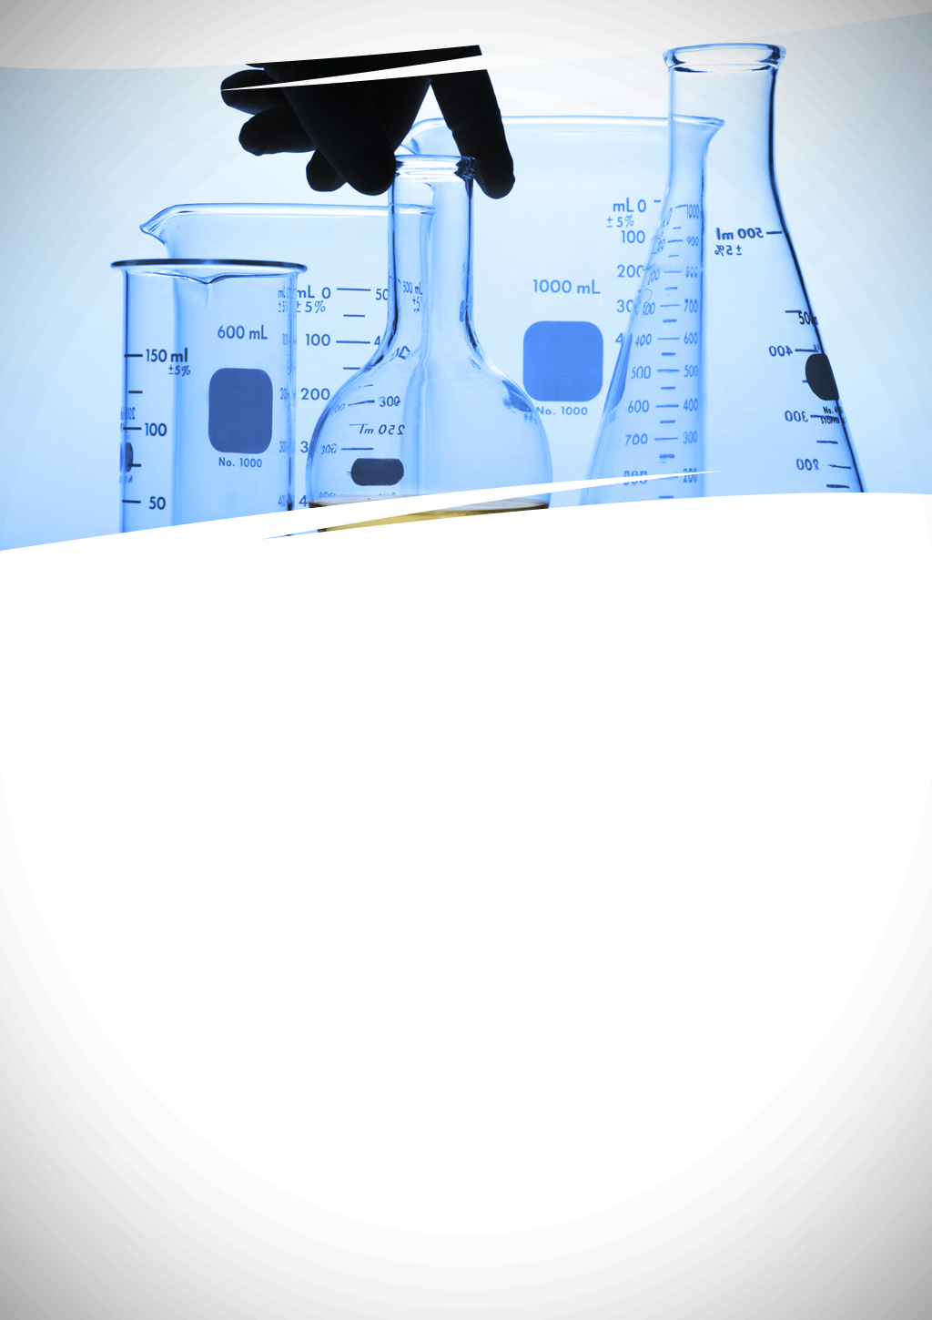

Determination of water salinity

Worksheet no. 3



Determination of water salinity

**Overview**

Salinity is a chemical property of seawater that plays an important role thermal regime flow, in the water currents formation and in the development of marine life conditions.

The salinity of water is determined by the chlorides in the water.

Chlorides from water result from soil or from animal/human pollution.

The chloride concentration in the water varies over time.

Necessary lab equipment and reagents: water sample, burette, pipette, Berzelius beaker, Erlenmeyer beaker, distilled water, 0.1 N AgNO3 solution, 10% K2CrO4 solution

The Cl- ion present in water is determined by volumetric methods based on precipitation reactions. The Cl- ion reacts with AgNO3 to form insoluble silver chloride. The potassium chromate solution is used as an indicator. The red-brick color of the silver chromate indicates the end point of the titration.

The equations of the chemical reactions are:

Cl- + AgNO3 → AgCl↓ + NO3-

K2CrO4 + AgNO3 → Ag2CrO4 ↓ + 2KNO3

**Procedure**

• take 2 ml of the water sample in an Erlenmeyer beaker

• add 3 drops of potassium chromate solution

• titrate with silver nitrate solution (AgNO3), until the color turns from yellow to red – brick.

**LABORATORY TASK**

Determine the salinity of your water sample.

**Requirements**

•perform the given task

•fill in table with the results

•comply with safety and security measures in laboratory

•compare the obtained results to the water quality standard values.

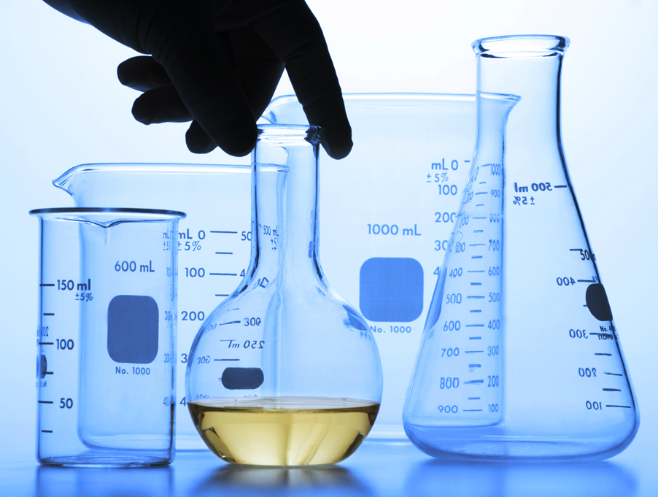



Determination of water salinity

Calculations:



* Where:

VAgNO3 - stands for the volume of AgNO3 solution used in titration, measured in ml

CAgNO3 – stands for the concentration of the solution of AgNO3

ACl – stands for the atomic mass of chlorine (35,5)

Vp - stands for the water sample volume, measured in ml

* Salinity is calculated by the Knudsen method

**Q = 1,811×Cl (0/00)**

|  |  |  |  |  |
| --- | --- | --- | --- | --- |
| **Sample No.** | **The source of the water sample** | **Salinity of**  **analyzed water**  **0/00** | **Standard Salinity ​​of water**  **0/00** | **Remarks** |
| **1** | Atlantic ocean |  | 33-37 |  |
| **2** | Adriatic sea |  | 35-38 |  |
| **3** | Black sea |  | 18 |  |
| **4** | Fresh water |  | ≤ 0.5 |  |

