Endangered animals in Greece- Primary School of Ippeios
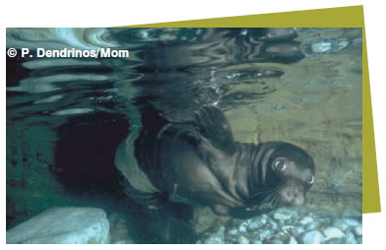
1)Monachus monachus seal lives in the Mediterranean Sea. Its colour is brown or grey. It lives 45 years. It is three metres long and weighs 300 kilos. It eats small fish, octopuses and squid. It has one baby (pup). There are only 250 Monachus monachus seals in Greece today.

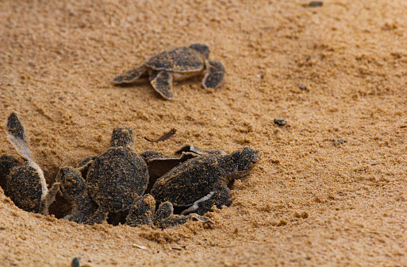
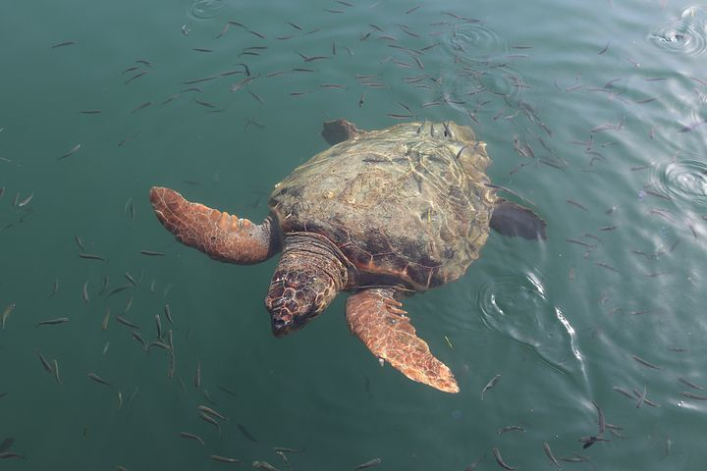 Pixabay

2) Caretta caretta sea turtle lives 100 years. It weighs 90-100 kilos and it is about one metre long. The colour of its shell is red and brown.
It lays its eggs on land, on beaches in Zakynthos, Peloponnesus and Crete. Each sea turtle lays about 115 eggs every two or three years, but there are many dangers for the baby turtles. Only one out of a thousand baby sea turtles survives and there are only about 4,000 caretta caretta sea turtles in Greece today.

WWF Greece is a part of the WWF Mediterranean Marine Initiative (MMI) and collaborates with the other WWF national offices in the region to protect our common home, the Mediterranean. Volunteers are asked to “adopt” an endangered animal and donate money for its protection.

Endangered plants in Greece- Primary School of Ippeios

1) Ipomoea imperati:

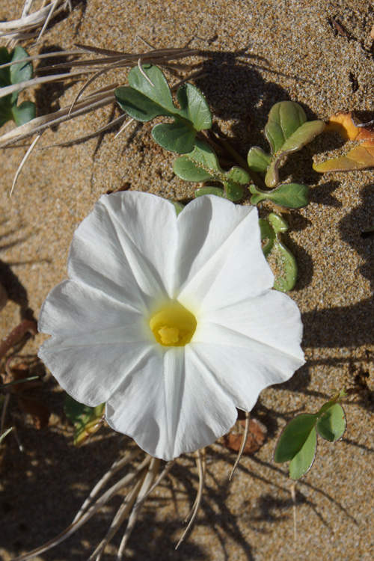 Steve Lenton

A cosmopolitan plant that grows in Greece on a few beaches in Crete and Rhodes. Tourist activity is developed on these beaches.

2) Viola cephalonica:

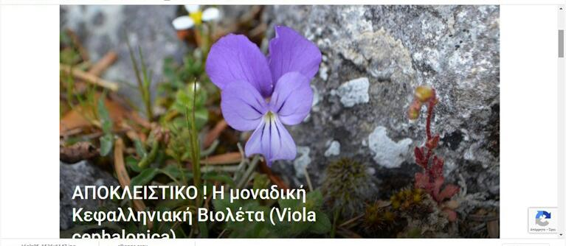

It is the rarest plant of Kefalonia (a Greek island), since it is found only in the highest peaks of Mount Ainos. It does not exist anywhere else in the world.
In an effort to protect Viola cephalonica from human influences, a fence was constructed in 2008 at the Chionistra site by the Ainos National Park Management Agency with the assistance of the Kefallinia Forest Department.

