Endangered Animals in Turkey

The fauna of Turkey is abundant and very varied. The wildlife of Turkey includes a great diversity of plants and animals, each suited to its own particular habitat, as it a large country with many geographic and climatic regions About 1500 species of vertebrates have been recorded in the country and around 19,000 species of invertebrate. The country acts as a cross roads with links to Europe, Asia and the Near East, and many birds use the country as a staging post during migration.

Taurus Frog

Rana holtzi, also known as the Taurus frog, is a frog species of the Ranidae family endemic to Turkey, varying in size from 6.0 to 7.5cm. It is the only extant frog species that doesn't croak. Although it was only thought to be present in Karagöl and Çiniligöl, research conducted in 2007 revealed Eğrigöl as another habitat where the species is present.

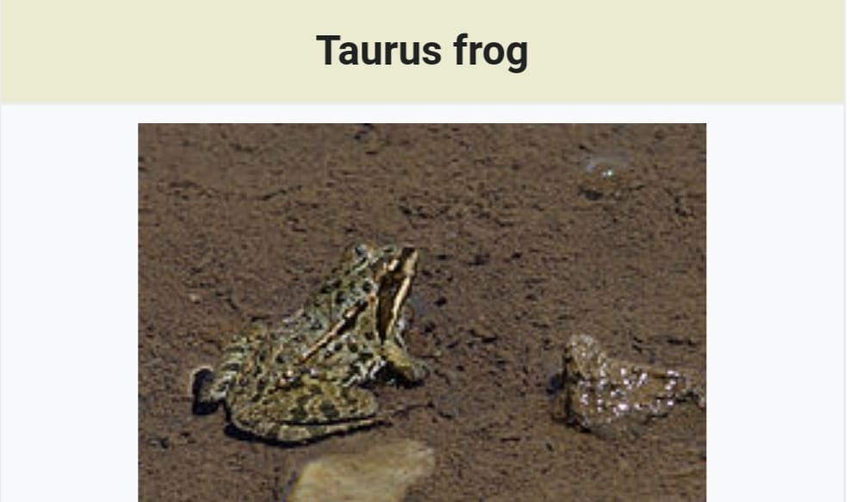

Panthera
Pardus Tulliana/ Anatolian Leopard

Panthera pardus tulliana is a leopard subspecies native to the Iranian Plateau and surrounding areas encompassing Turkey, the Caucasus, Iran, Turkmenistan, Afghanistan and possibly Pakistan. Since 2016, it has been listed as Endangered on the IUCN Red List, as the wild population is estimated at less than 1000 mature individuals.

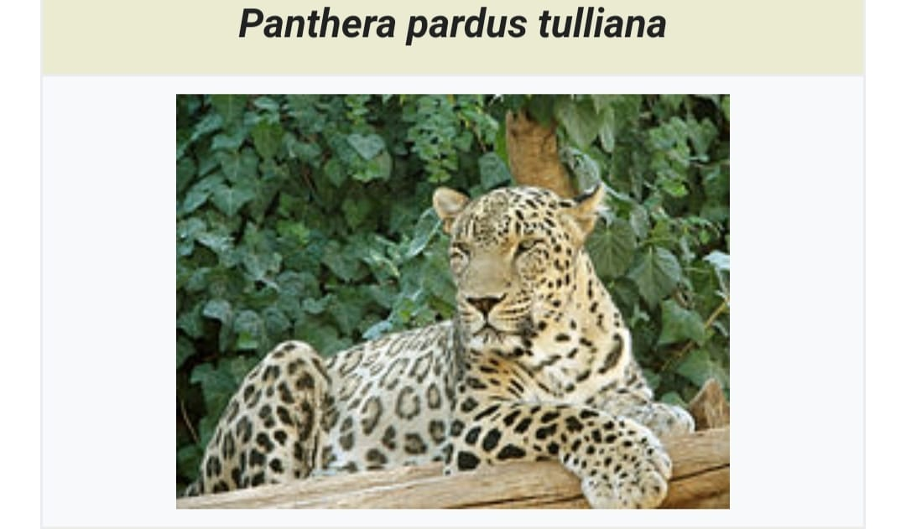

Wild Goat

The wild goat (Capra aegagrus) is a wild goat species, inhabiting forests, shrublands and rocky areas ranging from Turkey and the Caucasus in the west to Turkmenistan, Afghanistan and Pakistan in the east. It has been listed as near threatened on the IUCN Red List and is threatened by destruction and degradation of habitat.

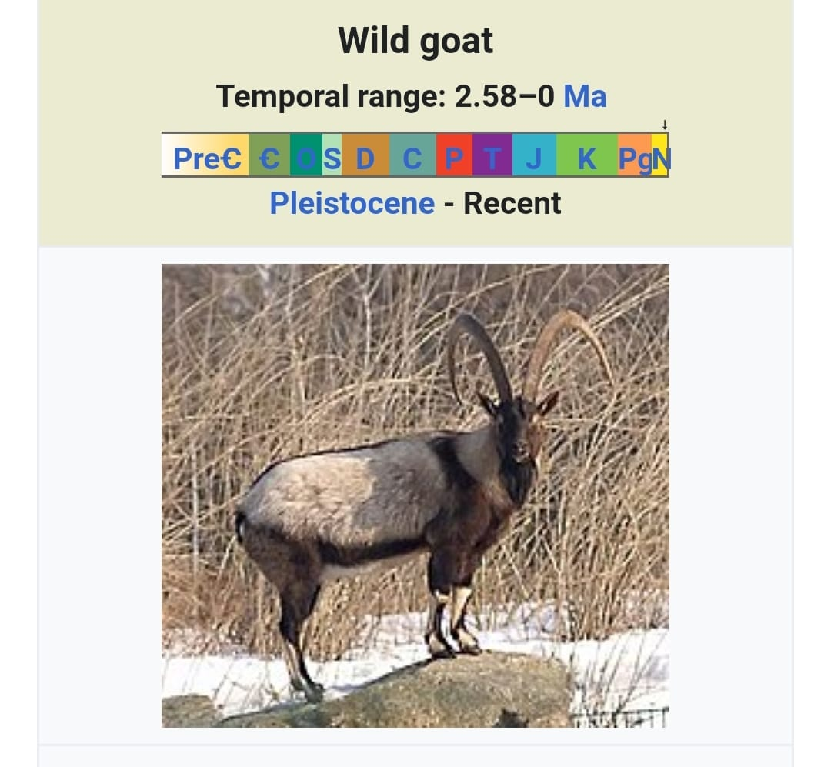
Mediterranean Monk Seal

The Mediterranean monk seal (Monachus monachus) is a monk seal belonging to the family Phocidae. As of 2015, it is estimated that fewer than 700 individuals survive in three or four isolated subpopulations in the Mediterranean, (especially) in the Aegean Sea, the archipelago of Madeira and the Cabo Blanco area in the northeastern Atlantic Ocean. It is believed to be the world's rarest pinniped species.

