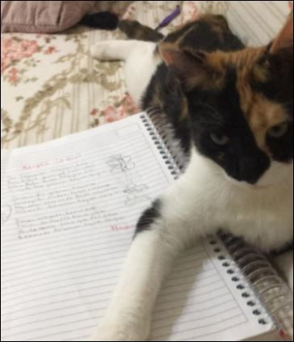
LET'S LOVE ANIMALS
Nature is beautiful with animals,
Let's love and protect them
Animals are very useful
Let's not hurt them, let's not upset them

Emir Cinar A.

STREET ANIMALS
All animals
I love so much
I will feed them
Let's not hurt them
Let's not be mean,
let's love so much
Street animals,

Ilkay S.

ANIMALS OUTDOOR
My dear cat
You're out while I'm at home
I know you are cold.
Let's do it.
Let's put food and water every day
Let's not hurt your transcendent
Let's lay and count.
Secil D.

TO MY TINY FRIENDS
All the animals on the street
They're cold in the cold
Let's feed them
Let's not torture.
In short, all animals
It is as emotional as we are.
Let's protect
As long as we can.
Ali Kaan B.

WINTER FROM SEASONS
Winter from the seasons
Lying softly in his bed,
fell asleep on the pavement,
Winter from the seasons
Open on the street
Of love,
Winter from the seasons
The mother did not go hungry.
He meowed with delight.
He warmed hearts with his love.

Ecrinsu A.

