WRITE THE MAIN DIFFERENTS THAT YOU HAVE LEARNT BETWEEN SPAIN AND TURKEY. WHAT DO WE HAVE IN COMMON?
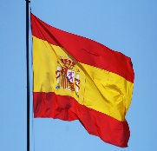
Esta foto de Autor desconocido está bajo licencia CC BY-SA

