L’EURO

Mobilité à Lipari

Evaluation de la rencontre

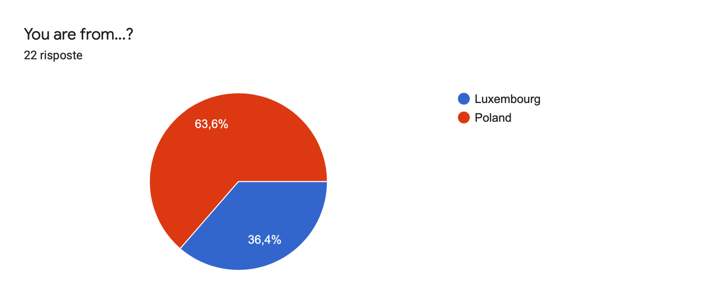

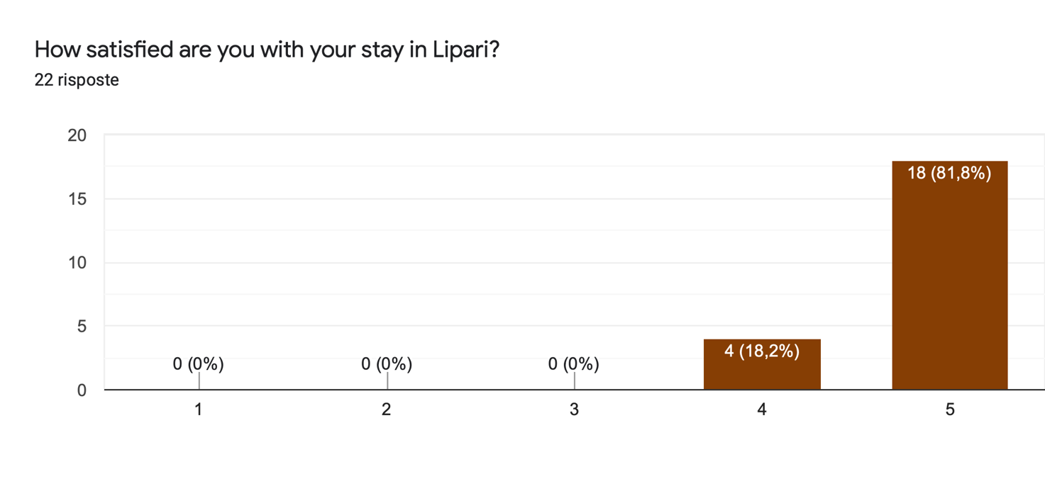
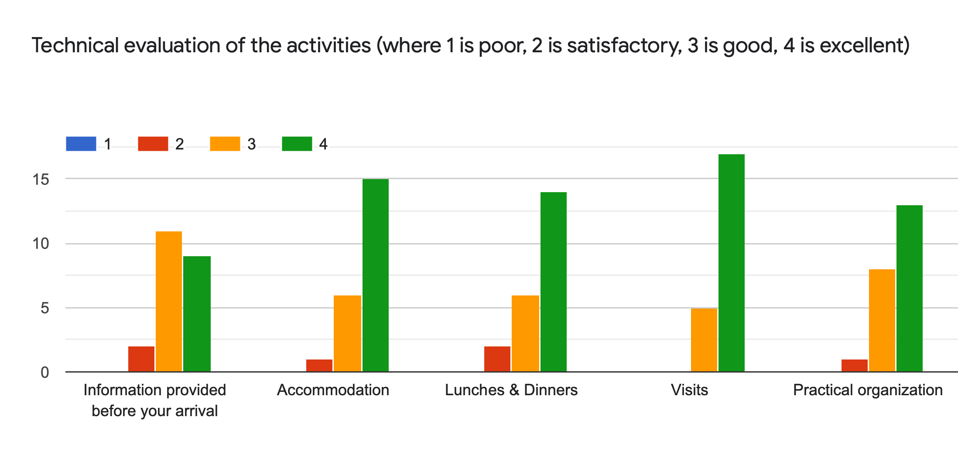
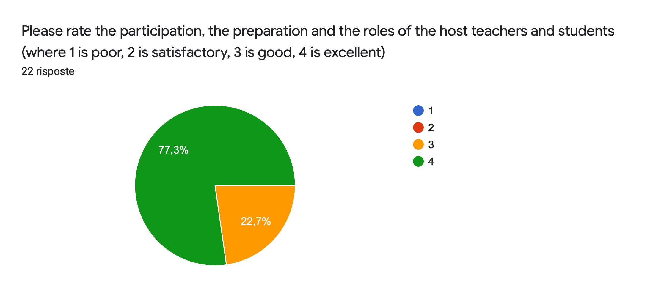

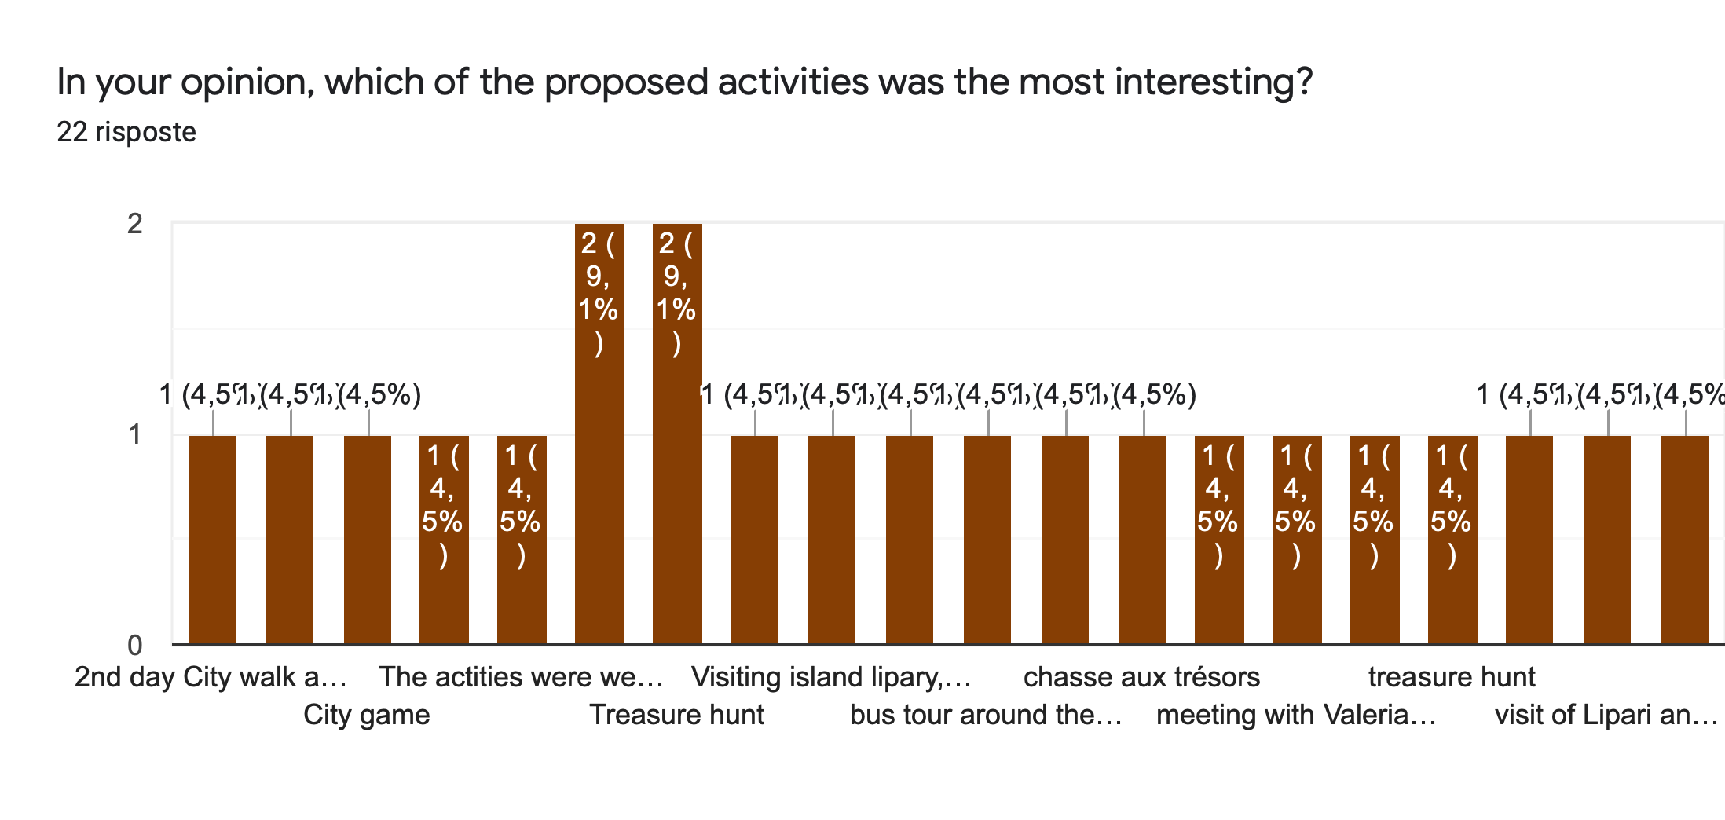
DETAILS OF THE ANSWERS:
- Treasure hunt (10 answers)
- meeting with Valeria Schifilliti
- visit of Lipari and the workshops
- Kahoot
- The activities were well-chosen, well-balanced and super well-organised!
- visting the museum
- 2nd day City walk and activities in groups
- Trip around Lipari (3 answers)
- meeting with the owner of Aktea Hotel
- all of them
- Visiting island lipary, ctivities at school, integration after activities

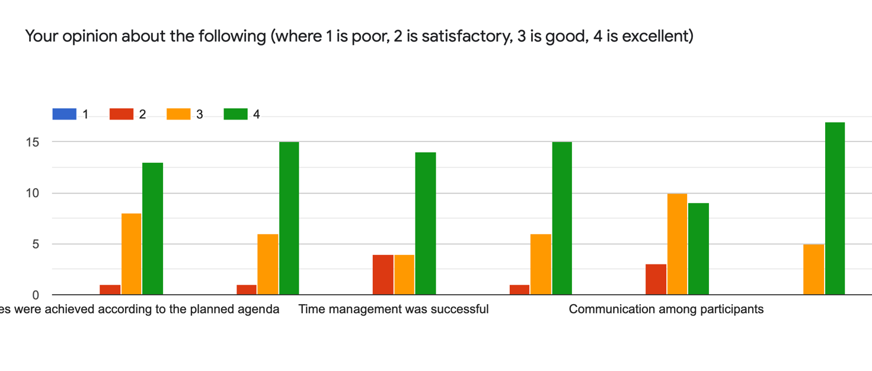
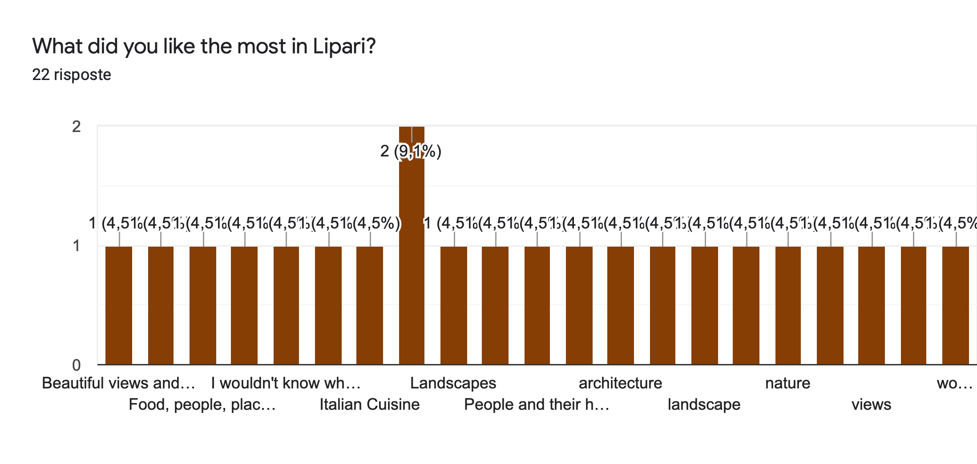
DETAILS OF THE ANSWERS:

- Landscapes (5 answers)
- meal
- the beautiful nature
- views and people
- Beautiful views and places, nice and friendly people
- Hospitality of the locals, food and views
- friendliness
- The views
- In Lipari I really like the views. The combination of mountains and sea it's wonderful. There are very polite people, everyone cares about everyone - it's beautiful!
- People and their hospitality
- Food, people, places and weather
- Italian Cuisine
- Food
- wonderful views
- I wouldn't know where to start but if I have to limit myself to one thing it would be the perfect hospitality of the organisers, the school staff and everyone else I met on the island!
- Open-minded and kind people, gorgeous landscapes and tasty food
- nature
- architecture

Is there anything you didn't like? (22 answers)

- No (15 answers)
- Waiting for the food to arrive
- Luxembourg students could be more open for others
- Contact with group from Luxembourg
- Fear that the ferry won't go to Sicily.
- Mc Donald’s Pizza (2 answers)
- that we couldn’t stay long

What do you think you have gained at this project visit? - State at least 3 things

new friends, at least 5kg, Italian words
more English words, full of Italian speaches, more opened mind
Improve language skills, after project I am more open to the people
1. I’m more aware of impact that euro has on tourism 2. I’m more confident with my language skills 3. I’ve gained international friends
I improved my language skills (English and Italian languages), I met a lot of amazing people, my knowlenge about euro currency is better now
i’m more comfortable with my english language, also i’m more confident with meeting new people, and I'm not afraid to fly anymore
Knowledge of island life; observation of the way of thinking of young people from different countries; the way students from different countries approach their school responsibilities.
Practising language, meeting people and culture
new friends, I learned a lot about the euro, new experiences
I have gained a confident, I met a lot of fantastic and my English has become better
Friends, some knowledge about a part of the world I never thought I'd visit, sanity
I think that during this trip, I opened up to people. I broke my language barrier, for which I am very proud of myself. I also tried different Italian dishes! And in general, I don't try new foods, so it means a lot to me
Better view on other culture
Increased language abilities
I broadened the language barrier, I learned more about the euro, business and I got to know the island of Lipari and their culture, but I also learned a lot of interesting facts about Italy that I didn't know.
cultural knowledge, collaboration, friends
new very good friends from Poland
practice to make teamwork
new friends, knowledge, seen lipari
experience
Great inspiration on how to organise Erasmus mobilities, a better understanding of island life in Lipari and amazing memories of a perfect trip.
to see the real life of an island, organization, and to see how the euro was seen in Lipari

For the development of the next project meeting, what could you suggest? 17 risposte

more interacting with others took an
react more when participants are passive, suggest that is a project and not holiday trip
More group activities
i have no idea for everything was perfect
Selection of young people for the project. Mobility should go to those who want to learn something, want to work, cooperate, and not those who consider traveling as a punishment.
I haven't got any sugestions
nothing
I would do more integration activities
longer stay time?
I suggest maybe some project on medical topics.
/
slightly better english proficiency from the host country
i would suggest to make more practice than theory
a larger city
/
Just stick to what you are doing. Really.
to have a little more free time

