VRIJE ASO.SCHOOL
Let’s go for a ride! The physics of roller-coasters
Creating a scale model and performing
measurements on the model

In this file we are going to discuss the results of our scale model. We got the data from the analyses of the program tracker. We calculated three kinds of energy. Kinetic, potential and mechanical energy. We made our conclusions based on the difference of these energy. We could not calculate V_{x} because there's no horizontal movement.

E_{kin} = m . v²

The kinetic energy at the beginning:
Data: m = 60 g = 60 . 10³ kg
V_{b} = - 88, 097 m/s
Wanted: E_{kin, b}
Solution: E_{kin, b} = 60 . 10³ kg . (- 88,97) m/s = - 5,3 . 10⁶ J

The kinetic energy in the middle
Data: m = 60 g = 60 . 10³ kg
v_{m} = -115 m/s
Wanted: E_{kin, m}
Solution: E_{kin, m} = 60 . 10³ kg . (-115) m/s = - 6,9 . 10⁶ J

The kinetic energy at the end
Data: m = 60 g = 60 . 10³ kg
v_{e} = - 250 m/s
Wanted: E_{kin, e}
Solution: E _{kin, e} = 60 . 10³ kg . (-250) m/s = - 1,5 . 10⁷J

The difference in kinetic energy
Δ E_{kin} = E_{kin, e} – E_{kin,b}
= - 1,5 . 10⁷ - (- 5,3 . 10⁶) = - 1,4 . 10⁷J

E_{pot} = m . g . h

The potential energy at the beginning
Data: m = 60 g = 60 . 10³ kg
g = 9,81 m/s²
h = 38 m
Wanted: E_{pot, b}
Solution: E_{pot, b} = 60 . 10³ kg . 9,81 m/s^{2 .} 38 m = 2,2 . 10⁷ J
The potential energy in the middle
Data: m = 60 g = 60 . 10³ kg
g = 9,81 m/s²
h = 18 m
Wanted: E_{pot, b}
Solution: E_{pot, b} = 60 . 10³ kg . 9,81 m/s^{2 .} 18 m = 1,1 . 10⁷ J

The potential energy at the end
Data: m = 60 g = 60 . 10³ kg
g = 9,81 m/s²
h = 2 m
Wanted: E_{pot, b}
Solution: E_{pot, b} = 60 . 10³ kg . 9,81 m/s^{2 .} 2 m = 1,2 . 10⁶ J
The difference in potential energy
Δ E _{pot}= E_{pot, e} – E_{pot,b}
= 1,2 . 10⁶ J - 2,2 . 10⁷ J = - 2,0 . 10⁷J

E_{mech} = E_{kin} + E_{pot}

The mechanical energy at the beginning
Data: E_{kin, b} = - 5,3 . 10⁶ J
E_{pot, b} = 2,2 . 10⁷ J
Wanted: E_{mech, b}
Solution: E_{mech, b} = E_{kin,b} + E_{pot,b} = - 5,3 . 10⁶ + 2,2 . 10⁷ J = 2,7 . 10 ⁷J

The mechanical energy in the middle
Data: E_{kin, m} = - 6,9 . 10⁶J
E_{pot, m} = 1,1 . 10⁷J
Wanted: E_{mech, m}
Solution: E_{mech, m} = E_{kin,m} + E_{pot,m} = - 6,9 . 10⁶ + 1,1 . 10⁷J = 5,1 . 10⁶ J

The mechanical energy at the end
Data: E_{kin, e} = - 1,5 . 10⁷J
E_{pot, e} = 1,2 . 10⁶ J
Wanted: E_{mech, e}
Solution: E_{mech, e} = E_{kin,e} + E_{pot,e} = - 6,9 . 10⁶ J + 1,1 . 10⁷J = 4,1 . 10⁶J

The difference in mechanical energy
Δ E _{mech}= E_{mech, e} – E_{mech,b}
= 4,1 . 10⁶J - 2,7 . 10 ⁷J = - 2,2 . 10⁷J

Conclusion
We can conclude that our results are not completely correct, because we used a scale model. We realized that our v_{x}-graphic is not important, because we have a drop tower and the graphic is based on the left and right movements in its drop. The speed increases when it drops, that’s also what we thought, because it only falls because of the gravity. It’s not a smooth line because it slipped at the end.

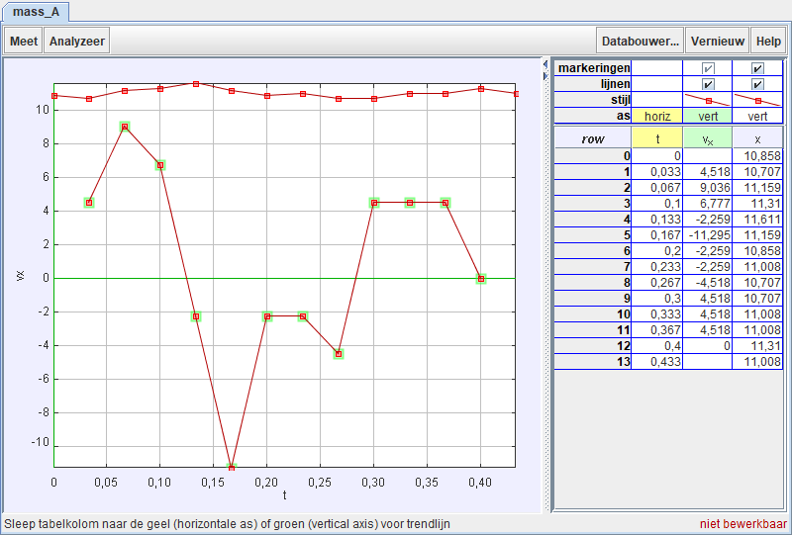
This graph is not useable because there’s no horizontal movement.

This is the V_{x}(T) graph and shows the speed of the falling cage. It’s not a smooth graph because it slipped at the end.
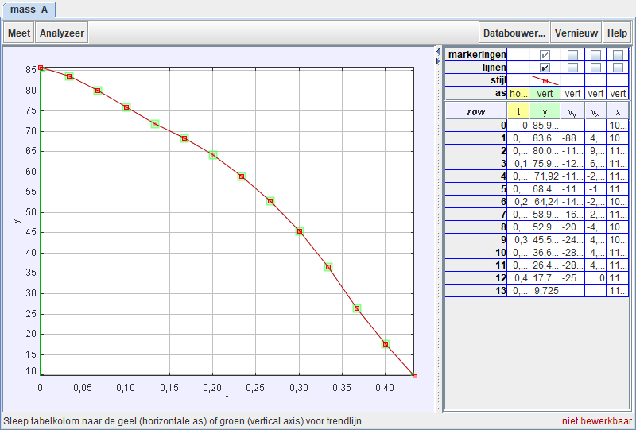
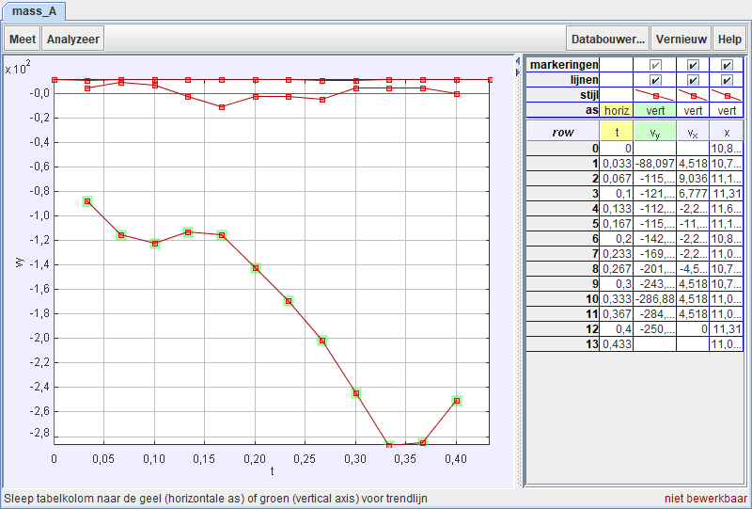
This is the Y(T) - graph and shows the height of our cage in function of the time

