THE PROGRAM OF MEETING

SUNDAY 31 MARCH 2019
By hour 19⁰⁰ | 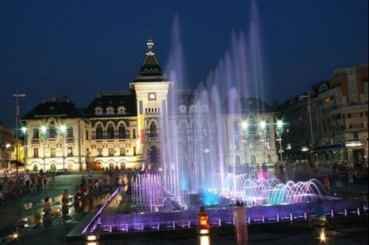  Arriving in Craiova
19⁰⁰-20⁰⁰ | 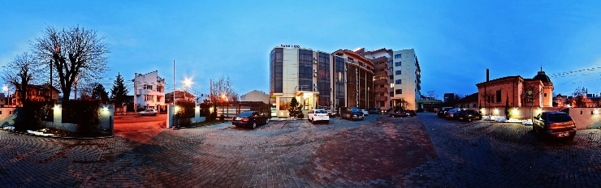  Dinner at Lido Hotel
MONDAY 01 APRIL 2019
8⁰⁰-9⁰⁰ | Breakfast at Lido Hotel
9⁰⁰-13⁰⁰ | 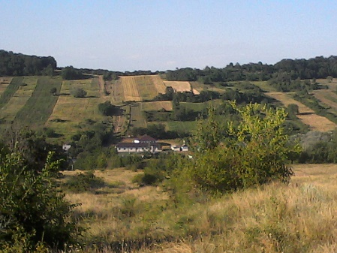  Presentation of the school (Primary School) and of the Romanian education system  Workshop - a small Romanian language course  Workshop - environmental education
13⁰⁰-15⁰⁰ | Lunch at the Grozesti - Carceni Primary School
15⁰⁰-19⁰⁰ | 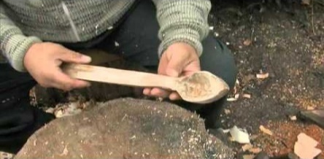  Demonstrative activity - traditional crafts (How to make a wooden spoon?)
19⁰⁰-20⁰⁰ | 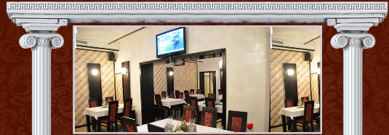  Dinner at Akropolis Restaurant (Greek specific)

TUESDAY 2 APRIL 2019
8⁰⁰-9⁰⁰ | Breakfast in Lido Hotel
9⁰⁰-13⁰⁰ | 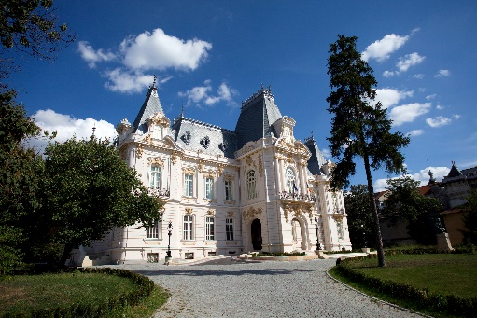  Painting workshop at The Art Museum in Craiova
13⁰⁰-15⁰⁰ | 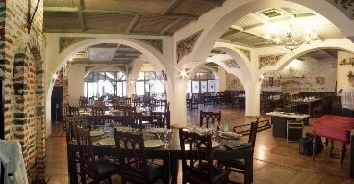  Lunch at "Casa Ghincea" (Traditional Romanian restaurant)
15⁰⁰-19⁰⁰ | 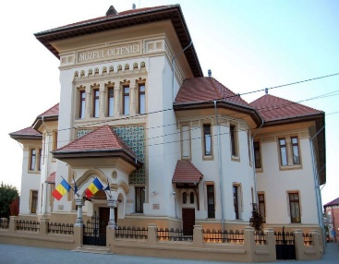  Museum of History Craiova
19⁰⁰-20⁰⁰ | 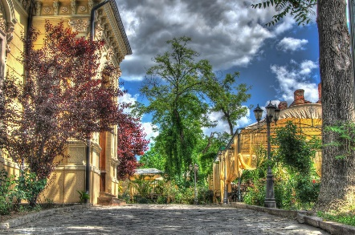  Dinner at ”Casa cu tei” – Craiova
WENSDAY 3 APRIL 2019
8⁰⁰-9⁰⁰ | Breakfast in Lido Hotel
9⁰⁰-13⁰⁰ | 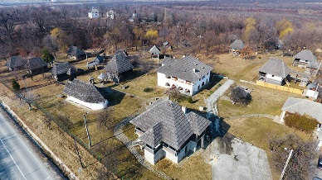  Museum of Popular Architecture - Curtisoara (Gorj)
13⁰⁰-15⁰⁰ | 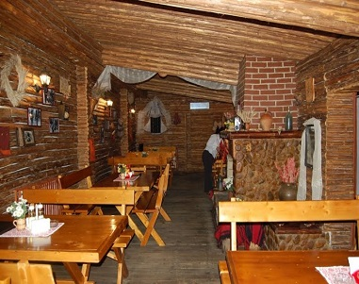  Lanch at Hanul Domnesc – Targu-Jiu
15⁰⁰-19⁰⁰ | 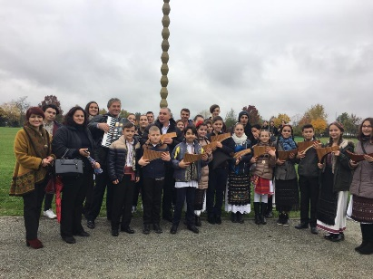  Targu Jiu  Music Miniconcer at the High School of Arts
19⁰⁰-20⁰⁰ | Dinner
THURSDAY 4 APRIL 2019
8⁰⁰-9⁰⁰ | Breakfast in Lido Hotel
9⁰⁰-13⁰⁰ | 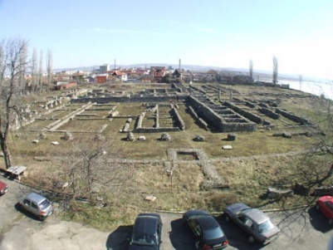  Drobeta Turnu Severin  Workshop at the History Museum
13⁰⁰-15⁰⁰ | Lanch at ”Taverna sarbului!
15⁰⁰-19⁰⁰ | Visit the center of Severin and the medieval fortress and Danube Trip
19⁰⁰-20⁰⁰ | Dinner
FRIDAY 5 APRIL 2019
8⁰⁰-9⁰⁰ | Breakfast in Lido Hotel
9⁰⁰-13⁰⁰ | 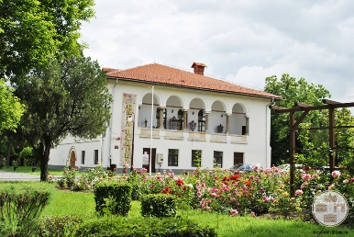  Casa Baniei Craiova
13⁰⁰-15⁰⁰ | 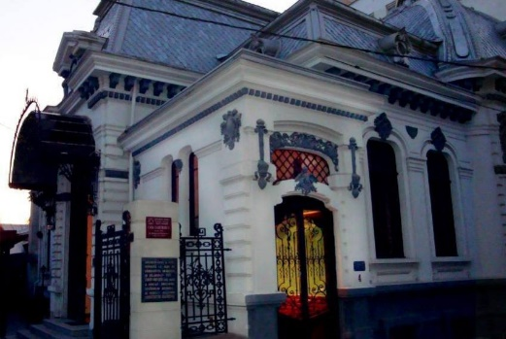  Lanch at Marmara Restaurant (Turkish specific)
15⁰⁰-19⁰⁰ | Visiting the Center of Craiova or free time
19⁰⁰-20⁰⁰ | Festive dinner - at Lido Hotel
SATURDAY 6 APRIL 2019
 | Departure from Craiova

