OUR RECREATIONS

CLASS A1: Panamarenko - Belgium

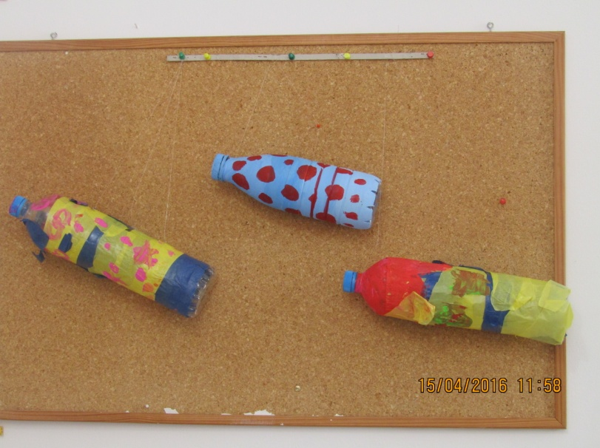

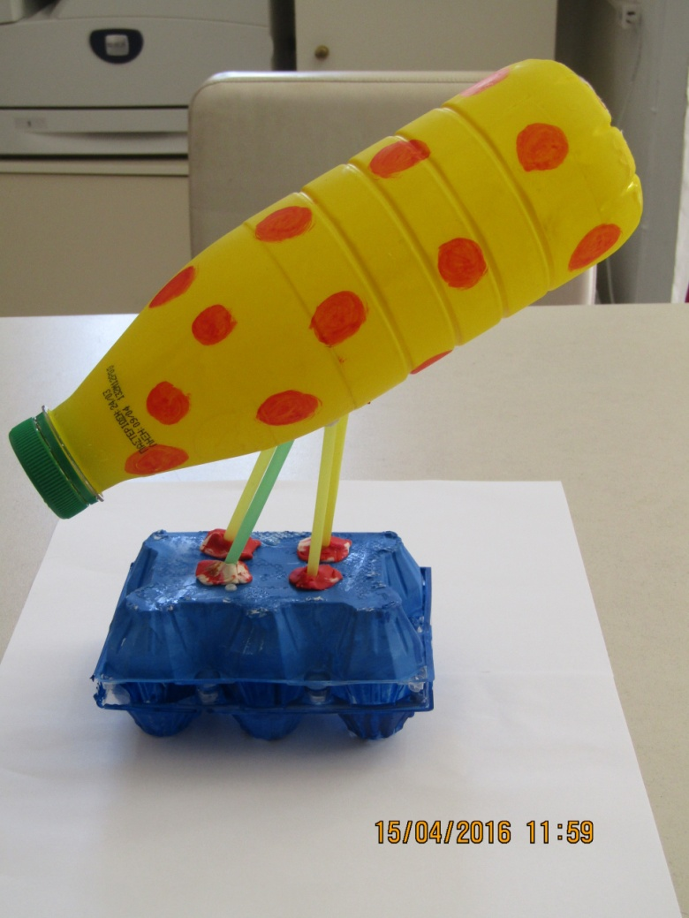

CLASS A2: Miro’s sculptures - Spain

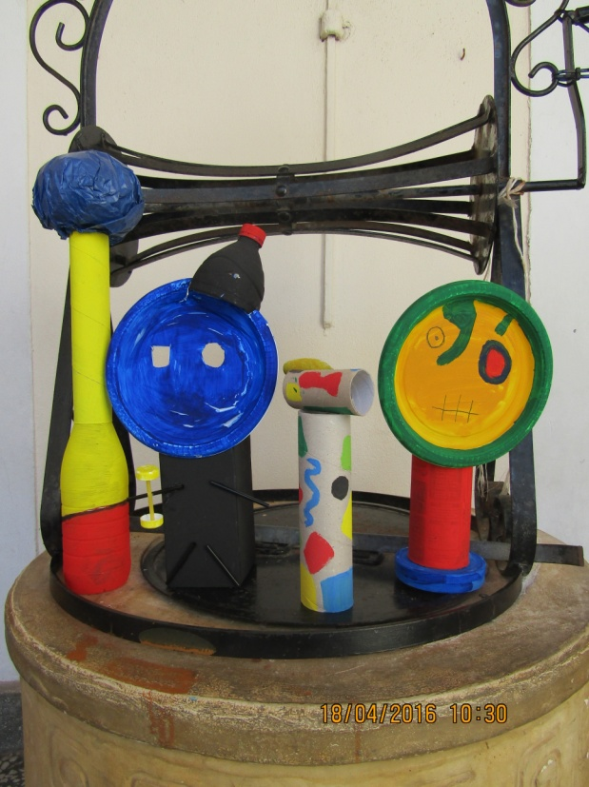

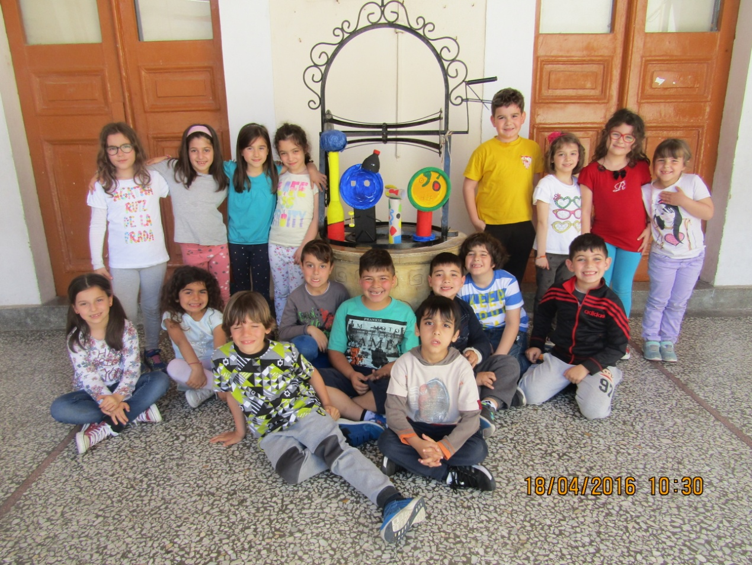

CLASS B1: Antoni Gaudi ( Lizard) - Spain

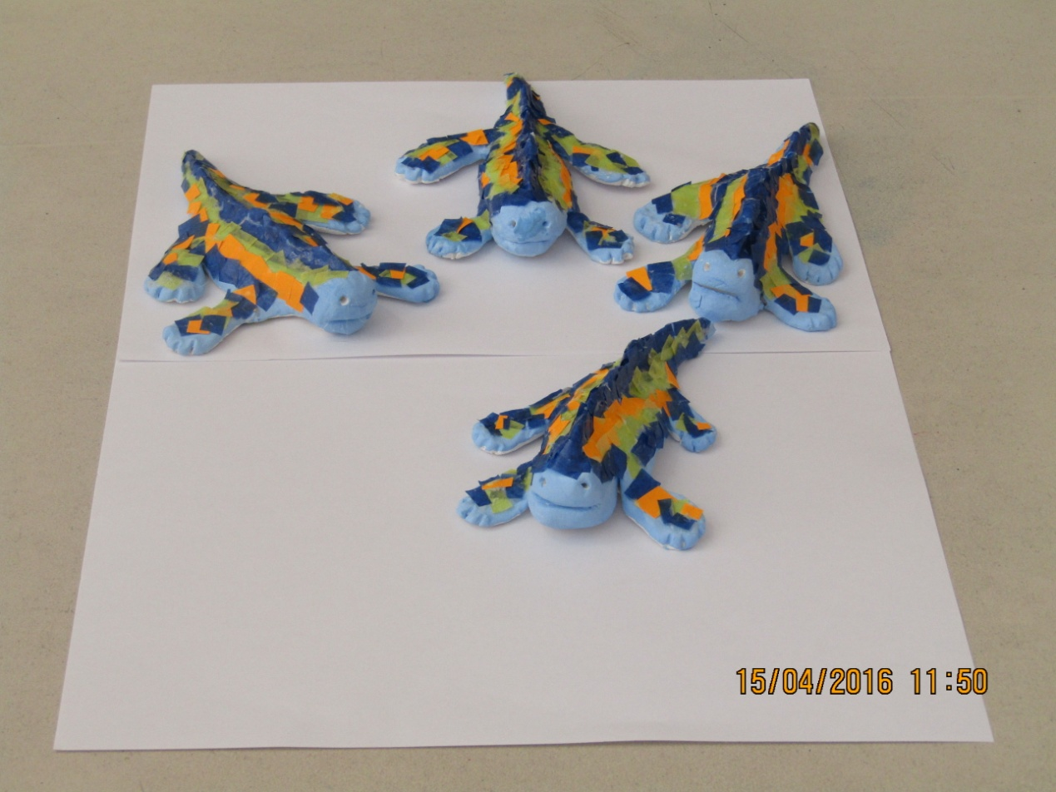

CLASS B2:

Florian Barsan ( Poppies) - Romania

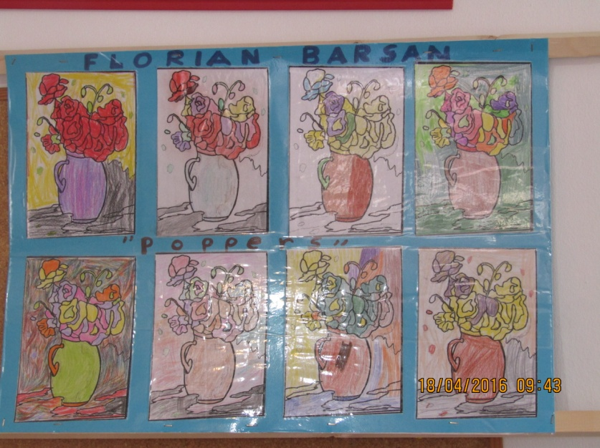

N. Tonitza (Child portrait) - Romania

# D:\ARTISTS BOX\IMG_0580.JPG

CLASS C: El Greco (Night with his hand on his breast)

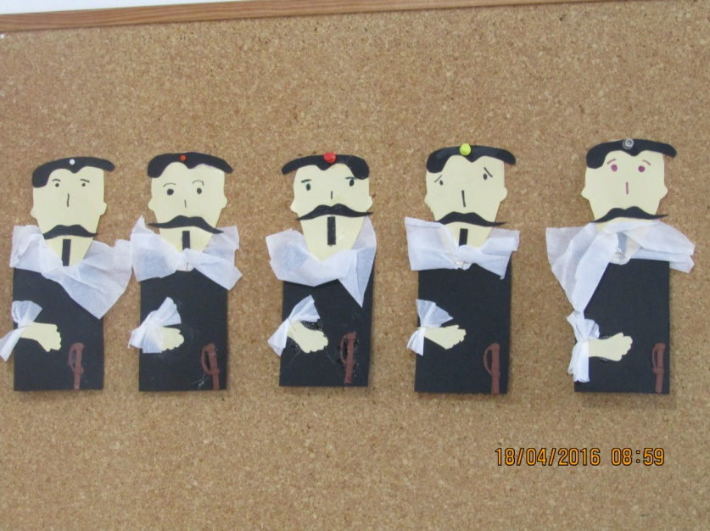

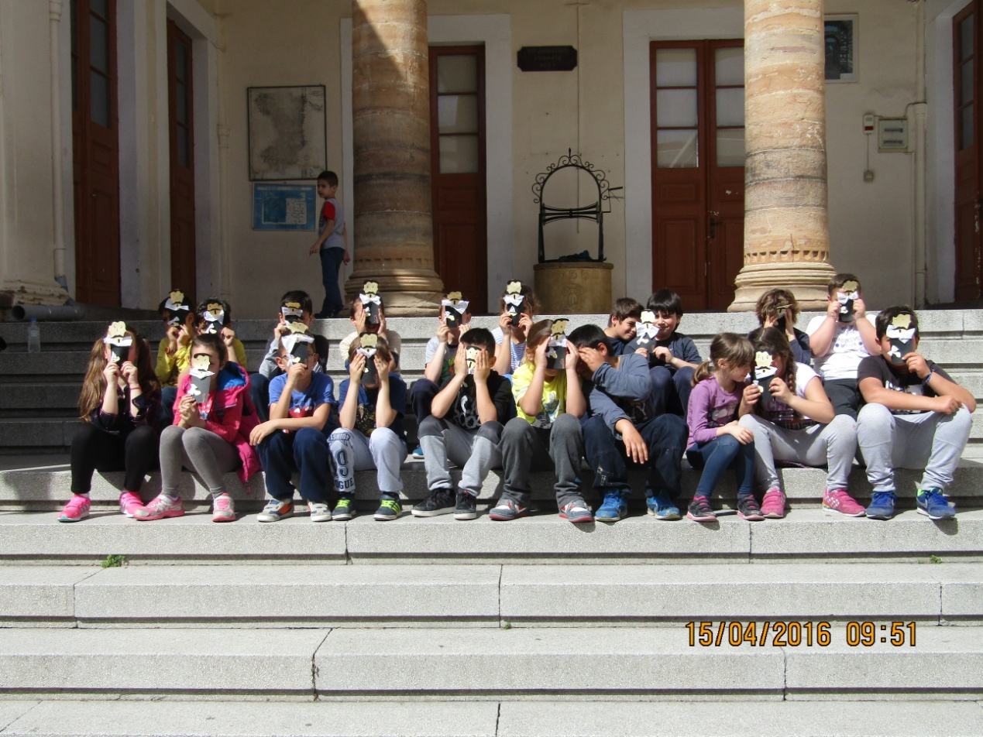

CLASS D1: Pablo Picasso (Guernica) – Spain

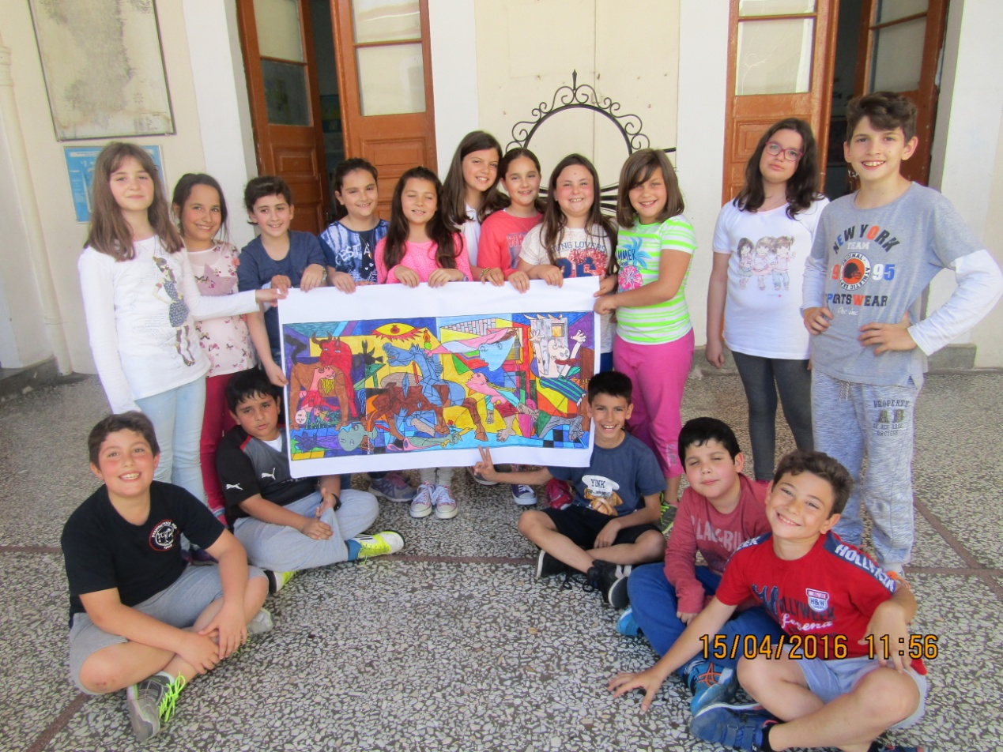

CLASS D2: Ferdinand von Wright – Finland

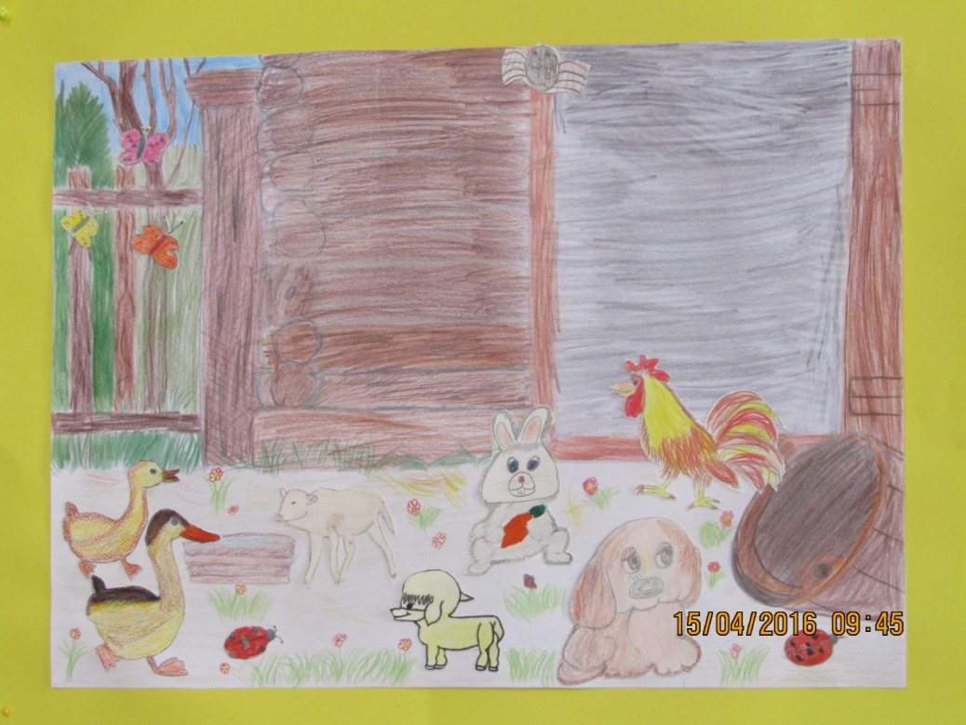

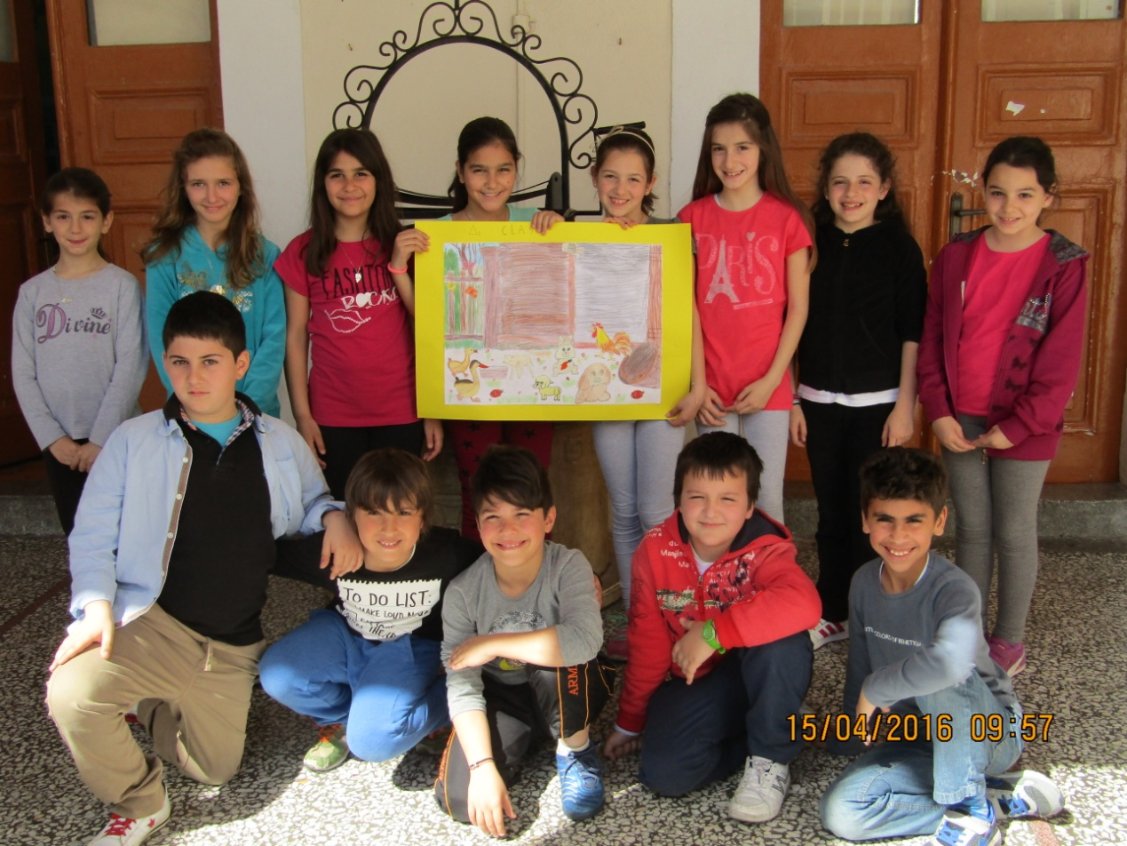

CLASS E1: Van Gogh (Sunflowers)

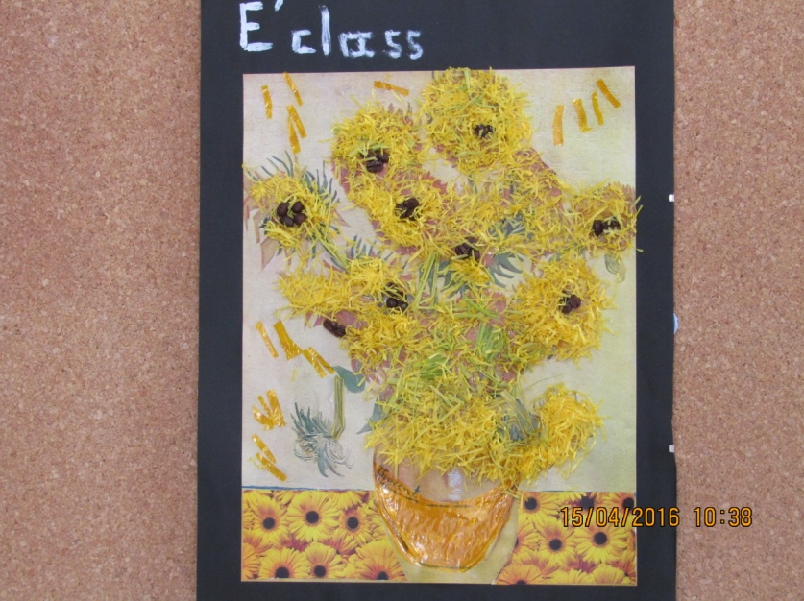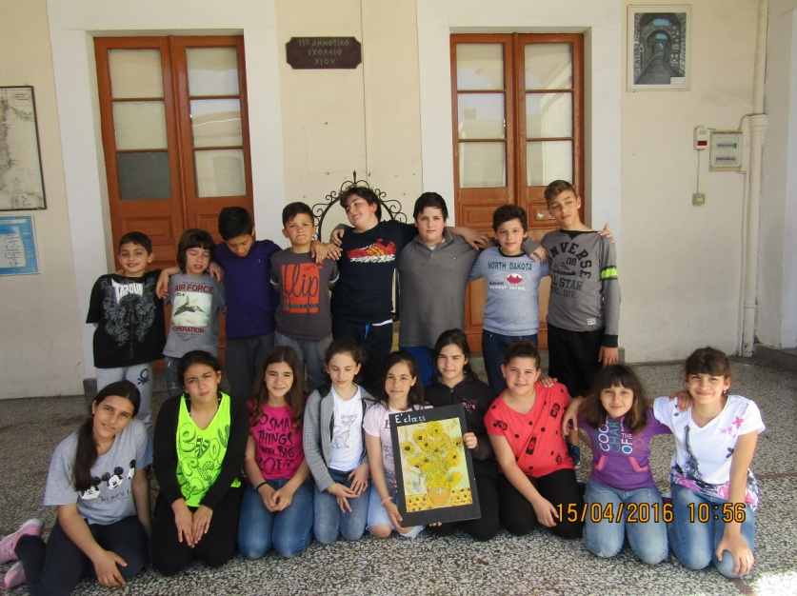

CLASS E2 : N. Grigorescu - Romania

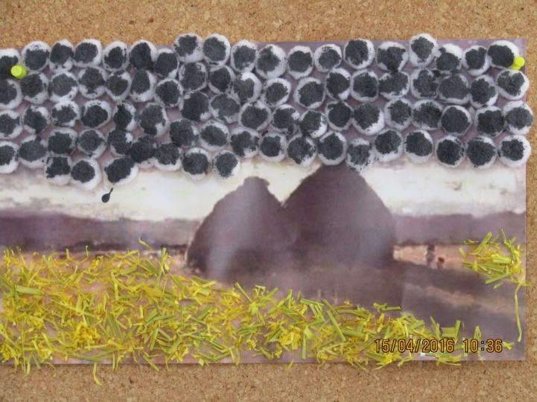

CLASS F : Cesar Monrique – Spain

